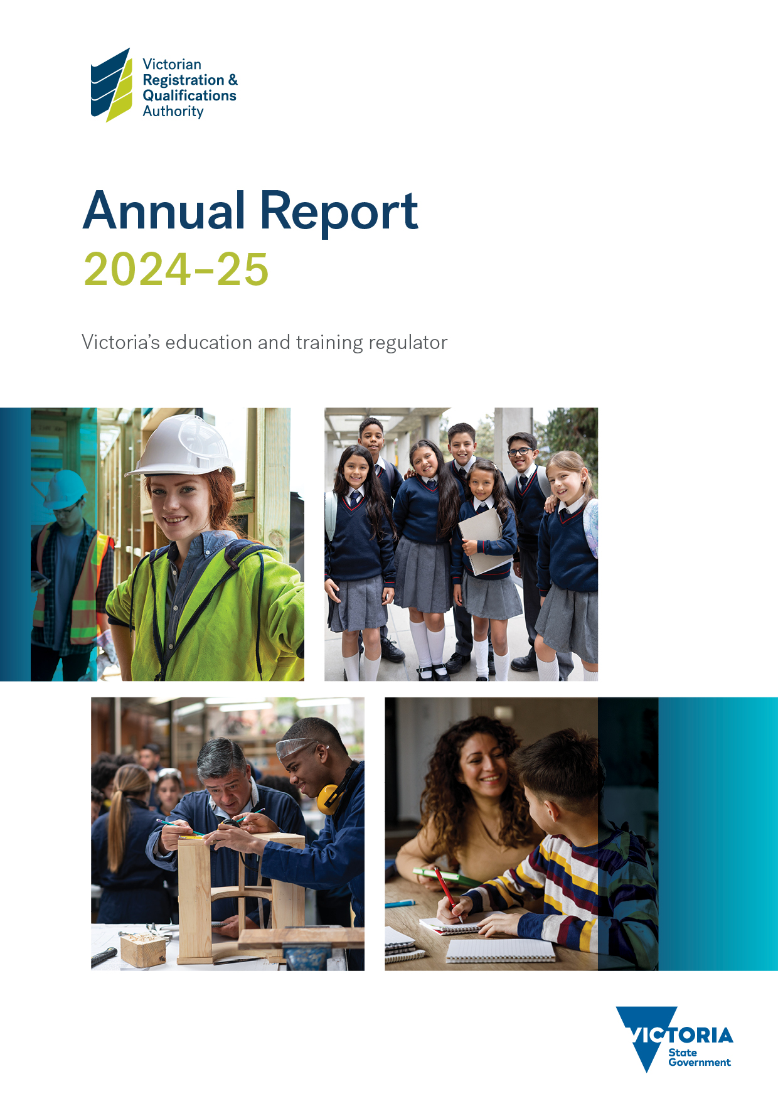

Published and authorised by:
Victorian Registration and Qualifications Authority
Level 7
1 Spring Street
Melbourne VIC 3000
GPO Box 2317
Melbourne VIC 3001
Tel: (03) 9637–2806
Email the VRQA <vrqa@education.vic.gov.au>
Visit the VRQA website <https://www2.vrqa.vic.gov.au>
October 2025
© State of Victoria (VRQA) 2025
Victorian Registration and Qualifications Authority Annual Report 2024–25 is licensed under a Creative Commons Attribution 4.0 licence. You are free to reuse the work under that licence on the condition that you credit the State of Victoria (VRQA), indicate if changes were made and comply with the other licence terms available here. The licence does not apply to:
- any trademarks or branding, including the Victorian Government logo and the VRQA logo
- images or photographs or other content supplied by third parties.
Copyright queries may be directed by email <vrqa@education.vic.gov.au>.
ISSN 2204–0463 (Print) ISSN 2204–0471 (Online)
If you would like to receive this publication in an accessible format such as large print or audio, please telephone 1800 809 834 or email <edline@vic.gov.au>.
This document is available in Microsoft Word and Adobe PDF at the VRQA website <https://www2.vrqa.vic.gov.au>.

The Hon. Ben Carroll MP
Minister for Education
The Hon. Gayle Tierney MP
Minister for Skills and TAFE
The Hon. Danny Pearson, MP
Minister for Economic Growth and Jobs
Dear Ministers,
In accordance with the Financial Management Act 1994 and the Education and Training Reform Act 2006, I am pleased to present the Victorian Registration and Qualifications Authority’s annual report for the year ended 30 June 2025.
Yours sincerely,
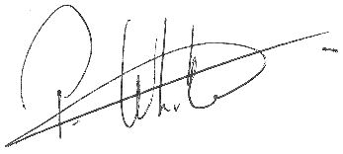
Pam White PSM
Chair
Victorian Registration and Qualifications Authority
11 September 2025

Contents
Report of operations – year in review 1
Our purpose 1
Our principles 1
Our values 1
Report of the Chair 2
Report of the CEO (Director) 3
Introduction 5
Purpose and functions 5
Strategic priorities, ministerial expectations and key achievements 6
Strategic plan 6
Statement of Expectations (SoE) 6
Key achievements 7
Progress towards objectives and indicators 10
Schools, school boarding premises, senior and foundation secondary education 10
Non-school providers of senior secondary or foundation secondary courses 14
International education 14
Vocational education and training (VET) 15
Child Safe Standards 17
Home schooling 19
Apprenticeships and traineeships 21
Complaints 23
Access to information 24
Working with stakeholders and duty holders 25
VRQA financial review 2024–25 27
Report of operations – governance and organisational structure 28
Ministers 28
The VRQA Board 28
Standing committee 32
Subcommittees 32
VRQA staff 33
VRQA organisational structure 36
Report of operations – workforce data 37
Public administration values and employment principles 37
Occupational health and safety 37
Comparative workforce data 38
Executive data 41
Report of operations – other disclosures 42
Local Jobs First 42
Government advertising expenditure 42
Consultancies expenditure 42
Reviews and studies expenditure 42
Disclosure of major contracts 42
Freedom of information 43
Compliance with the Building Act 1993 43
Competitive Neutrality Policy 43
Compliance with the Public Interest Disclosures Act 2012 44
Compliance with the Carers Recognition Act 2012 and the Disability Act 2006 45
Disclosure of emergency procurement 45
Disclosure of procurement complaints 45
Environmental reporting 45
Fees and charges 45
Additional information available on request 45
Compliance with DataVic Access Policy 46
Compliance with Victoria’s Social Procurement Framework 46
Compliance with the Asset Management Accountability Framework (AMAF) 47
Attestation for financial management compliance with Ministerial Standing Direction 5.1.4 49
Financial statements 50
Declaration in the financial statements 50
Victorian Auditor-General’s Office Report 51
How this report is structured 53
Notes to the financial statements 57
Appendices 79
Appendix 1. Disclosure index 79
Appendix 2. Ministerial Statement of Expectations for the VRQA 81
Appendix 3. Ministerial Directions for the VRQA 85
Appendix 4. Acronyms and abbreviations 86

Report of operations – year in review

Our purpose
The Victorian Registration and Qualifications Authority (VRQA) regulates for quality learning outcomes.

Our principles
The principles that underpin all our interactions with duty holders, co-regulators, stakeholders and the public are:
- transparency
- proportionality
- consistency and predictability
- sector neutrality
- efficiency and agility.

Our values
The VRQA upholds the Victorian Public Sector Values and applies them at all levels of the organisation.

Report of the Chair

It has been a busy time for the VRQA, but one where we have benefitted from having our new CEO in place for the full year. This stability enhanced the organisation’s ability to embed the VRQA Regulatory Approach Statement 2022 and acquit the VRQA Strategic Plan 2022–25.
During the reporting period, the VRQA fulfilled the commitments and expectations defined by the Board and the priorities of the Victorian Government. Details of key achievements against our Ministerial Statement of Expectations (SoE) and strategic priorities are in Table 1 on page 7.
In 2024–25, the outcomes of significant, long-term reform initiatives became evident. The full implementation of Victoria’s Child Safe Standards was the focus of the VRQA’s annual school review cycle. Senior and foundation secondary certificate reforms are now in place. Increased engagement with our review bodies has improved the efficiency and effectiveness of VRQA’s regulation of schools and strengthened review body arrangements.
In the training and skills sector, we have embedded our Compliance and enforcement framework for regulating apprenticeships and traineeships. The implementation of the Heads of Agreement has deepened VRQA’s relationships with co-regulators. This collaboration has resulted in increased knowledge sharing and greater awareness among employers of their obligations.
None of this would have been possible without the vision and steadfast leadership of my fellow Board members. All Board members play an active role on our subcommittees, as well as at meetings of the full Board. They bring to our deliberations an extensive range of views and experiences, and improve the work of the VRQA. I would also like to acknowledge Board member Dr Geraldine Atkinson. In June 2025, Dr Atkinson was appointed an Officer of the Order of Australia for distinguished service to First Nations community, education, self-determination and reconciliation.
To those who provided constructive feedback through our client and stakeholder forums and research this year, I express the Board’s gratitude. You helped shape our reforms and improved our regulatory services, and during the coming year, we will seek to act on the feedback you have provided.
My thanks also to Stefanie Veal, CEO (Director) and the VRQA staff. The Board is consistently impressed by the commitment, capability and dedication to delivering quality learning outcomes and ensuring providers and employers keep children and young people safe.

Pam White PSM
Chair

Report of the CEO (Director)

Every Victorian has the right to quality education and training that enables them to reach their full potential. Whether at school or in the workplace, children and young people can only learn and thrive if they are safe.
In 2024–25, the VRQA continued its work to eliminate harm to students, apprentices and trainees. We did this by focusing our resources on the highest risk of harm. For us, this includes physical, psychological, emotional and financial harms, and poor-quality education and training.
The focus of our school and school boarding premises reviews in 2024–25 was the Child Safe Standards. We want to ensure schools are embedding a culture of child safety, where every child and young person feels safe and is safe.
During the reporting period, we responded to feedback by continuing to enhance our engagement and collaboration with schools. The VRQA worked closely with schools and stakeholders to drive voluntary compliance. We did this through more information sessions, site visits, and targeted guidance and support during reviews.
In response to feedback from schools, and to ensure an outcome-focused approach, we also commenced a major review of the Guidelines to the minimum standards and other requirements for school registration. The review will streamline evidence requirements and improve clarity for schools about what compliance looks like.
Over the past 10 years, there has been a significant increase in the size and complexity of the school sector and the VRQA’s regulatory remit. There has also been innovation in the use of technology and modes of delivery. This brings with it both risks and opportunities. For the VRQA, this means a growing need to prioritise its resources to minimise the greatest risk of harm.
At 30 June 2025, there were 25,527 active employers, and 66,823 apprentices and trainees in training. As a small organisation in a large sector with multiple co-regulators, we seized opportunities to raise our profile. To increase our regulatory reach, we continued to improve information sharing and collaboration with co-regulators, including WorkSafe and the Fair Work Ombudsman.
We completed the Connect:Protect campaign in collaboration with the Labour Hire Authority to protect apprentices and trainees working in labour hire from exploitation. We also increased our communications with employers to drive awareness of their obligations, and with apprentices, including by going out to technical and further education institutes (TAFEs) to talk to them about their rights.
The VRQA continued to uplift its regulation of the apprenticeship sector by embedding the Compliance and enforcement framework for regulating apprenticeships and traineeships. We set our 2025–26 enforcement and compliance priorities, and worked with the Department of Jobs, Skills, Industries and Regions on implementation of the Apprenticeship Taskforce reforms.
In 2024–25, the VRQA continued to support home educators with resources and online information sessions. We also worked with the Department of Education and the Victorian Home Education Advisory Committee to understand trends in home schooling.
Quality learning outcomes are only achieved with the engagement of our duty holders and stakeholders. I thank the peak bodies, school review bodies, the home education and parent advisory groups, and our co-regulators. Your collaboration and willingness to provide thoughtful feedback informs and improves
our work.

In my second year as VRQA CEO (Director), I feel grateful to lead an organisation and team of people so willing to engage and respond to that feedback. I thank them for their dedication to improvement and reform.
I also thank the VRQA Board. It is a privilege to work under your strategic vision and focus. Expertly led by Chair Pam White PSM, the Board’s accountability and strategic stewardship drive the work we do to ensure quality learning outcomes and the safety of all Victorian students and apprentices and trainees.
I look forward to continuing to work with the Board, the VRQA team and our duty holders in the coming year to continuously improve outcomes for children and young people through quality training and education that enables them to reach their full potential.

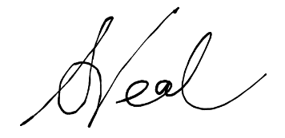
Stefanie Veal
CEO (Director)

Introduction
This annual report meets the Financial Reporting Direction FRD 30D, Standard requirements for the publication of annual reports, that states annual reports must be ‘reports of the financial and business operations of an entity, produced to comply with legislation and financial reporting directions’. This report complies with the Department of Treasury and Finance’s 2024–25 Model Financial Report and does not include material not required under relevant legislation and directions.
Appendix 1 is an index of the VRQA’s compliance with statutory disclosure requirements.

Purpose and functions

Strategic purpose
The VRQA regulates for quality learning outcomes.
Regulation aims to eliminate or minimise harm. For the VRQA, harm includes physical, psychological, emotional and financial harms, and reductions in individual and societal benefits of education and training. The VRQA seeks to eliminate or minimise harm and the risk of harm to children, students, apprentices and trainees receiving education and training services within its scope of regulation. We do this directly and through our co-regulators.

Functions
The VRQA is a statutory authority established under the Education and Training Reform Act 2006 and is responsible to the Minister for Education, the Minister for Skills and TAFE, and the Minister for Economic Growth and Jobs.
The VRQA registers:
- schools, including approval on the Commonwealth Register of Institutions and Courses for Overseas Students (CRICOS) to deliver courses in schools
- school and non-school senior secondary or foundation secondary education providers
- school boarding premises
children for home schooling in Victoria
- organisations to award senior secondary qualifications
- vocational education and training (VET) providers delivering accredited training to domestic students in Victoria only, or Victoria and Western Australia only.
The VRQA also:
- regulates apprenticeships and traineeships in Victoria
- issues trade papers
- recognises group training organisations (GTOs) in Victoria
- approves school and non-school providers as overseas secondary student exchange organisations
- accredits courses and registers qualifications for VRQA-registered providers, and senior secondary and foundation secondary courses and qualifications in Victoria
- investigates complaints against duty holders
- maintains a register of all VRQA-registered education providers and accredited courses
acts to protect the interests of students as consumers of education.

Strategic priorities, ministerial expectations and key achievements

Strategic plan
The VRQA Strategic Plan 2022–25 sets out 6 strategic priorities:
- Implement government directions effectively – deliver government decisions and expectations on time and to a high quality.
- Continue to strengthen our regulatory approach – provide duty holders with clear education and support to drive compliance and strengthen our oversight of review bodies undertaking regulatory functions on our behalf.
- Build greater clarity and visibility about our role – strengthen the visibility and understanding of our role and function, and continue to clarify roles with co-regulators to ensure effective regulatory oversight.
- Continue to improve business processes and systems – streamline business processes to improve internal efficiency and productivity, and apply technology to improve client interactions. Evidence-based decision-making will be supported by building on our business analytics capabilities.
- Develop, empower and support our people – build a positive workplace climate and culture underpinned by integrity that encourages leadership, energy and enthusiasm. We will attract and develop staff capabilities to meet current and future operational requirements.
- Prudent financial management – undertake our regulatory functions and activities on a sustainable basis, working with the Department of Education (the department) to clarify our financial needs and pressures, including the dynamic and continuing changes in the sectors that we regulate.
The VRQA Board monitors progress and achievements against the strategic plan quarterly, which are highlighted throughout this report.

Statement of Expectations (SoE)
The Minister for Education and the Minister for Skills and TAFE issue statements that outline the Victorian Government’s expectations of the VRQA as a regulator.
Effective from November 2022, the current SoE is reproduced in full in Appendix 2. This SoE is the seventh issued by ministers.
It details 7 expectations in the areas of:
- home schooling
- schools
apprenticeships and traineeships.
The Department of Treasury and Finance revised the Statement of Expectations Framework for Regulators in September 2022. The revised framework removes the requirement to update SoEs every 2 years, and allows regulators to align updates with existing planning processes and timelines, unless changes in government or regulator priorities require more timely updates.
The VRQA Board monitors progress and achievements against the SoE. This progress is reported as required directly to ministers and is included in this annual report, in line with the Department of Treasury and Finance Statement of Expectations Framework for Regulators.

Key achievements
Table 1 highlights the VRQA’s key achievements in the 2024–25 reporting period and aligns them to the VRQA’s 6 strategic priorities and the 7 expectations in its SoE.
Table 1. Key achievements against the strategic priorities and SoE
Key achievements in 2024–25 | SoE alignment | Strategic priority
Home schooling
Collaborated with the Victorian Home Education Advisory Committee and other networks to communicate about changes to the Education and Training Reform Act 2006 and unregistered schools. | 1a, 1c | 1, 2, 3
Commenced procurement and development of a new home education management system. | 1b, 1c | 4, 5
Raised the profile of VRQA’s Home Education Facebook page, increased shared resources and launched a series of online information sessions for the home education community. | 1b | 2, 3
Worked with the department’s Performance and Evaluation Division to examine the trends in home schooling. | 1c | 1, 2
Schools
Continued to provide guidance and support to schools to comply with the minimum standards, which included:  - refocusing the approach to reviews to improve engagement and understanding of each school’s unique operating context  - driving voluntary compliance through collaboration, information sessions and school forums  - offering every school with a rectification plan a meeting to provide targeted compliance support. | 3a, 4a | 1, 2, 4
Championed the implementation of the Child Safe Standards by:  - making compliance with the Child Safe Standards the focus of the 2025 cyclical review program  - collecting detailed compliance data and reporting to the Commission for Children and Young People (CCYP)  - collaborating with Child Safe Standards regulators to share information, and discuss compliance trends and emerging risks  - incorporating guidance about the Child Safe Standards into every VRQA information session for duty holders. | 3a, 4a | 1, 4
Implemented the revised Review Body Assurance Program, which included:  - facilitating the Review Body Community of Practice, validation and moderation of assessments, reviewer training and VRQA shadowing of onsite assessments  - bimonthly review body meetings to discuss operational and strategic matters, and the timely sharing of information aligned with Memorandums of Understanding (MoUs), including about registrations and common non-compliances  - commenced final negotiations on new review body MoUs. | 3a, 4a, 4b, 4c | 1, 2, 5
Continued contributions to significant department initiatives, which included:  - the implementation of the department’s policy on minimum workplace hours for school-based apprentices and trainees (SBATs)  - supporting the commitment to build new schools by identifying mandated department policies for new and ongoing school registration, where appropriate  - ongoing provision of advice and data to support reforms relating to non-school senior secondary and foundation secondary providers, complementary education settings, SBATs and VET in schools. | 3b, 4b, 7h | 1, 2, 3
Improved the efficiency and effectiveness of VRQA’s regulation of schools, which included:  - holding online and in-person information sessions in partnership with Independent Schools Victoria  - improving response times to school queries and rectification submissions  - completing a review of the approach to school regulation, including consulting with stakeholders  - commencing a major review of the Guidelines to the minimum standards and other requirements for school registration to improve clarity and guidance about what compliance looks like. | 3, 4 | 2, 3, 4, 5
Apprenticeships and traineeships
Implemented a reform program and co-implemented recommendations from the Apprenticeships Taskforce report, which included:  - an exchange of letters with the Fair Work Ombudsman  - signing of an MoU with the Australian Skills Quality Authority and the Western Australian Training Accreditation Council  - implementing the Heads of Agreement with WorkSafe, Energy Safe Victoria, Victorian Building Authority, Labour Hire Authority, and Wage Inspectorate Victoria  - continuing to improve information sharing and collaboration with co-regulators, including WorkSafe  - embedding the VRQA compliance and enforcement framework for regulating apprenticeships and traineeships and publishing the  2025–26 enforcement and compliance priorities. | 5a, 7a, 7b, 7c | 1, 2, 3
Raising the profile of our in-house apprenticeship field services, which included:  - increasing employer awareness, as measured by the annual client and stakeholder research, from 49% to 56% in 2024  - conducting the Connect:Protect campaign in partnership with the Labour Hire Authority  - increasing communications about the monitoring and compliance of employers and commencing a communications strategy to regularly share regulatory actions online and with co-regulators. | 5a, 6, 7g | 2, 3, 4

Key achievements in 2024–25 | SoE alignment | Strategic priority
Corporate
Completed a funding review, including reviewing the cost base and cost drivers for the VRQA’s schools and VET teams. | – | 6
Built organisational capability through onboarding, learning and development, which included:  - whole-of-organisation respectful behaviours workshops and management coaching, targeted mental health first aid training  - refreshing intranet and induction resources, and increasing professional development opportunities. | – | 5
Advanced the modernisation of regulatory tools and registers, including implementing digitisation projects and completing the redevelopment of the public website <https://www2.vrqa.vic.gov.au/>. | – | 3, 4
Continued to embed the VRQA Regulatory Approach Statement 2022 across all policies, operations and communications. | 6 | 2, 3, 4

Progress towards objectives and indicators

Schools, school boarding premises, senior and foundation secondary education

Significant activities and achievements
The VRQA registers and regulates all Victorian schools across the government, Catholic and independent sectors. It regulates government and Catholic schools through review body arrangements with the department and the Victorian Catholic Education Authority (VCEA).
All Victorian schools must meet the minimum standards for registration of schools (minimum standards). In response to the growth in unregistered providers operating as quasi-schools, the VRQA increased regulatory activity to ensure every Victorian student receives a quality education in a safe environment.
In February 2025, the Victorian Government passed a bill that amends the Education and Training Reform Act 2006 . These amendments significantly increase the penalties for operating an unregistered school or school boarding premises and allow the VRQA to:
- cancel the registration of a school or school boarding premises that has ceased to operate
- more easily share information with a prescribed person or body
- require a person or organisation to produce documents or information that helps to determine if they should be registered
accept an enforceable undertaking when there is a risk or likelihood of non-compliance.
In 2024–25, the VRQA’s work focused on consulting and engaging with stakeholders and responding to feedback from schools. A review of the approach to school regulation and the minimum standards evidence requirements was completed in the reporting period.
As an outcome of that review, the VRQA improved the efficiency and effectiveness of school regulation with the introduction of:
- site visits for every school under review and offering meetings to every school with a rectification plan, to provide targeted guidance and support to comply
improved response times to school queries and rectification submissions.
The VRQA also commenced a major review of the Guidelines to the minimum standards and other requirements for school registration to ensure more clarity on evidence requirements for schools.
The assurance of review body arrangements also enhanced the effectiveness and sector neutrality of school regulation with:
- reviewer training and VRQA shadowing of onsite assessments
- Review Body Community of Practice and bimonthly review body meetings to discuss operational and strategic matters, the timely reporting of child safety matters and significant breaches of the minimum standards
final negotiations on the new review body MoU.
To support this work and provide sector and school leaders with support and guidance, during the reporting period, the VRQA:
- increased engagement and collaboration, including meeting with schools with non-compliances to provide targeted support
- updated and improved application and amendment forms
provided information sessions and ongoing guidance at other duty-holder forums.
VRQA information sessions for duty holders were held online and in person to provide guidance about the cyclical review process for schools and school boarding premises, the Child Safe Standards and the process for reapproval of registration to provide education to overseas students. Information sessions and pre-application meetings were also conducted for prospective independent school applicants.
The VRQA increased engagement with schools, including by attending duty-holder forums and partnering with Independent Schools Victoria to offer additional guidance to schools about compliance. The VRQA also presented to the Victorian Student Representative Council to empower students to better understand both the Child Safe Standards and the minimum standards.

School boarding premises regulation
The VRQA regulates school boarding premises to ensure they meet minimum standards and the Child Safe Standards.
There are 37 school boarding premises registered in Victoria (2 government, 7 Catholic, 24 independent and 4 non-school providers).
The VRQA provides guidance to school and non-school providers on compliance with the minimum standards for school boarding premises.
To minimise regulatory burden, where possible and in consultation with schools, cyclical reviews of school boarding premises were conducted in conjunction with a school’s cyclical review and/or CRICOS reregistration. The VRQA undertook analysis of compliance data to identify areas where boarding premises require greater support to comply.

Secondary education pathways reform
In 2023, the Victorian Certificate of Education Vocational Major, a program of study within the Victorian Certificate of Education (VCE), replaced the Intermediate and Senior Victorian Certificate of Applied Learning. Additionally, the Victorian Pathways Certificate replaced the Foundation Victorian Certificate of Applied Learning.
In the reporting period, the VRQA continued to work with the department and the Victorian Curriculum and Assessment Authority to implement these reforms in relation to:
- SBATs and non-school senior and foundation secondary providers
- the accreditation of new Victorian Pathways Certificate courses
- collaborating with the Victorian Curriculum and Assessment Authority about completion rates and unscored VCE.

Other activities
The VRQA conducts reviews of independent schools on a 5-year cycle to ensure their continuing compliance with the minimum standards. The VRQA may also open an out-of-cycle review if concerns are identified regarding a school’s compliance with the minimum standards, including matters relating to the safety of students.
Of Victoria’s 2,329 schools, 69% are government schools, 21% are Catholic and 10% are independent. In 2024–25, the VRQA registered 15 new schools – 8 primary schools, 2 secondary schools, 4 specialist schools and one specific purpose school.

Figure 1. Registered schools by sector at 30 June 2025

Table 2. Number of registered schools at 30 June 2025^{(a)}
School type | 2025 | 2024
Government | 1,600 | 1,595
Catholic | 496 | 496
Independent | 233 | 232
Total | 2,329 | 2,323
Note: (a) While the department’s census date for registered schools is February, the VRQA’s census date is June. Unlike the department’s data, the VRQA’s data includes schools with temporary populations, such as hospital schools and those in youth justice facilities.

Table 3. School registration by activity 2024–25
Registration type | Government | Catholic | Independent | Total
New school
Primary | 5 | 2 | 1 | 8
Secondary | 1 | – | 1 | 2
Specialist | – | – | 4 | 4
Specific purpose | 1 | – | – | 1
Additions and amendments
Additional campuses | 3 | 6 | 14 | 23
Additional secondary year levels | 8 | 2 | 10 | 20
Additional primary year levels | – | 1 | 1 | 2
School relocation | 1 | – | 1 | 2
Campus relocation | 3 | – | 2 | 5
Change of proprietor | – | – | 1 | 1
Senior secondary registration | 6 | – | 7 | 13
Other | – | 1 | – | 1
Closures/cancellations
Schools closed | 2 | 2 | 5 | 9
Campuses closed | 5 | 2 | – | 7
Table 4. School boarding premises registration by activity 2024–25
Registration type | Government | Catholic | Independent | Total
Premises closed | – | 1 | – | 1
Campuses closed | – | – | 2 | 2
Table 5. Number of registered school boarding premises at 30 June 2025
School boarding premises type
Government | 2
Catholic | 7
Independent | 24
Non-school provider^{(a)} | 4
Total | 37
Note: (a) see the non-school provider section for a description of this provider category.

Non-school providers of senior secondary or foundation secondary courses

Significant activities and achievements
Non-school providers deliver senior secondary or foundation secondary courses to students in a non-school environment.
The number of non-school providers continues to decrease. At 30 June 2025, there were only 15 registered non-school providers in Victoria. Of these, two providers are not seeking reregistration beyond 31 December 2025.
From 2026, all but one of these providers will be TAFEs/universities.

Other activities
In the reporting period, no new non-school providers were registered and one non-school provider requested voluntary cancellation of their registration. Another provider was administratively cancelled following the expiry of registration. One provider added 2 additional delivery sites to its registration.
Table 6. Non-school providers at 30 June 2025
Organisation type | 2025 | 2024
Community-based adult education provider | 1 | 1
TAFE institute/university | 12 | 13
Other | 2 | 3
Total | 15 | 17

International education

Significant activities and achievements
At 30 June 2025, there were 71 Victorian providers with CRICOS registration to deliver school education to international students. These comprised 70 registered schools (58 independent and 12 Catholic) and the department. Victorian government schools are registered under a single CRICOS registration held by the department.
The VRQA approved a new CRICOS registration for one non-government school and reapproved 27 non-government schools to provide courses to overseas students. Seven non-government schools chose to voluntarily cancel their registration. Two other providers voluntarily cancelled courses under their approved CRICOS registration.

Other activities
The VRQA regulates secondary student exchange programs in Victoria, and approves schools and not-for-profit organisations that offer outbound student exchange programs to Victorian students and inbound exchange programs to international students.
In the 2024 school year, the VRQA received the details of 303 students departing Victoria to participate in student exchange programs from student exchange organisations (SEOs) and 364 students arrived in Victoria to take part in student exchanges.
Table 7. CRICOS approval activity 2024–25
Approval type | Government | Catholic | Independent | Non-school | Total
CRICOS approvals | – | 1 | – | – | 1
CRICOS reapprovals | – | 2 | 25 | – | 27
Provider cancellations | – | 4 | 3 | – | 7
Course cancellations | – | – | 1 | 1 | 2
Table 8. SEOs at 30 June 2025
Approved SEOs | 2025 | 2024
Government school | 4 | 8
Non-government school | 9 | 9
Non-school organisation | 11 | 13
Total | 24 | 30

Vocational education and training (VET)
Victoria’s regulatory framework for VET providers comprises the Australian Quality Training Framework and the VRQA Guidelines for VET Providers. These apply to all VRQA-registered providers delivering VET qualifications in Victoria and Western Australia.

Significant activities and achievements
In 2024–25, the VRQA redeveloped all its VET and VRQA-registered training organisations (RTOs) website content to a more accessible, user-friendly format. This improved the accessibility and clarity of compliance information for duty holders.
The VRQA focused on ensuring consistency with national standards for VRQA-RTOs, following an announcement from the Australian Government Department of Employment and Workplace Relations in March 2024 about changes to standards for RTOs.
In the reporting period, the VRQA supported RTOs to understand their obligations with pre-audit information sessions and multiple pre-registration information sessions for prospective RTOs.
The VRQA has the authority to extend the end-date of training packages and qualification transition end-dates beyond the standard 12-month period. There was one extension approved in 2024–25.

Other activities
The VRQA approved 95 amendment-to-scope applications.
In terms of course accreditation activity, the VRQA:
- accredited 9 courses
- reaccredited 20 courses
extended 11 courses.
The process for the accreditation of crown copyright courses was streamlined to support the Victorian Skills Plan and increase collaboration with the Victorian Skills Authority.
Table 9. Number of VRQA-registered RTOs by type at 30 June 2025
Organisation type | 2025 | 2024
Education/training business or centre | 28 | 31
Community-based adult education provider | 38 | 37
Industry association | 4 | 5
Enterprise – non-government | 3 | 3
Enterprise – government | 9 | 9
School – government | 15 | 15
School – independent | 15 | 21
School – Catholic | 4 | 5
Other – not elsewhere classified | 2 | 2
Total | 118 | 128
Table 10. Number of new VRQA-registered RTOs by type
Organisation type | 2024–25
Education/training business or centre | 1
School – government | 1
Total | 2
Table 11. VET registration activity
Registration activity | 2024–25 | 2023–24
New registration | 2 | 2
Cancellation | 9 | 2
Transfer to Australian Skills Quality Authority | 3 | 9
Registration renewal | 31 | 30
Amendment to scope | 95 | 176

Table 12. Course accreditation activity
Activity type | 2024–25 | 2023–24
New courses accredited | 9 | 11
Courses reaccredited | 20 | 34
Course modifications | 1 | 2
Course accreditations extended (max. 12 months) | 10 | 10
Course expired/deleted | 34 | 33
Table 13. VRQA-accredited courses by qualification type at 30 June 2025
Qualification type | 2025 | 2024
Short courses | 61 | 91
Certificate I | 9 | 9
Certificate II | 16 | 16
Certificate III | 19 | 20
Certificate IV | 15 | 16
Diploma | 12 | 15
Advanced diploma | 9 | 12
Graduate certificate | 3 | 2
Graduate diploma | 3 | 3
Total | 147​ | 173

Group Training Organisations (GTOs)
The VRQA is responsible for GTO recognition and assesses compliance against the National Standards for GTOs. At 30 June 2025, there were 40 organisations recognised as GTOs. The VRQA received one new application and did not award recognition to any new organisations in the reporting period. The VRQA conducted 13 financial capability assessment audits and 13 quality audits of GTOs.

Child Safe Standards
The VRQA worked with the department and the CCYP to ensure the Child Safe Standards and Ministerial Order 1359 continue to be implemented across regulated sectors.

Significant activities and achievements
The VRQA maintains a dedicated Child Safe Standards website with guidance for education providers on how to comply with the standards. In 2024–25, the VRQA, in consultation with the department, transitioned this website to VRQA’s new website.

The new website provides support and guidance to:
- schools across all sectors
- school boarding premises
- non-school senior secondary and foundation secondary providers
- international education providers
RTOs.
Guidance about the Child Safe Standards and Ministerial Order 1359 was incorporated into all VRQA information sessions held for providers during this reporting period.
In addition, compliance with the Child Safe Standards was the focus of the 2025 school cyclical review program, and training sessions were held for school reviewers that covered Ministerial Order 1359 and the Child Safe Standards.
Strategies to assure consistent approaches to compliance and assessment regarding Ministerial Order 1359 were discussed at meetings of the Review Body Community of Practice, whose members comprise the VRQA, VCEA and the department. Review body sessions that focused on individual standards were also held to support more consistent approaches to compliance and assessment. Under the previous review model for Catholic schools, reviews were conducted by diocesan school proprietors. The VCEA commenced directly reviewing Catholic schools in 2025. As part of the new review body MoU under negotiation, the VCEA is required to develop a comprehensive assurance framework and ensure the quality and rigour of reviews.
The VRQA also supported the CCYP’s release of new resources for Child Safe Standard 1, which requires organisations to establish culturally safe environments for Aboriginal children and young people. The VRQA worked collaboratively with the CCYP and the 5 other regulators of Child Safe Standards in Victoria to ensure consistency of messaging and to share information and learnings.

Other activities

Monitoring of compliance with the Child Safe Standards
There were 621 assessments completed of providers’ compliance with the Child Safe Standards and Ministerial Order 1359. This included registration and review activities for regulated entities, complaints investigations and assessments following concerns raised with the VRQA, including through referrals from CCYP and other regulators.
Table 14 shows data about compliance with the Child Safe Standards collected by the VRQA and its school review bodies for schools, school boarding premises, non-school providers, international providers and RTOs.

Table 14. Monitoring of compliance with the Child Safe Standards
1 July 2024 to 30 June 2025 | No. | % assessed as not compliant | % assessed as not compliant following rectification
School and school boarding premises reviews | 575 | 79% | 0%
School and school boarding premises investigations | 5 | 100% | 0%
Registration activity including assessment of
compliance against the Child Safe Standards
Schools and school boarding premises | 21 | 57% | 0%
Non-school providers of senior or foundation secondary | 2 | 100% | 0%
SEOs | 11 | 100%^{(a)} | 0%
RTOs | 6 | 80% | 0%
Complaints – all sectors
Complaint investigations (Child Safe Standards) | 1 | 100% | 0%
Total assessments | 621
Referrals from CCYP^{(b)} | 4
Sanctions imposed relating to the Child Safe Standards | 5
Enforceable undertakings relating to the Child Safe Standards | 0
Notes: (a) Five SEOs had conditions imposed on their registration at reapproval; these were removed following rectification. (b) Not all CCYP referrals result in assessments; where assessment is undertaken, it is captured elsewhere in the table.

Home schooling

Significant activities and achievements
Home schooling registrations continued to increase during the 2024–25 reporting period, but the rate of growth was lower than in recent years. The VRQA launched a series of information sessions in March 2025 to support families interested in or already registered for home education.
In 2024–25, the VRQA also:
- communicated to home schooling families about the annual review cycle and what to expect if they were selected for review
- notified families about the continuation process and provided guidance on how to respond
- wrote to every registered family with information to assist them to understand the forms home education can take and how to identify unregistered schools
commenced work on a replacement database system to modernise the home education register and improve the regulatory experience for home schooling families.
The VRQA took 13 days on average to notify families about the outcomes of complete registration applications. This is an increase from the 2023–24 reporting period, when the average was 11 days.
The VRQA Home Education Facebook page continued to be used to communicate and interact with the home education community. At 30 June 2025, the page audience had increased by 15% from the previous reporting period to 2,869 followers.

Other activities
During the reporting period, the VRQA completed 437 reviews, received 4,084 home schooling applications and registered 3,867 children. Home schooling registrations have increased by 4% since the previous reporting period, with 11,691 children registered in 8,154 households (Table 15). Some home schooling applications were still being assessed at the close of the reporting period.
The VRQA did not refuse any applications in the reporting period. However, 877 parents were informed that their application did not meet requirements at initial submission. Most subsequently provided sufficient information to meet registration requirements. There were 71 applications withdrawn prior to refusal.
The 693 exemptions granted from one or more of the learning areas were mainly for children with individual learning needs. For older children, exemptions were generally due to wanting to focus on learning area(s) relevant to their future study or career goals. Some exemption applications were withdrawn by the parent, following clarification from the VRQA.
Table 15. Home-schooling registrations at 30 June 2025
 | 2025 | 2024
Children | 11,691 | 11,240
Households | 8,154 | 7,716
Table 16. Metrics from the SoE, 1 July 2024 to 30 June 2025
Metric | 2024–25
Registrations | 3,867
Applications received | 4,084
Incomplete applications received | 877
Average days to notify of outcome of complete application | 13
Applications seeking an exemption from one or more learning areas | 1
Exemptions from learning area(s) granted | 693
Applications refused | 0
Registrations reviewed | 437
Registrations cancelled | 0
VRQA registration decisions resulting in an internal review request | 0
VRQA registration decisions resulting in the applicant seeking review at  the Victorian Civil and Administrative Tribunal | 0

Apprenticeships and traineeships
The VRQA registers training contracts and approves employers to employ apprentices and trainees in Victoria. The VRQA Compliance and enforcement framework for regulating apprenticeships and trainees explains the approach to ensuring employers meet their obligations and that apprentices and trainees are protected from harm.
This includes workplace visits by authorised officers and strategic campaign investigations. Where employers do not comply with requirements, the VRQA responds in a range of ways, such as providing education, opportunities to rectify non-compliance and using its regulatory powers.
These regulatory powers include:
- revoking an employer’s approval to employ apprentices and trainees in Victoria
- refusing to approve or register training contracts
- cancelling registered training contracts
making orders regarding disputes between employers and apprentices.

Significant activities and achievements
In 2024–25, the VRQA continued to protect apprentices and trainees from harm, through compliance and investigation activities, regulatory actions and reforms in response to the VRQA’s Ministerial SoE.
Regulatory actions taken by the VRQA in 2024–25 included:
- 22 employer approvals revoked (compared to 27 in 2023–24, and 24 in 2022–23)
136 delegate-ordered cancellations of training contracts (compared to 92 in 2023–24 and 274 in
2022–23).
The VRQA also exercised its powers by:
- refusing 2 training contract proposals because employers did not demonstrate they could meet their obligations (resulting in 259 training contracts not being registered)
listing 5 formal disputes, a decrease from 7 in 2023–24 and 11 in 2022–23 (due to a higher resolution of disputes by authorised officers, rather than VRQA delegate-issued orders).
The continuation of VRQA’s apprenticeship and traineeship reform program included:
- consolidation of the insourced regulatory field services
- publication of 2025–26 compliance and enforcement priorities in April 2025
- the Connect:Protect campaign, ensuring that labour hire employers are meeting their training contract obligations
increasing engagement with apprentices and trainees, and raising awareness of the VRQA through the attendance of authorised officers at the Melbourne Career Expo and TAFE trade days.
The VRQA continued to work with co-regulators, building on the December 2023 Heads of Agreement with WorkSafe Victoria, Wage Inspectorate Victoria, Energy Safe Victoria, Victorian Building Authority and the Labour Hire Authority. It also strengthened information sharing with the Fair Work Ombudsman through an Exchange of Letters in March 2025.
Of the 22 employer revocations in 2024–25, 11 were the result of information sharing. Of these:
- 4 were complaints or referrals from Apprenticeship Victoria’s Apprenticeship Support Officer program
- 4 were referrals from RTOs about employers not releasing apprentices and trainees to attend training
- 3 were related to actions taken by other agencies, including prosecutions by the Fair Work Ombudsman, WorkSafe Victoria and a coronial inquest.
In the reporting period, the VRQA also provided data and information to co-regulators, including the Labour Hire Authority, Energy Safe Victoria, the Victorian Building Authority, the Fair Work Ombudsman and WorkSafe.

Other activities
The VRQA operates a call centre that received over 8,700 calls for assistance in the reporting period. Callers included apprentices and trainees, parents, employers, Apprentice Connect Australia providers and RTOs.
Many of the requests for assistance were resolved immediately or soon after the call. Others were referred to more appropriate services for assistance, including the VRQA Apprenticeships Field Services.
The VRQA also received over 14,000 emails, many seeking assistance regarding matters directly or indirectly impacting a successful apprenticeship and traineeship experience.
During the reporting period, the VRQA increased its communication to employers, apprentices and trainees, partnering with co-regulator, the Labour Hire Authority, to promote the Connect:Protect campaign using targeted email communications.
The VRQA also intensified public communications about the monitoring and compliance of employers and other issues impacting apprentices and trainees.
Table 17. Apprenticeship and traineeship activity
Activity type | 2024–25 | 2023–24 | 2022–23
Training contracts registered | 24,888 | 33,023 | 58,620
Employer approvals | 3,584 | 3,960 | 6,325
Employer approvals revoked | 22 | 27 | 24
Training schemes approved | 3 | 19 | 18
Apprenticeship cancellations | 12,395 | 14,027 | 16,333
Traineeship cancellations | 5,077 | 8,451 | 13,879
Formal disputes listed | 5 | 7 | 11
Delegate as guardian on training contract | 2 | 5 | 8
Delegate-ordered cancellations or withdrawals | 136 | 92 | 274
Training contract proposals refused | 2 | – | –

Apprenticeship field services
The Apprenticeship Field Services unit has authorised officers who undertake investigations and conduct workplace inspections. The 2024–25 reporting period marked the second year of operation for the insourced field services, which commenced on 1 July 2023.
A new case management system for authorised officers was implemented in 2024, allowing for more detailed information to be recorded. This involved reclassification of previously reported job or investigation types and the addition of new types. Therefore, investigation activities reported for 2024–25 differ from those reported in previous years.
In the reporting period, Apprenticeship Field Services completed 838 jobs, including:
- 571 Risk Assessment Contact (RAC) calls to apprentices and trainees, to identify potential compliance issues for escalation to review (previously reported as Risk Assessment Services)
- 27 enquiry, review and advice cases, including providing advice and responding to information requests from internal and external stakeholders, and assessing high-risk training contract proposals from employers (not previously reported)
- 211 investigations, including from complaints, referrals, RAC escalations, other agency actions, VRQA-directed campaigns and follow-ups (previously reported as medium-complexity and high-complexity investigations)
29 disputes between employers and apprentices, most commonly where apprentices wish to cancel their training contracts, but employers do not agree (reporting of these is unchanged).
Table 18. Apprenticeship Field Services activity
Job type | 2024–25 | Job type | 2023–24
RAC | 571 | Risk assessment services | 551
Enquiry, review and advice | 27 |  | –
Investigations from complaint, referral^{(a)}, RAC escalation, other agency action or VRQA-directed | 211 | Medium-complexity investigations | 128
 | 211 | High-complexity investigations – escalations | 90
Disputes | 29 | High-complexity investigations – disputes | 15
Total | 838 | Total | 784
Note: (a) Complaint referral is complaints received and investigated by the Apprenticeship Field Services, which are separate from those managed by the VRQA’s Complaints unit (see Table 19).

Trade papers
A trade paper is a certificate recognising the successful completion of a trade apprenticeship. The Victorian Government reintroduced trade papers in 2019. In the reporting period, the VRQA issued 10,804 trade papers.

Complaints

Significant activities and achievements
The VRQA received 349 complaints in 2024–25, an increase of 34% compared to 2023–24 (Table 19). The largest number of complaints related to the school sector.
School complaints within jurisdiction were most commonly about compliance with the minimum standards for the care, safety and welfare of students, or unregistered schools. There was an increase in the number of complaints about VRQA-registered RTOs. Most related to the closure of a VRQA-registered RTO and students seeking academic transcripts. The VRQA assisted these students in moving to another RTO.
Consistent with its strategic goal to build greater visibility and clarity about its role, the VRQA also published complaints data on its website during the reporting period.

Other activities
The number of apprenticeship and traineeship complaints remained low. These are complaints lodged through the VRQA’s website complaints form and passed on to Apprenticeship Field Services for appropriate action. However, the main gateway for employers, apprentices and trainees, and related stakeholders to raise issues with the VRQA is through its dedicated apprenticeship administration call centre.
See the ‘Apprenticeships and traineeships’ section on page 20 for details of the issues identified and investigated.
Table 19. Number of complaints received
Type | 2024–25 | 2023–24 | 2022–23
Vocational education (VRQA) | 34 | 15 | 12
Vocational education (Australian Skills Quality Authority) | 38 | 62 | 59
School | 189 | 129 | 129
VRQA | 17 | 6 | 11
School boarding premises | 14 | – | –
Senior or foundation secondary | 15 | 6 | 2
SEOs | 3 | 3 | 4
Home schooling | 10 | 10 | 2
Apprenticeships | 6 | 9 | 12
Other | 23 | 21 | 17
Total | 349 | 261 | 248

Access to information

VRQA websites
The VRQA publishes online information, advice, policies and data to give duty holders and stakeholders access to accurate and meaningful information across all regulatory areas. The VRQA also publishes its annual stakeholder research findings.
The VRQA continues to implement feedback to improve the VRQA website. In the previous reporting period, the redevelopment of all website content began transitioning the VRQA public website <https://www2.vrqa.vic.gov.au> to the vic.gov.au platform. At 30 June 2024, all corporate information, resources and information for home educators and schools had been published on the new site in a more accessible, user-friendly format.
On 30 November 2024, the website redevelopment was completed with the transition of vocational education, course accreditation and employer, apprentice and trainee content to the new site.
Due to this transition, the 2024–25 website statistics are reported separately for the previous and new site, and include that:
- the previous website had 99,968 page views, for 64,488 sessions, by 42,984 users, of which 37.5% were via mobile devices (including tablet devices) from 1 July 2024 to 30 November 2024
the new website had 453,016 page views, for 239,368 sessions, by 143,329 users, of which 31.5% were via mobile devices (including tablet devices) over the entire reporting period.
The Child Safe Standards for education providers website, a shared department and VRQA resource hosted on the vic.gov.au platform, had 147,651 sessions by 110,246 users in 2024–25. VRQA’s Child Safe Standards Content transitioned from this shared website to the VRQA public website on 30 June 2025.

Information sessions
The VRQA hosted 11 information sessions in 2024–25, attended by 3,654 stakeholders and duty holders. To maximise accessibility and attendance, the VRQA held information sessions online and in person during the reporting period.
In response to duty-holder feedback, from January 2025, the VRQA also implemented improvements to enhance the quality of presentations at information sessions.
Of attendees who completed information session follow-up surveys in 2025:
- 100% said they would be ‘likely’ or ‘very likely’ to recommend them to a colleague
63% said presenters were ‘effective’ or ‘very effective’ at delivering presentations.

State Register
The VRQA website offers access to the State Register, which provides information on VRQA-registered education and training providers, and the qualifications and courses they deliver. The State Register also publishes each Victorian school’s annual report.

Digital news and social media
In 2024–25, the VRQA sent:
- 4 editions of the VRQA e-News to all subscribed stakeholders
- campaign emails to 7,185 recipients in the apprentice and trainee sector
- targeted emails to home school families (8,092 unregistered schools information emails and 11,695 continuation process emails)
8 updates for Epsilon portal users.
We posted 106 times on the VRQA Home Education Facebook page, and it was viewed 9,115 times, an increase of 4.5% from the previous reporting period.

Working with stakeholders and duty holders
All individuals and entities regulated by the VRQA have duties and obligations under Victorian law. We refer to these entities as duty holders. The VRQA recognises that effective engagement of stakeholders and duty holders improves regulatory capacity and capability.
The VRQA Regulatory Approach Statement 2022 outlines the high-level regulatory approach, including key terms, regulatory purpose, regulatory toolkit, who we regulate and how we regulate. It provides regulated individuals, entities and the public with a clear statement of how the VRQA performs its role and what can be expected from it. It sets out 5 regulatory principles that underpin how the VRQA engages with stakeholders and duty holders.
These principles are:
- Transparency – that relevant information, other than private and commercial-in-confidence information, is available to duty holders and the community.
- Proportionality – that processes, incentives and penalties are proportional to the consequences of the particular risk.
- Consistency and predictability – that processes and decisions will be sufficiently consistent as to be predictable to duty holders.
- Sector neutrality – that all duty holders will be held to the same standards within the regulated sector, while respecting their diversity and not taking a one-size-fits-all approach.
Efficiency and agility – that processes deliver maximum public benefit for minimum resources. We will use co-regulators effectively, allow for flexible, case-specific responses and decisions will be timely.

Client and stakeholder research
The VRQA conducts annual client and stakeholder research to measure provider and stakeholder satisfaction with the VRQA’s performance as a regulator. The VRQA uses this research for reporting, to update services and to improve regulatory activities. The 2024 study included qualitative and quantitative research. It received feedback from schools, RTOs, home educators, employers, apprentices and trainees.
Key findings include that:
- 84% of independent schools, 90% of RTOs, 84% of apprentices and trainees, and 89% of their employers surveyed considered the VRQA an effective regulator
- 61% of independent schools, 75% of RTOs and 89% of home educators, 90% of stakeholders, 69% of apprentices and trainees, and 62% of employers surveyed were satisfied with the VRQA’s performance
56% of employers and 31% of apprentices and trainees surveyed reported awareness of the VRQA.
This feedback contributed to opportunities to improve our regulatory services, including the redevelopment of website resources and enhancing the quality of information sessions for all education providers.

VRQA financial review 2024–25
This is the VRQA’s 18th year of operation. Table 20 summarises the 2024–25 financial information and compares it with that of previous years.
In 2024–25, total income from transactions decreased by $2.76 million to $16.10 million.
VRQA’s major sources of revenue were grants and resources received free of charge from the Victorian Government, representing 91%. Fees represented 6% and interest and other income represented 3%.
In addition:
- total expenses from transactions decreased by $0.77 million to $19.39 million
- the VRQA ended the year with a net deficit of $3.29 million, compared to a net deficit of $1.30 million in 2023–24
- total assets decreased by $3.19 million to $6.79 million
total liabilities increased $0.11 million to $1.51 million.
Table 20. Five-year financial summary
 | 2025  $ | 2024  $ | 2023  $ | 2022  $ | 2021  $
Total income from transactions | 16,099,483 | 18,858,412 | 18,969,608 | 18,413,634 | 18,880,832
Total expenses from transactions | 19,393,014 | 20,161,685 | 19,410,944 | 19,867,122 | 17,265,534
Net result from transactions | (3,293,531) | (1,303,273) | (441,336) | (1,453,488) | 1,615,298
Net gain/loss on non-financial assets | – | – | – | – | –
Net result from transactions (net operating balance) | (3,293,531) | (1,303,273) | (441,336) | (1,453,488) | 1,615,298
Net cash flow from (used) operating activities | (3,221,107) | (1,884,505) | 186,919 | 994,267 | 627,885
Total assets | 6,792,219 | 9,977,970 | 11,863,324 | 12,693,244 | 13,054,326
Total liabilities | 1,507,605 | 1,399,825 | 1,981,906 | 2,370,490 | 1,278,083

Report of operations – governance and organisational structure

Ministers
Minister for Education, Minister for Medical Research (until December 2024), Minister for WorkSafe and the TAC (since December 2024), Deputy Premier
The Hon. Ben Carroll MP
The Hon. Ben Carroll MP was appointed as the Deputy Premier and Minister for Education in October 2023 and as Minister for WorkSafe and the TAC in December 2024.
The Minister for Education is responsible for overseeing Victoria’s Education State reforms and providing education to more than a million Victorian students. This portfolio includes Victorian Government investment in school infrastructure and programs.
Minister for Skills and TAFE, Minister for Regional Development (until December 2024). Minister for Water (since December 2024)
The Hon. Gayle Tierney MP
Minister Tierney was elected to the Victorian Parliament as the Member for Western Victoria in 2006. She held the office of Minister for Training and Skills from November 2016 to October 2023, when it changed to the Minister for Skills and TAFE.
Among other roles in the Victorian Government, Minister Tierney has also served as Deputy Leader of the Government in the Legislative Council, Minister for Corrections, Minister for Agriculture, Cabinet Secretary and Deputy President of the Legislative Council. She was Deputy Chair of the Rural and Regional Parliamentary Committee from March 2007 to November 2010, and Deputy Chair of the Education and Training Parliamentary Committee from February 2010 to June 2013.
The Minister for Skills and TAFE is responsible for ensuring that Victoria’s VET and Adult Community Education systems play a key role in achieving the economic and social objectives of government, industry, local communities and individuals.
Minister for Economic Growth and Jobs, Minister for Finance
The Hon. Danny Pearson MP (since December 2024)
Minister Pearson was elected to the Victorian Parliament in 2014 as the Member for the seat of Essendon.
He has held the office of Minister for Economic Growth and Jobs since December 2024.
Before entering Parliament, Minister Pearson operated his own small business.
He was Parliamentary Secretary to the Premier between December 2018 and June 2020, and Assistant Treasurer between June 2020 and December 2024.
Minister Pearson’s previous portfolio responsibilities have included Creative Industries, Regulatory Reform, Housing, Consumer Affairs, Government Services, Transport Infrastructure, Suburban Rail Loop, WorkSafe and the TAC.

The VRQA Board
VRQA Board membership requires ministerial nomination and appointment by the Governor in Council. Section 4.2.4 of the Education and Training Reform Act 2006 sets out criteria the Minister must regard when considering nominees.
Nominations aim to ensure the Board incorporates appropriate skills and experience from relevant fields, including education (school education, VET and adult, community and higher education), quality assurance, business management, institutional governance, law, finance and industry.
The Board met 6 times during the reporting period.
Ms Pam White, PSM, BA (Hons), GAICD
Chair
Ms Pam White has over 30 years of experience in senior management and leadership positions in the Victorian Public Service, in both policy development and operations. Most of her work has been in child protection, disability, housing, youth justice and emergency management.
For 2 years, she led the State Services Authority (now the Victorian Public Sector Commission), the body responsible for public sector administration, governance, service delivery, and workforce management and development. She is a member of the department’s Remuneration Committee, a Board Member at the Country Fire Authority and a Board Director at Launch Housing.
Ms White has an expert understanding of the roles and workings of all levels of government, the development and administration of legislation and regulations, and the importance of good governance in delivering effective and integrated public services. In 2012, she was awarded the Public Service Medal (PSM) for her work in improving services for vulnerable children, and for services to emergency management recovery services.
Ms Andrea Del Monaco, Ex-officio member
Ms Andrea Del Monaco was the Deputy Secretary, Schools Workforce and the Acting Deputy Secretary of Financial Policy and Information Services during the reporting period. She leads corporate service functions including finance, oversight of school budgets and the Student Resource Package, as well as procurement, budget and corporate strategy and information technology management. Andrea has extensive public sector experience, including senior executive roles at the Department of Treasury and Finance where she provided advice on the state’s public sector workforces, budget outlook and fiscal strategy, financial and resource management frameworks, and government’s industrial relations policy settings.
Andrea holds a Bachelor of Economics (Honours).
During the reporting period Andrea was the nominated Board member of the department’s Acting Secretary, Mr Tony Bates and the previous department Secretary, Ms Jenny Atta.
Dr Geraldine Atkinson, AO, BEd, MEd
Member
Dr Geraldine Atkinson has broad experience within Koorie Education. Dr Atkinson played a pivotal role in the establishment of the Minimbah Adult Education Program, which provided Koorie people with an opportunity to take a new direction through training. She has contributed her expertise to key policies and strategies that have yielded significant improvement in outcomes through her role as President of the Victorian Aboriginal Education Association Incorporated.
Dr Atkinson co-chairs the First Peoples’ Assembly of Victoria and has been instrumental in driving government and policy reform in Aboriginal education for over 40 years.
In the 2025 King’s Birthday Honours, Dr Atkinson was appointed as an Officer of the Order of Australia for distinguished service to the Indigenous community, to education, to First Nations self-determination, and to reconciliation.
Dr Julie Caldecott, MBBS, MBA
Member
Dr Julie Caldecott has extensive experience as a consultant and non-executive director across both the public and private sectors. As a Director and Partner of Boston Consulting Group, she focused on consumer goods, health and public policy reforms. She trained as a medical practitioner prior to joining Boston Consulting Group, and has an MBA from the Melbourne Business School, University of Melbourne.
Dr Caldecott chairs the Infrastructure Australia Audit and Risk Committee. She is a member of the Victorian Infrastructure Delivery Authority Board and chairs the Program Audit, Risk and Integrity Committee. In addition, Dr Caldecott is a member of the Service and Governance Working Group at Sacred Heart Mission and a non-executive Director at Scope (Australia).

Her previous board memberships include Board Chair of Blue Cross Aged Care and MaxLifeCare as well as non-executive directorships at Melbourne’s Royal Children’s Hospital, the Victorian Transport Accident Commission, the Institute for Safety, Compensation and Recovery Research and St John of God Healthcare.
Mr Mark Cameron, MAICD, BEng (Hons), MBA
Member
Mr Mark Cameron has had a long career in the industrial and manufacturing sectors. He is an industry representative with strong experience developing training programs and promoting apprenticeships in the transport, welding, and electrical trades. Mr Cameron is a non-executive Director of Sparkways, a leading independent social enterprise focused on children and young people delivering youth services and early education and care, a non-executive Director of Merri-bek Affordable Housing and Chair of Barker Trailers, a significant employer of trade-qualified personnel.
Ms Penny Hutchinson, BA, MA, GAICD, FCA, AmusA
Member
Ms Penny Hutchinson commenced her professional career with a chartered accounting firm in London before migrating to Australia in 1983. Ms Hutchinson was the Director of Arts Victoria from 2000 to 2013, managing relationships across several major government institutions and numerous non-government organisations across arts and culture. She had a leadership role in several major cultural infrastructure projects in Victoria. Ms Hutchinson is also highly experienced in the finance sector. She is a chartered accountant and was a partner in a large financial services and consultancy firm.
Ms Hutchinson has been on the Board of and chaired the audit committees of many organisations, including Medibank Private, the Federal Airports Corporation and Monash University, and is currently on the Board of Eastern Health and Central Gippsland Water.
Ms Hutchinson holds a Master of Public Policy and Management from the University of Melbourne, a Music Performance diploma, and an honours degree in German and Music from the University of London. She is also a Graduate of the Australian Institute of Company Directors, a Fellow of Chartered Accountants Australia and New Zealand, and an Associate of the Institute of Chartered Accountants in England and Wales.
Mr Peter Loney, BA, TPTC
Member
Mr Peter Loney is a former teacher, Member of Parliament and academic. Following a long teaching career, he was elected to the Parliament of Victoria in 1992.
A Member of Parliament until 2006, Mr Loney held several parliamentary positions, including Deputy Speaker, Chair of the Public Accounts and Estimates Committee, Chair of the Australasian Council of Public Accounts Committees, Chair of the Privileges Committee, and member of the Standing Orders and Law Reform Committees.
From 2006 to 2010, Mr Loney was Adjunct Professor and Executive Director of the Public Sector Governance and Accountability Research Centre at La Trobe University, and was Adjunct Professor specialising in legislative governance at Deakin University’s Alfred Deakin Research Institute from 2010 to 2019.
Mr Tony Nippard, MA, BComm (Hons), BA, FGIA, FCG, FCHSM, FAICD
Member
Mr Nippard is a governance professional, Board Chair, Board Director and committee member. Since 1988, he has been a director of not-for-profit and public entities spanning sectors including higher education and training, children’s services, community and mental health, and school governance. He has worked on advisory committees in the child protection, defence, public sector governance and university sectors.
He is a Principal of Thoughtpost Governance, Governance and Managing Director of Nippard Pty Ltd and a Board Director of Melbourne Forum. Mr Nippard has previously been a Board Director at Neami Ltd, Mental Health and Wellbeing Australia Ltd and Box Hill Institute of TAFE, as well as a Board Member at the Victorian TAFE Association.
Mr Nippard has extensive experience as a senior executive in various roles, primarily in the areas of health, housing finance, public and community housing, homeless housing services, financial management, corporate services, public administration and integrity, knowledge management and public sector governance.
Mr Neil Pharaoh, LLB, BComm, GAICD
Member
Mr Neil Pharaoh sits on a number of boards, including Tactiv Systems and Thorne Harbour Health, where he is also a member of the Risk, Audit and Finance Committee. He is an Advisory Board Member at Hybrid Energy Australia, Executive Director at Tanck Pty Ltd and Director of Corporate Affairs at Hireup. He is also a Board Director of Sustainability Victoria.
He is experienced in social purpose, government, public policy, and advocacy organisations. Mr Pharaoh has been a strong contributor to leading social policy and advocacy campaigns, as well as national and international philanthropic and development work in child welfare, education, refugee, and LGBTIQ+ issues.
Mr Tri Nguyen, LLB, BSc, GCLP, GradDipAppCorpGov, Notary Public, FGIA, FCG
Member
Mr Tri Nguyen was born in Vietnam and arrived in Australia via Malaysia by boat as part of the United Nations High Commissioner for Refugees program in the early 1980s. He was the first Vietnamese law graduate of the University of Adelaide. He is an accomplished corporate lawyer highly experienced in corporate governance, compliance, risk and finance. Mr Nguyen has over 2 decades of board-level experience.
He is a non-executive Director of the Indigenous Education Foundation, an Independent Director of First Super (member of Audit and Compliance Committee), Chair of NoLo Life Ltd, a Founding Board Member at Vietnamese Australian Benevolent Foundation, Special Legal Counsel and Company Secretary at genU. He is also Company Secretary at the National Aboriginal Community Controlled Health Organisation, Trustee at Trust for Nature (Chair, Finance and Investment Committee; member, Audit and Risk Committee; member, Development Committee), and Director at Clean Swell Dreaming Pty Ltd.
Mr Nguyen was formerly General Counsel at Indigenous Land and Sea Corporation.
Ms Fran Reddan, BA (Hons), DipEd, BEdSt, MEdSt, FACEL, GAICD, ACC, CCEO
Member
Fran Reddan is a Board director, executive coach and former school principal. She led Mentone Girls’ Grammar School as Principal and CEO for almost 15 years and has held senior leadership roles in the independent education sector for over 30 years. She has contributed to a variety of education boards and advisory groups and served as President of an Australasian girls’ education advocacy body.
Her experience is informed by cross-sectoral and international work, and a long-standing commitment to education. A Fellow of the Australian Council for Educational Leaders, she is recognised in Who’s Who in Australia for her significant contributions to education. She now coaches education leaders across sectors to strengthen leadership capability and support high-performing teams.
Ms Judy Rose, PSM, BA, BEd, GradDipSpecEd, DipEd
Member
Ms Judy Rose was the Regional Director for the North Eastern Victoria Region Department of Education and Training, where she had direct responsibility for over 400 schools. She has worked for the Victorian Department of Education for over 35 years in both metropolitan and rural Victoria, as well as at Monash University’s education faculty.
Ms Rose served on the department’s Education State Board for several years, the Australian Institute for Teaching and School Leadership (School Teaching and Learning Advisory Committee), and the Deakin University Education Faculty Board (Primary Education).
In 2016, Ms Rose was awarded the PSM for her work in establishing flexible learning options for disengaged young people in northeast Victoria. Ms Rose is also a consultant with Waldara Business Support Services.

Standing committee
The Board’s one standing committee is the Audit and Risk Management Committee.

Audit and Risk Management Committee
The members of the Audit and Risk Management Committee are:
- Penelope Hutchinson (Chair), VRQA Board
- Tri Nguyen, VRQA Board
Fran Reddan, VRQA Board (independent).
The Committee helps the VRQA Board fulfil its monitoring and oversight responsibilities for governance, risk management, audit, integrity and business assurance activities, including monitoring Board delegations. The Committee exchanges minutes with the department’s Audit and Risk Committee. It met 4 times during 2024–25.

Subcommittees
VRQA Board subcommittees provide advice and make recommendations to the Board on specific areas. Three subcommittees convened during 2024–25.

Apprenticeships and Skills Compliance and Quality Subcommittee
The members of the Apprenticeships and Skills Compliance and Quality Subcommittee are:
- Tony Nippard (Chair), VRQA Board
- Peter Loney, VRQA Board
Mark Cameron, VRQA Board
Gary Workman (independent).
Amanda Threlfall (independent).
This subcommittee oversees VET regulation, and the reform and modernisation of apprenticeship and traineeship regulation, on behalf of the VRQA Board. It met 3 times in 2024–25.

Schools and Students Compliance and Quality Subcommittee
The members of the Schools and Students Compliance and Quality Subcommittee are:
- Dr Julie Caldecott (Chair), VRQA Board
- Dr Geraldine Atkinson, VRQA Board
- Neil Pharaoh, VRQA Board
Judy Rose, VRQA Board
This subcommittee oversees providers’ compliance with regulatory requirements. It provides guidance on specific matters as they arise and periodically tests the VRQA’s regulatory framework to ensure the effectiveness of its quality assurance processes. It met 4 times in 2024–25.

Home Schooling Review Subcommittee
The members of the Home Schooling Review Subcommittee are:
- Pam White (Chair), VRQA Board
- Dr Julie Caldecott, VRQA Board
- Tony Nippard, VRQA Board
- Fran Reddan, VRQA Board
Judy Rose, VRQA Board.
This subcommittee provides an internal review mechanism for parents, where an initial application for their child’s registration for home schooling is refused, or they are advised that the VRQA intends to cancel their child’s registration following a review. The subcommittee was formed in February 2018 and meets when needed. It did not meet in 2024–25.

VRQA staff
VRQA staff are department employees. They provide advice and report to the VRQA Board on the functions they perform, which include:
- accrediting courses and registering providers of education and training
- developing and implementing accreditation and registration procedures and processes
- administering quality assurance services related to:
- Victorian minimum standards for school, school boarding premises and non-school senior secondary registration
- providing VET and complying with national standards and protocols
- providing courses to overseas students
- regulating apprenticeships and traineeships
- regulating secondary exchange organisations
- regulating home schooling
- monitoring various institutions’ and agencies’ quality of implementation of the VRQA’s directions
- strategic planning
managing the VRQA’s resources.

CEO (Director)
The CEO (Director) is responsible to the VRQA Board for the effective and efficient implementation of the Board’s decisions and to the department Secretary for the organisation’s management and effective interaction with the department.

Staff organisation
VRQA staffing was organised into the 14 functional areas of:
- Home Schooling
- Communications
- Information Services
- Complaints and Student Services
- Finance
- Legal
- Governance and Corporate Services
- Regulatory Projects, Risks and Resources
- International Education
- Registration
- School Reviews
- Apprenticeships Field Services
- Apprenticeships Administration
VET Industry and Engagement.
VRQA has a core staffing establishment, with additional staff appointed through secondments or short-term contracts to work on specific projects.
Figure 2 (on page 36) illustrates the VRQA’s organisational structure.

Delegations
Section 4.2.7 and clause 11 of Schedule 2 of the Education and Training Reform Act 2006 empowers the VRQA Board to delegate its functions and powers. The VRQA Board has made instruments of delegation to delegate the following functions and powers:
- all functions and powers of the VRQA, other than the power of delegation, to the VRQA CEO (Director)
- all functions and powers of the VRQA in Chapters 4 and 6 of the Act (except for the reserved powers listed in the Limitations and Conditions), other than the power of delegation, to the Deputy CEO – Schools
- all functions and powers of the VRQA under Chapter 4, Part 5.5 and Chapter 6 of the Act (except for the reserved powers listed in the Limitations and Conditions), other than the power of delegation, to the Deputy CEO – Skills and Training, and the Deputy CEO – Students and Services
- all functions and powers under sections 4.3.16, 4.3.19, 4.3.25, 5.5.2 and 5.5.17 of the Act, other than the power of delegation, to the Manager, VET and Industry Engagement, VRQA
- all functions and powers under sections 5.5.2 and 5.5.14 of the Act, other than the power of delegation, to the Manager, Apprenticeship Field Officers, VRQA
- all functions and powers under section 5.5.17 of the Act, other than the power of delegation, to the Principal Lawyer, VRQA
- all functions and powers under section 4.3.9(1)(a) of the Act and regulations 72, 73(1), 74, and 76 to 80 of the Education and Training Reform Regulations 2017, other than the power of delegation, to the Manager Home Schooling, VRQA and the Home Schooling Senior Officer, VRQA
- all functions and powers under section 4.3.9 of the Act and Part 6 of the Regulations, other than the power of delegation, to the members of the Home Schooling Review Subcommittee
- all functions and powers under section 5.5.24 of the Act relating to the payment of subsidies to apprentices to officers within the department’s Higher Education and Skills Group (until 31 December 2022, thereafter, to be delegated to officers within the Department of Jobs, Skills, Industry and Regions)
the power to establish and maintain an Emergency Contact Register for Schools and School Boarding Premises under section 4.2.3(1) of the Act, in connection with section 4.2.2(1)(g) of the Act, to specified positions in the department’s Security and Emergency Management Division.
(Note: Financial delegations to the CEO are from the Minister, while financial delegations to the management team are from the Secretary.)
A report on activities conducted under delegation is made at each Board meeting to ensure statutory responsibilities are being met.

Authorised officers
Part 5.8 of the Act provides for the appointment of authorised officers.
At 30 June 2025, there were 32 authorised officers (all VRQA staff).
All authorised officers are issued with identification cards and, where applicable, a document setting out their powers in accordance with Part 5.8 of the Act.

VRQA organisational structure
Figure 2. Organisational structure at 30 June 2025
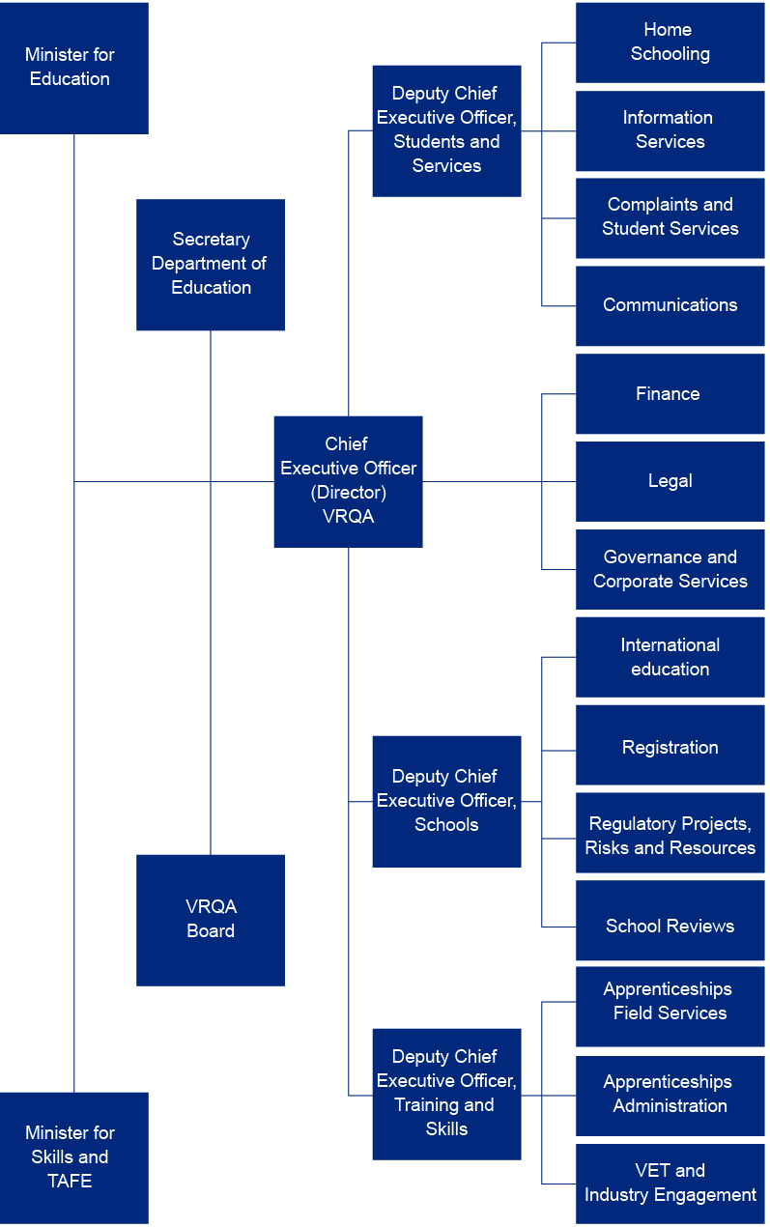

Report of operations – workforce data
The VRQA operates within the financial, asset, human resources and information technology policy frameworks of the department.

Public administration values and employment principles
The VRQA applies the employment principles issued by the Victorian Public Sector Commission. These set out the essential requirements for managers to apply the public sector values and employment principles under the Public Administration Act 2004.
The principles stipulate that:
- employment decisions are merit-based
- public sector employees are treated fairly and reasonably
- equal employment opportunity is provided
- public sector employees have a reasonable avenue of redress against unfair or unreasonable treatment
a career in the public service is fostered (in the case of public service bodies).
The VRQA is committed to developing and supporting its workforce by:
- building leadership capacity
- building a future workforce by enhancing workforce capacity
- actively shaping supply and managing employee relations
- creating and supporting a culture of health, safety and wellbeing
- creating and supporting a performance and development culture
implementing robust human resources management systems.

Occupational health and safety
The VRQA operates within the department’s infrastructure and abides by the department’s occupational health and safety policies and procedures (see the Department of Education Annual Report 2024–25 for more information).

Comparative workforce data
Table 21. Full-time equivalent (FTE) staffing trends 2021–2025 ^{(a)(b)}
2021 | 2022 | 2023 | 2024 | 2025
74.9 | 71.9 | 77.7 | 92.2 | 83.4
Notes: (a) Figures are for staff on pay during the last full pay period in June of each year and exclude those on leave without pay or absent on secondment, external contractors and consultants, temporary staff employed by employment agencies and a small number of people who are not employees, but are appointees of a statutory office, as defined in the Public Administration Act 2004.
(b) The Victorian Public Service (VPS) comprises the Senior Executive Service (SES), VPS-classified staff, allied health staff, nurses, senior medical advisers and ministerial transport officers.
Table 22. Summary of employment levels, June 2024 and 2025 ^{(a)(b)}
 | Ongoing employees (headcount) |  |  |  | Fixed-term and casual employees
 | Employees | Full-time | Part-time | FTE | FTE
June 2024 | 94 | 80 | 5 | 92.2 | 8.6
June 2025 | 85 | 76 | 5 | 83.4 | 3.8
Notes: (a) Figures are for staff on pay during the last full pay period in June of each year and exclude those on leave without pay or absent on secondment, external contractors and consultants, temporary staff employed by employment agencies and a small number of people who are not employees, but are appointees of a statutory office, as defined in the Public Administration Act 2004.
(b) The VPS comprises the SES, VPS-classified staff, allied health staff, nurses, senior medical advisers and ministerial transport officers.

Table 23. Details of VRQA employment levels in June 2024 and 2025 ^{(a)(b)(c)(d)}
 |  | June 2024 |  |  |  |  |  |  |  | June 2025
 |  | All employees |  | Ongoing |  |  |  | Fixed-term and  casual employees |  | All employees |  |  | Ongoing |  |  |  | Fixed-term and  casual employees
 |  | Number  (headcount) | FTE | Full-time  (headcount) | Part-time  (headcount) | FTE | Number  (headcount) |  | FTE | Number  (headcount) |  | FTE | Full-time  (headcount) | Part-time  (headcount) | FTE | Number  (headcount) |  |  | FTE
Demographic data | Gender
Demographic data | Women | 66 | 64.4 | 54 | 4 | 56.8 |  | 8 | 7.6 | 55 | 53.6 |  | 48 | 4 | 50.8 |  | 3 | 2.8
Demographic data | Men | 27 | 26.8 | 25 | 1 | 25.8 |  | 1 | 1.0 | 29 | 28.8 |  | 27 | 1 | 27.8 |  | 1 | 1
Demographic data | Self-described | 1 | 1.0 | 1 | – | 1.0 |  | – | – | 1 | 1 |  | 1 | – | 1 |  | – | –
Demographic data | Age
Demographic data | 15–24 | 2 | 2.0 | 1 | – | 1.0 |  | 1 | 1.0 | 1 | 1 |  | 1 | – | 1 |  | – | –
Demographic data | 25–34 | 17 | 16.8 | 13 | – | 13.0 |  | 4 | 3.8 | 9 | 9 |  | 8 | – | 8 |  | 1 | 1
Demographic data | 35–44 | 20 | 19.9 | 19 | 1 | 19.9 |  | – | – | 16 | 15.9 |  | 15 | 1 | 15.9 |  | – | –
Demographic data | 45–54 | 29 | 28.6 | 26 | 1 | 26.8 |  | 2 | 1.8 | 28 | 27.6 |  | 26 | 1 | 26.8 |  | 1 | 0.8
Demographic data | 55–64 | 24 | 23.7 | 20 | 2 | 21.7 |  | 2 | 2.0 | 27 | 26.7 |  | 24 | 2 | 25.7 |  | 1 | 1
Demographic data | 65+ | 2 | 1.2 | 1 | 1 | 1.2 |  | – | – | 4 | 3.2 |  | 2 | 1 | 2.2 |  | 1 | 1
Classification data | VPS 1–6 | 91 | 89.2 | 77 | 5 | 80.6 |  | 9 | 8.6 | 81 | 79.4 |  | 72 | 5 | 75.6 |  | 4 | 3.8
Classification data | VPSG1 | – | – | – | – | – |  | – | – | – | – |  | – | – | – |  | – | –
Classification data | VPSG2 | 8 | 8 | 6 | – | 6.0 |  | 2 | 2.0 | 7 | 7 |  | 6 | – | 6 |  | 1 | 1
Classification data | VPSG3 | 12 | 12 | 12 | – | 12.0 |  | – | – | 8 | 8 |  | 7 | – | 7 |  | 1 | 1
Classification data | VPSG4 | 22 | 21.7 | 18 | 1 | 18.9 |  | 3 | 2.8 | 21 | 20.9 |  | 20 | 1 | 20.9 |  | – | –
Classification data | VPSG5 | 34 | 32.8 | 28 | 2 | 29.0 |  | 4 | 3.8 | 29 | 27.8 |  | 25 | 2 | 26 |  | 2 | 1.8
Classification data | VPSG6 | 15 | 14.7 | 13 | 2 | 14.7 |  | – | – | 16 | 15.7 |  | 14 | 2 | 15.7 |  | – | –
Classification data | Senior employees | 3 | 3 | 3 | – | – |  | – | – | 4 | 4 |  | 4 | – | 4 |  | – | –
Classification data | STS | – | – | – | – | – |  | – | – | – | – |  | – | – | – |  | – | –
Classification data | Executives | 3 | 3 | 3 | – | – |  | – | – | 4 | 4 |  | 4 | – | – |  | – | –
 | Total employees | 94 | 92.2 | 80 | 5 | 80.6 |  | 9 | 8.6 | 85 | 83.4 |  | 76 | 5 | 79.6 |  | 4 | 3.8

Notes: (a) ‘Headcount’ refers to the number of people employed, where each person counts as an employee, regardless of the number of hours engaged to work.
(b) ‘Casual’ means a person who is subject to clause 25, Casual Employees – Loading of the VPS Agreement 2006, or similar clauses in other relevant agreements. It includes persons employed on a sessional basis, where such provision is made under an applicable industrial agreement.
(c) ‘Age’ of staff calculated at 30 June each year.
(d) The category VPSG2 includes graduate recruits.

Executive data
Table 24. Number of SES classified in ‘ongoing’ and ‘special projects’
 | All |  | Ongoing |  | Special projects
Class | Number | Variance | Number | Variance | Number | Variance
SES–3 | – | – | – | – | – | –
SES–2 | 1 | – | 1 | – | – | –
SES–1 | 3 | 1 | 3 | 1 | – | –
Total | 4 | 1 | 4 | 1 | – | –
Table 25. Gender breakdown of SES in ‘ongoing’ and ‘special projects’
 | Ongoing |  |  |  |  |  |  | Special projects
 | Male |  | Female |  | Self-described |  | Vacancies | Male |  | Female |  | Vacancies
Class | No. | Var. | No. | Var. | No. | Var. | Number | No. | Var. | No. | Var | Number
SES–3 | – | – | – | – | – | – | – | – | – | – | – | –
SES–2 | – | – | 1 | – | – | – | – | – | – | – | – | –
SES–1 | 1 | -1 | 2 | 2 | – | – | – | – | – | – | – | –
Total | 1 | -1 | 3 | 2 | – | – | – | – | – | – | – | –
Table 26. Reconciliation of executive numbers
 |  | 2024 | 2025
 | Executives with total renumeration over $100,000 (see Note 8.3.1) | 2 | 4
Add | Vacancies | 1 | –
 | Executives employed with total remuneration less than $100,000 | – | –
 | Accountable officer (Director) | 1 | 1
Less | Separations | – | -1
Less | Portfolio entity executives | – | –
 | Total executive numbers at 30 June | 4 | 4

Report of operations – other disclosures

Local Jobs First
There were no contracts related to the Local Jobs First Act 2003, which brings together the Victorian Industry Participation Policy and the Major Skills Guarantee. Details of disclosed contracts can be viewed at Buying for Victoria <https://www.buyingfor.vic.gov.au>.

Government advertising expenditure
In 2024–25, the VRQA had no government advertising campaigns with a total media spend of $100,000 or greater.

Consultancies expenditure
There were no major consultancies over $10,000 for the period 1 July 2024 to 30 June 2025. The VRQA did not engage any consultancies costing less than $10,000 each during 2024–25.

Reviews and studies expenditure
During 2024–25, there were 2 reviews and studies undertaken with the total cost of $386,969. Details of individual reviews and studies are outlined below.
Table 27. Reviews and studies expenditure
Name | Reason for review or study | Scope | Anticipated outcomes | Costs  (ex. GST) |  | Publicly available (Y/N)
Annual Client and Stakeholder Research | Stakeholder consultation and engagement, annual reporting obligations | Gather feedback from duty holders about the VRQA’s performance | Findings in a report that the VRQA uses in strategic planning and operations | Estimated cost  $105,331  Final cost  $105,331  Cost to 30 June 2025  $105,331 | Y
Review of School Regulation | Ensure school regulation aligns with the VRQA Regulatory Approach Statement 2022 | Review regulatory approach and evidence required to demonstrate compliance | School regulation is efficient, effective and outcomes focused | Estimated cost  $289,638  Final cost  $281,638  Cost to 30 June 2025  $281,638 | N

Disclosure of major contracts
There were no major contracts greater than $10 million in value entered into by the VRQA during the financial year ended 30 June 2025.

Freedom of information
The Freedom of Information Act 1982 (FOI Act) allows public access to documents of the Victorian Government and its agencies, including those held by the VRQA.

Making a request
To access documents, write to the relevant freedom of information (FOI) officer detailed in section 17 of the FOI Act. The request should:
- be in writing
- clearly identify which document is being requested
- be accompanied by the appropriate application fee (may be waived in certain circumstances)
- be addressed to:
Freedom of Information Officer
Victorian Registration and Qualifications Authority
GPO Box 2317
Melbourne VIC 3001
Email the VRQA <vrqa@education.vic.gov.au>
Telephone: (03) 9637 2806
Access charges may apply once documents have been processed and a decision on access is made, for example, photocopying and search and retrieval charges.

FOI statistics and timelines
During 2024–25, the VRQA received 6 FOI applications. Of these requests, one was from the media and the remainder were from the public.
The VRQA made 5 FOI decisions during the 12 months ended 30 June 2025.
Two decisions were made within the statutory 30-day period and 2 were made within an extended statutory 15–60-day period. One request was satisfied outside the FOI process. The VRQA met all response times required by statute in the reporting period.
During 2024–25, 2 requests were subject to an internal review by the Office of the Victorian Information Commissioner.

Further information
Further information regarding the operation and scope of FOI can be obtained from the FOI Act, the regulations made under the FOI Act and the Office of the Victorian Information Commissioner <https://ovic.vic.gov.au/>.

Compliance with the Building Act 1993
The VRQA does not own or control any government buildings and consequently, is exempt from notifying its compliance with the building and maintenance provisions of the Building Act 1993.

Competitive Neutrality Policy
The review of fees and charges indicated that the VRQA did not add any restrictions on competition between providers of accredited courses.

Compliance with the Public Interest Disclosures Act 2012
The Public Interest Disclosures Act 2012 (the PID Act) encourages and assists people in making disclosures of improper conduct by public officers and public bodies. The PID Act provides protection to people who make disclosures in accordance with the PID Act, and establishes a system for the matters disclosed to be investigated and rectifying action to be taken.
The VRQA Board does not tolerate improper conduct by employees, or the taking of reprisals against those who come forward to disclose such conduct. It is committed to ensuring transparency and accountability in its administrative and management practices, and supports the making of disclosures that reveal corrupt conduct, conduct involving a substantial mismanagement of public resources or conduct involving a substantial risk to public health and safety or the environment.
The VRQA Board will take all reasonable steps to protect people who make such disclosures from any detrimental action in reprisal for making the disclosure. It will also afford natural justice to the person who is the subject of the disclosure to the extent it is legally possible.

Making disclosures
Disclosures of improper or corrupt conduct by the VRQA Board or its employees are protected if made in accordance with Division 2 of Part 2 of the PID Act to either the:
- Independent Broad-based Anti-corruption Commission (IBAC)
GPO Box 24234
Melbourne VIC 3001
Telephone: 1300 735 135
IBAC website <https://www.ibac.vic.gov.au>
- Victorian Ombudsman
Level 2, 570 Bourke Street
Melbourne VIC 3000
Telephone: (03) 9613 6222
Toll-free: 1800 806 314 (regional only)
Email the Victorian Ombudsman <ombudvic@ombudsman.vic.gov.au>
Victorian Ombudsman website <https://www.ombudsman.vic.gov.au>
Disclosures of detrimental action taken by the VRQA Board or its employees in reprisal for making a protected disclosure, may be made to:
- The Public Interest Disclosures Coordinator
Victorian Registration and Qualifications Authority
GPO Box 2317
Melbourne Vic 3001

Procedures under the PID Act
The procedures for protecting people from detrimental action in reprisal for making a protected disclosure are available on request.
The VRQA Board did not receive disclosures of detrimental action taken in reprisal for the making of a protected disclosure in 2024–25.

Compliance with the Carers Recognition Act 2012 and the Disability Act 2006
The VRQA operates within the department’s infrastructure and abides by the department’s human resources policies and procedures (see the Department of Education Annual Report 2024–25 for more information).

Disclosure of emergency procurement
There were no contracts, of any value, awarded under emergency procurement procedures during the financial year ended 30 June 2025.

Disclosure of procurement complaints
The VRQA operates within the department’s procurement policies and received no complaints related to procurement in the financial year ended 30 June 2025 (see the Department of Education Annual Report 2024–25 for more information).

Environmental reporting
Environmental data related to VRQA operations, systems and processes is collected and managed through the department. This includes indicators related to energy, water and waste generated in office accommodation and transportation, such as fleet and air travel (see the Department of Education Annual Report 2024–25 for more information).

Fees and charges
Section 5.2.13 of the Education and Training Reform Act 2006 enables ministers to fix fees and charges. Ministerial Order 957 held VET fees at 2014 levels.
All other fees were increased on 1 January 2025. Details of fees and charges are available on the VRQA website <https://www2.vrqa.vic.gov.au/fees>.

Additional information available on request
In compliance with the requirements of the Standing Directions of the Assistant Treasurer, details in respect of the items listed have been retained by the VRQA and are available on request, subject to the FOI Act provisions, including:
- a statement that declarations of pecuniary interests have been duly completed by all relevant officers
- details of shares held by a senior officer as nominee or held beneficially in a statutory authority or subsidiary
- details of publications produced by the entity about the entity, and how these can be obtained
- details of changes in prices, fees, charges, rates and levies charged by the VRQA
- details of any major external reviews carried out on the VRQA
- details of major research and development activities undertaken by the VRQA
- details of overseas visits undertaken, including a summary of the objectives and outcomes of each visit
- details of major promotional, public relations and marketing activities undertaken by the VRQA to develop community awareness of the VRQA and its services
- details of assessments and measures undertaken to improve the occupational health and safety of employees
- a general statement on industrial relations within the VRQA, and details of time lost through industrial accidents or disputes
- a list of major committees sponsored by the VRQA, the purposes of each committee and the extent to which the purposes have been achieved
- details of all consultancies and contractors, including:
- consultants and contractors engaged
- services provided
- expenditure committed for each engagement.
This information is available on request from:
- Manager, Governance and Corporate Services, VRQA
GPO Box 2317
Melbourne VIC 3001
Telephone: (03) 9637 2806

Compliance with DataVic Access Policy
Consistent with the DataVic Access Policy issued by the Victorian Government in 2016, which enables public access to government data, information included in this annual report will be available at DataVic in machine-readable format.
The VRQA contributes to data sets published by the department to DataVic.

Compliance with Victoria’s Social Procurement Framework
The VRQA operates within the department’s corporate procurement framework, including its Social Procurement Strategy.
The Social Procurement Strategy was revised in February 2024 to reflect the evolution of Victoria’s Social Procurement Framework and the guidance on its implementation that has been provided by the Department of Government Services.
The Social Procurement Strategy prioritises 5 social procurement objectives for:
- opportunities for Victorian Aboriginal people
- opportunities for Victorians with disability
- women’s equality and safety
- opportunities for Victorian priority jobseekers
- environmentally sustainable outputs.
See the Department of Education Annual Report 2024–25 for more information, including consolidated metrics on direct spend with social benefit suppliers.

Compliance with the Asset Management Accountability Framework (AMAF)
The following information summarises the VRQA’s assessment of maturity against the requirements of the AMAF.
The AMAF is a non-prescriptive, devolved accountability model of asset management that requires compliance with 41 mandatory requirements. These requirements can be found on the Department of Treasury and Finance website <www.dtf.vic.gov.au/infrastructure-investment/asset-management-accountability-framework>.
The VRQA’s target maturity rating is ‘competence’, meaning systems and processes are fully in place, consistently applied and systematically meeting the AMAF requirements, including a continuous improvement process to expand system performance above AMAF minimum requirements.
Figure 3. The VRQA’s AMAF maturity assessment
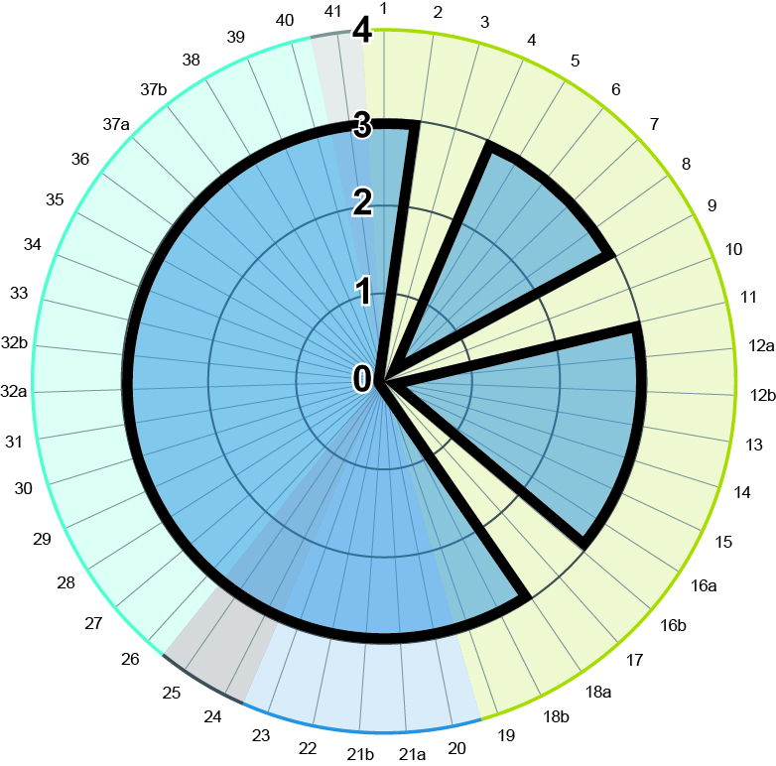
Legend
Target
Overall
Status | Scale
Not applicable | N/A
Innocence | 0
Awareness | 1
Developing | 2
Competence | 3
Optimising | 4
Unassessed | U/A

Leadership and accountability (requirements 1–19)
The VRQA has met its target maturity level under most requirements within this category. Requirements 3 and 10 were not applicable, since the VRQA does not outsource asset management functions to entities excluded from the Standing Directions. Requirement 17 is not applicable, since the VRQA does not have an Asset Information Management System. This is due to the VRQA having very few assets and these have a short-term life cycle.
The VRQA can still provide relevant asset information and performance data and respond to reasonable information reporting requests, as required by government and central agencies.
There is no material non-compliance reported in this category.

Planning (requirements 20–23)
The VRQA has met its target maturity level in this category.

Acquisition (requirements 24 and 25)
The VRQA has met its target maturity level in this category.

Operation (requirements 26–40)
The VRQA has met its target maturity level in this category.

Disposal (requirement 41)
The VRQA has met its target maturity level in this category.

Attestation for financial management compliance with Ministerial Standing Direction 5.1.4
Victorian Registration and Qualifications Authority financial management compliance attestation statement
I, Pam White, on behalf of the Responsible Body, certify that the Victorian Registration and Qualifications Authority has no Material Compliance Deficiency with respect to the applicable Standing Directions under the Financial Management Act 1994 and Instructions.

Pam White PSM
Chair
Victorian Registration and Qualifications Authority
11 September 2025

Financial statements

Declaration in the financial statements
The attached financial statements for the Victorian Registration and Qualifications Authority have been prepared in accordance with Direction 5.2 of the Standing Directions of the Assistant Treasurer under the Financial Management Act 1994, applicable Financial Reporting Directions and Australian Accounting Standards, including interpretations and other mandatory professional reporting requirements.
We further state that, in our opinion, the information set out in the comprehensive operating statement, balance sheet, statement of changes in equity, cash flow statement and accompanying notes, presents fairly the financial transactions during the year ended 30 June 2025 and the financial position of the Victorian Registration and Qualifications Authority at 30 June 2025.
At the time of signing, we are not aware of any circumstance that would render any particulars included in the financial statements to be misleading or inaccurate.
We authorise the attached financial statements for issue on 11 September 2025.

Pam White PSM
Chair
Victorian Registration and Qualifications Authority
Melbourne 11 September 2025

Stefanie Veal
CEO (Director)
Victorian Registration and Qualifications Authority
Melbourne 11 September 2025

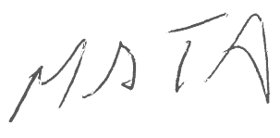
Matthew Tibb
Chief Financial Officer
Victorian Registration and Qualifications Authority
Melbourne 11 September 2025

Victorian Auditor-General’s Office Report
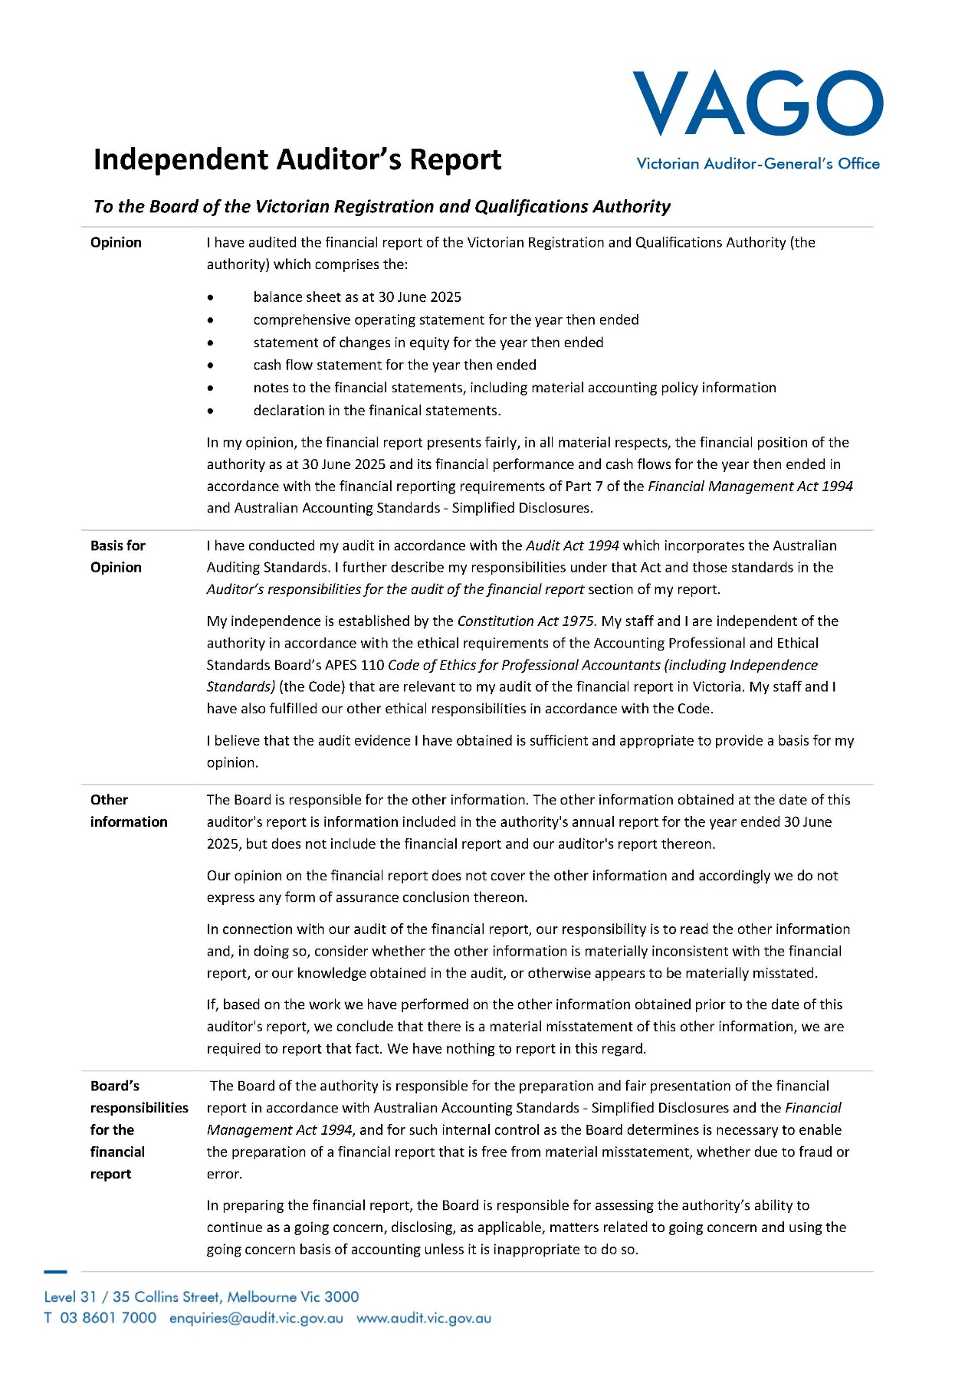

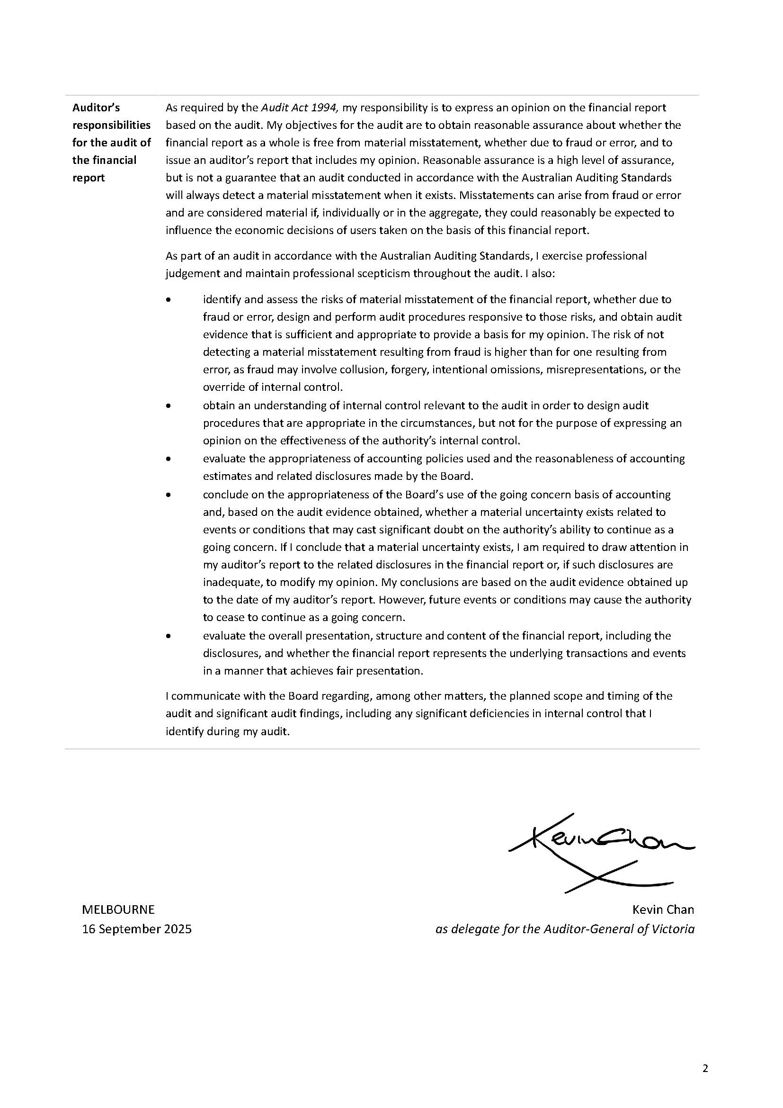

How this report is structured
The Victorian Registration and Qualifications Authority (VRQA) has presented its audited general purpose financial statements for the financial year ended 30 June 2025 in the following structure to provide users with information about the VRQA’s stewardship of resources entrusted to it.

Financial statements
Comprehensive operating statement for the financial year ended 30 June 2025 54
Balance sheet as at 30 June 2025 55
Cash flow statement for the financial year ended 30 June 2025 56
Statement of changes in equity for the financial year ended 30 June 2025 56

Index to the notes to the financial statements
Note 1. About this report 57
Note 2. Funding delivery of our services 58
Note 3. The cost of delivering services 60
Note 4. Key assets to support service delivery 62
Note 5. Other assets and liabilities 64
Note 6. How we financed our operations 66
Note 7. Financial instruments, contingencies and valuation judgements 69
Note 8. Other disclosures 73

Comprehensive operating statement for the financial year ended 30 June 2025
 | Notes | 2025  $ | 2024  $
Revenue and income from transactions
Grants | 2.2.1 | 13,903,576 | 16,267,322
Registration and accreditation fees | 2.2.2 | 1,009,135 | 1,142,291
Assets and services received free of charge or for nominal consideration | 2.2.3 | 730,098 | 847,902
Interest | 2.2.4 | 456,616 | 600,722
Other income |  | 58 | 175
Total revenue and income from transactions |  | 16,099,483 | 18,858,412
Expenses from transactions
Administrative expenses | 3.1.1 | 13,823,615 | 12,890,117
Depreciation and amortisation | 4.2 | 24,985 | 21,209
Contractors | 3.1.2 | 4,103,375 | 5,934,824
Supplies and services | 3.1.3 | 709,661 | 467,408
Assets and services provided free of charge or for nominal consideration | 3.1.4 | 730,098 | 847,902
Interest expense | 6.1.2 | 1,280 | 225
Total expenses from transactions |  | 19,393,014 | 20,161,685
Net result from transactions |  | (3,293,531) | (1,303,273)
Note: The accompanying notes form part of these financial statements.

Balance sheet as at 30 June 2025
 | Notes | 2025  $ | 2024  $
Assets
Financial assets
Cash and deposits | 6.3 | 6,545,087 | 9,774,458
Receivables | 5.1 | 146,978 | 80,633
Total financial assets |  | 6,692,065 | 9,855,091
Non-financial assets
Other non-financial assets | 5.2 | 30,000 | 44,652
Property, plant and equipment | 4.2 | 70,154 | 78,227
Intangible assets | 4.1 | – | –
Total non-financial assets |  | 100,154 | 122,879
Total assets |  | 6,792,219 | 9,977,970
Liabilities
Payables | 5.3 | 1,363,667 | 1,136,111
Contract liabilities | 5.4 | 97,822 | 226,245
Borrowings – lease liabilities | 6.1 | 46,116 | 37,469
Total liabilities |  | 1,507,605 | 1,399,825
Net assets |  | 5,284,614 | 8,578,145
Equity
Accumulated surplus |  | 3,871,995 | 7,165,526
Contributed capital |  | 1,412,619 | 1,412,619
Net worth |  | 5,284,614 | 8,578,145
Note: The accompanying notes form part of these financial statements.

Cash flow statement for the financial year
ended 30 June 2025
 | Notes | 2025  $ | 2024  $
Cash flows from operating activities
Receipts
Receipts from government |  | 13,903,576 | 16,267,322
Receipts from other entities |  | 815,795 | 1,084,282
Interest received |  | 456,616 | 600,722
Total receipts |  | 15,175,987 | 17,952,326
Payments
Payments to suppliers and employees |  | (18,394,788) | (19,836,606)
Goods and services tax paid to ATO^{(a)} |  | (1,026) | –
Interest and other costs of finance paid |  | (1,280) | (225)
Total payments |  | (18,397,094) | (19,836,831)
Net cash flows from/(used in) operating activities |  | (3,221,107) | (1,884,505)
Cash flows from investing activities
Purchases of non-financial assets |  | (29,643) | (39,653)
Sales of non-financial assets |  | 12,732 | –
Net cash flows from/(used in) investing activities |  | (16,911) | (39,653)
Cash flows from financing activities
Borrowings |  | 29,643 | 39,795
Repayment of borrowings (principal portion of lease liabilities) |  | (20,996) | (4,594)
Net cash flows from financing activities |  | 8,647 | 35,201
Net increase/(decrease) in cash and cash equivalents |  | (3,229,371) | (1,888,957)
Cash and cash equivalents at beginning of financial year |  | 9,774,458 | 11,663,415
Cash and cash equivalents at end of the financial year | 6.3 | 6,545,087 | 9,774,458
Note: (a) GST paid to the Australian Tax Office is presented on a net basis.

Statement of changes in equity for the financial year
ended 30 June 2025
 | Contributed capital  $ | Accumulated surplus  $ | Total  $
Balance at 30 June 2023 | 1,412,619 | 8,468,799 | 9,881,418
Comprehensive result for the year |  | (1,303,273) | (1,303,273)
Balance at 30 June 2024 | 1,412,619 | 7,165,526 | 8,578,145
Comprehensive result for the year |  | (3,293,531) | (3,293,531)
Balance at 30 June 2025 | 1,412,619 | 3,871,995 | 5,284,614
Note: the accompanying notes form part of these financial statements.

Notes to the financial statements

Note 1. About this report
The Victorian Registration and Qualifications Authority (VRQA) is a State-owned public authority established under the Education and Training Reform Act 2006. As an independent public authority, the VRQA is a separate legal entity and accountable for resources under its control. Section 4.2.8 of the Act requires the VRQA to maintain a fund to account for all money received and paid by the VRQA.
During the financial year ended 30 June 2025, the principal address of VRQA was:
Victorian Registration and Qualifications Authority
Level 4, Casselden, 2 Lonsdale Street
Melbourne VIC 3000
Subsequent to the end of the financial year, effective from 14 July 2025, the principal place of VRQA has changed to:
Victorian Registration and Qualifications Authority
Level 7, 1 Spring Street
Melbourne VIC 3000

Basis of preparation
These financial statements are Tier 2 general purpose financial statements prepared in accordance with AASB 1060 General Purpose Financial Statements – Simplified Disclosure for For-Profit and Not-for-Profit Tier 2 Entities (AASB 1060) and Financial Reporting Direction 101 Application of Tiers of Australian Accounting Standards (FRD 101).
VRQA is a Tier 2 entity in accordance with FRD 101. These financial statements are the first general purpose financial statements prepared in accordance with Australian Accounting Standards – Simplified Disclosures. VRQA’s prior year financial statements were general purpose financial statements prepared in accordance with Australian Accounting Standards (Tier 1). As VRQA is not a ‘significant entity’ as defined in FRD 101, it was required to change from Tier 1 to Tier 2 reporting effective from 1 July 2024.
These financial statements are in Australian dollars, and the historical cost convention is used unless a different measurement basis is specifically disclosed in the note associated with the item measured on a different basis.
The accrual basis of accounting has been applied in preparing these financial statements, whereby assets, liabilities, equity, income and expenses are recognised in the reporting period to which they relate, regardless of when cash is received or paid.
Consistent with the requirements of AASB 1004 Contributions, contributions by owners (that is, contributed capital and its repayment) are treated as equity transactions and, therefore, do not form part of the income and expenses of the VRQA.
Other transfers that are in the nature of contributions to, or distributions by, owners have also been designated as contributions by owners.
Transfers of net assets arising from administrative restructurings are treated as distributions to, or contributions by, owners. Transfers of net liabilities arising from administrative restructurings are treated as distributions to owners.
Judgements, estimates and assumptions are required to be made about financial information being presented. The significant judgements made in the preparation of these financial statements are disclosed in the notes where amounts affected by those judgements are disclosed. Estimates and associated assumptions are based on professional judgements derived from historical experience and various other factors that are believed to be reasonable under the circumstances. Actual results may differ from these estimates.
Revisions to accounting estimates are recognised in the period in which the estimate is revised and also in future periods that are affected by the revision. Judgements and assumptions made by management in applying Australian Accounting Standards (AAS) that have significant effects on the financial statements and estimates are disclosed in the notes.
These financial statements cover VRQA as an individual reporting entity and include all the controlled activities of VRQA. There is no entity consolidated into VRQA.
All amounts in the financial statements have been rounded to the nearest dollar unless otherwise stated.

Compliance information
These general purpose financial statements have been prepared in accordance with the Financial Management Act 1994 and applicable AASs, which include interpretations issued by the Australian Accounting Standards Board (AASB). In particular, they are presented in a manner consistent with the requirements of AASB 1049 Whole of Government and General Government Sector Financial Reporting.
Where appropriate, those AASs paragraphs applicable to not-for-profit entities have been applied. Accounting policies selected and applied in these financial statements ensure that the resulting financial information satisfies the concepts of relevance and reliability, thereby ensuring that the substance of the underlying transactions or other events is reported.

Note 2. Funding delivery of our services
The VRQA’s objectives are to ensure:
- high standards of education and training are maintained at Victorian registered providers
- information concerning the performance of education and training providers is publicly available
- decisions of the VRQA have regard to the interests of students and the public
regulatory processes are procedurally fair.

Economic dependence
To enable the VRQA to fulfil its objectives, it receives income from the Department of Education (the department) in the form of grant funding, on which it is economically dependent. The VRQA also charges fees for registration of providers of education and training, and accreditation of courses under the Education and Training Reform Act 2006. These fees and charges are set by Ministerial Order.

Summary of revenue and income that funds the delivery of our services
 | Notes | 2025  $ | 2024  $
Grants | 2.2.1 | 13,903,576 | 16,267,322
Registration and accreditation fees | 2.2.2 | 1,009,135 | 1,142,291
Assets and services received free of charge or for nominal consideration | 2.2.3 | 730,098 | 847,902
Interest income | 2.2.4 | 456,616 | 600,722
Other income |  | 58 | 175
Total revenue and income from transactions |  | 16,099,483 | 18,858,412
Revenue and income that fund delivery of the VRQA’s services are accounted for consistently with the requirements of the relevant accounting standards disclosed in the following notes.

Revenue and income from transactions

Grants
 | 2025  $ | 2024  $
General purpose | 13,903,576 | 16,267,322
Total grants | 13,903,576 | 16,267,322
The VRQA has determined that the grant income included in the table above under AASB 1058 has been earned under arrangements that are either not enforceable and/or linked to sufficiently specific performance obligations.
Income from grants without any sufficiently specific performance obligations, or that are not enforceable, is recognised when the VRQA has an unconditional right to receive cash, which usually coincides with receipt of cash. On initial recognition of the asset, the VRQA recognises any related contributions by owners, increases in liabilities, decreases in assets and revenue (‘related amounts’), in accordance with other AASs.
Related amounts may take any of the following forms:
- contributions by owners, in accordance with AASB 1004 Contributions
- revenue or a contract liability arising from a contract with a customer, in accordance with AASB 15 Revenue from Contracts with Customers
- a lease liability, in accordance with AASB 16 Leases
- a financial instrument, in accordance with AASB 9 Financial Instruments
a provision, in accordance with AASB 137 Provisions, Contingent Liabilities and Contingent Assets.

Registration and accreditation fees
 | 2025  $ | 2024  $
Registration and accreditation fees | 1,009,135 | 1,142,291
Total registration and accreditation fees | 1,009,135 | 1,142,291
The registration and accreditation fees included in the table above are transactions that the VRQA has determined to be classified as revenue from contracts with customers, in accordance with AASB 15.

Performance obligations and revenue recognition policies
Revenue is measured based on the consideration specified in the contract with the customer. The VRQA recognises revenue when it transfers control of a service to the customer (that is when or as the performance obligations for the services to the customer are satisfied).
Revenue from the rendering of services is recognised at a point in time when the performance obligation is satisfied, when the service is completed and over time, when the customer simultaneously receives and consumes the service as it is provided.
Revenue from annual registration fees is recognised at a point in time when the VRQA has completed its performance obligation to register the provider.
Application for registration and accreditation fees are recognised at a point in time as each performance obligation is satisfied (that is, with reference to the stage of the assessment process completed by the VRQA).
Consideration received in advance of recognising the associated revenue from the customer is recorded as a contract liability (Note 5.4). Where the performance obligation is satisfied, but not yet billed, a contract asset is recorded.

Assets and services received free of charge or for nominal consideration
 | 2025  $ | 2024  $
Accommodation for Level 4, 2 Lonsdale Street, Melbourne^{(a)} | 730,098 | 847,902
Total fair value of assets and services received free of charge or for nominal consideration | 730,098 | 847,902
Note: (a) The VRQA shares accommodation with the department, the cost of which is not charged to the VRQA (Note 8.4). The amounts are recognised in the operating statement as an expense and offset to income as resources received free of charge (Note 3.1.4).
Contributions of resources received free of charge, or for nominal consideration, are recognised at fair value when control is obtained over them, irrespective of whether these contributions are subject to restrictions or conditions over their use. The amount recognised as revenue from such contributions reflects the economic benefit received by the VRQA in the form of assets or services.

Interest income
 | 2025  $ | 2024  $
Interest on bank deposits | 456,616 | 600,722
Total interest income | 456,616 | 600,722
Interest income includes interest received on bank term deposits. Interest income is recognised using the effective interest method, which allocates the interest over the relevant period.

Note 3. The cost of delivering services
This section provides an account of the expenses incurred by the VRQA in delivering services and outputs. In section 2, the funds that enable the provision of services were disclosed and in this note, the cost associated with the provision of services is recorded.

Expenses incurred in delivering services
 | Notes | 2025  $ | 2024  $
Administrative expenses | 3.1.1 | 13,823,615 | 12,890,117
Contractors | 3.1.2 | 4,103,375 | 5,934,824
Supplies and services | 3.1.3 | 709,661 | 467,408
Assets and services provided free of charge or for nominal consideration | 3.1.4 | 730,098 | 847,902
Total expenses incurred in delivery of services |  | 19,366,749 | 20,140,251
Expenses from transactions are recognised as they are incurred and reported in the financial year to which they relate.

Administrative expenses
 | 2025  $ | 2024  $
Employee benefits for VRQA staff employed by the department | 12,529,208 | 11,730,812
Superannuation expense | 1,294,407 | 1,159,305
Total administrative expenses | 13,823,615 | 12,890,117
Administrative expenses relate to employee benefits for VRQA staff who are employees of the department. The VRQA reimburses the department for all employee entitlements, including wages and salaries, superannuation employer contributions, fringe benefits tax, leave entitlements, termination payments and Workcover premiums. The costs are classified as administrative expenses in the comprehensive operating statement.
Provisions for annual leave and long service leave for services rendered to the reporting date are recognised and recorded as liabilities by the department. Termination benefits are payable when employment is terminated before normal retirement date, or when an employee accepts an offer of benefits in exchange for the termination of employment. Termination benefits are recognised when the department is demonstrably committed to terminating the employment of current employees, according to a detailed formal plan, without possibility of withdrawal or providing termination benefits as a result of an offer made to encourage voluntary redundancy.

Contractors
 | 2025  $ | 2024  $
Contractors | 4,103,375 | 5,934,824
Total contractors | 4,103,375 | 5,934,824
Contractors represent the costs incurred in normal operations. This includes the hire of temporary staff, contractors used to undertake regulatory functions and contractors used to provide other services.

Supplies and services
 | Notes | 2025  $ | 2024  $
Purchase of supplies and consumables |  | 362,572 | 168,299
Travel expenses |  | 12,480 | 25,519
Printing |  | 5,251 | 11,040
Phone and postage |  | 49,983 | 70,095
Legal expenses |  | 163,504 | 85,350
Insurance |  | 43,097 | 35,293
Minor equipment purchases |  | 9,777 | 23,136
Advertising |  | 16,696 | 9,356
Audit fees | 8.5 | 46,300 | 39,320
Total supplies and services |  | 709,661 | 467,408
Supplies and services expenses generally represent the day-to-day running costs incurred in normal operation and are recognised as an expense in the reporting period in which they are incurred.

Assets and services provided free of charge or for nominal consideration
 | 2025  $ | 2024  $
Accommodation for Level 4, Casselden, 2 Lonsdale Street, Melbourne | 730,098 | 847,902
Total resources received free of charge | 730,098 | 847,902

Note 4. Key assets to support service delivery
The VRQA controls intangible assets and other assets that are utilised in fulfilling its objectives and conducting its activities. They represent the resources that have been entrusted to the VRQA to be utilised for delivery of those outputs.

Intangible assets
 | 2025  $ | 2024  $
At cost | 6,110,830 | 6,110,830
Plus: work in progress | – | –
Plus: additions | – | –
Less: accumulated amortisation | (6,110,830) | (6,110,830)
Less: accumulated impairment | – | –
Net book value at end of financial year | – | –

Initial recognition
When the recognition criteria in AASB 138 Intangible Assets is met, internally generated intangible assets are recognised at cost. Subsequently, intangible assets with finite useful lives are carried at cost less accumulated amortisation and accumulated impairment losses. Amortisation begins when the asset is available for use, that is, when it is in the location and condition necessary for it to be capable of operating in the manner intended by management.
An ‘internally generated intangible asset’ arising from development (or from the development phase of an internal project) is recognised if, and only if, all of the following are demonstrated:
- the technical feasibility of completing the intangible asset so that it will be available for use or sale
- an intention to complete the intangible asset and use or sell it
- the ability to use or sell the intangible asset
- the intangible asset will generate probable future economic benefits
- the availability of adequate technical, financial and other resources to complete the development and to use or sell the intangible asset
- the ability to measure reliably the expenditure attributable to the intangible asset during its development.

Subsequent measurement and amortisation
Intangible produced assets with finite useful lives are amortised as an ‘expense from transactions’ on a straight-line basis over their useful lives. Amortisation begins when the asset is available for use, that is, when it is in the location and condition necessary for it to be capable of operating in the manner intended by management.
The estimated useful lives, residual values and amortisation method are reviewed at the end of each annual reporting period, and adjustments made where appropriate. The following estimated useful lives are used in the calculation of amortisation.
 | 2025  Useful life years | 2024  Useful life years
Intangible assets | 3 | 3

Impairment of intangible assets
Intangible assets are tested annually for impairment and whenever there is an indication that the asset may be impaired. Intangible assets with finite useful lives are tested for impairment whenever an indication of impairment is identified.
If there is an indication of impairment, the assets concerned are tested as to whether their carrying value exceeds their possible recoverable amount. Where an asset’s carrying value exceeds its recoverable amount, the difference is written off as an ‘other economic flow’, except to the extent that the write-down can be debited to an asset revaluation reserve amount applicable to that class of asset.
If there is an indication that there has been a change in the estimate of an asset’s recoverable amount since the last impairment loss was recognised, the carrying amount shall be increased to its recoverable amount. This reversal of the impairment loss occurs only to the extent that the asset’s carrying amount does not exceed the carrying amount that would have been determined, net amortisation, if no impairment loss had been recognised in prior years.

Significant intangible assets
The VRQA has capitalised software development expenditure for the development of its State Register software. The State Register was fully amortised in August 2020.
The VRQA has capitalised software development expenditure for the development of its Apprenticeships and Traineeships database. The Apprenticeships and Traineeships database was fully amortised in February 2023.

Property, plant and equipment
 | Office equipment  $ | Leased motor vehicles  $ | Total  $
2025
At cost
Opening balance | 74,073 | 58,272 | 132,345
Additions | – | 29,643 | 29,643
Disposals | – | (29,135) | (29,135)
Closing balance | 74,073 | 58,780 | 132,853
Accumulated depreciation
Opening balance | 33,231 | 20,887 | 54,118
Depreciation | 16,662 | 8,323 | 24,985
Depreciation on asset disposed | - | (16,404) | (16,404)
Closing balance | 49,893 | 12,806 | 62,699
Net book value at year end | 24,180 | 45,974 | 70,154
2024
At cost
Opening balance | 74,073 | – | 74,073
Additions | – | 58,272 | 58,272
Closing balance | 74,073 | 58,272 | 132,345
Accumulated depreciation
Opening balance | 16,558 | 16,351 | 32,909
Depreciation | 16,673 | 4,536 | 21,209
Closing balance | 33,231 | 20,887 | 54,118
Net book value at year end | 40,842 | 37,385 | 78,227

Note 5. Other assets and liabilities
This section sets out those assets and liabilities that arose from the VRQA’s controlled operations.

Receivables
 | 2025  $ | 2024  $
Current receivables
Contractual
Fees receivable | 146,978 | 80,633
 | 146,978 | 80,633
Statutory | –
GST input tax credit recoverable | – | –
Total receivables | 146,978 | 80,633
‘Contractual receivables’ are classified as financial instruments and categorised as ‘financial assets at amortised cost’. They are initially recognised at fair value, plus any directly attributable transaction costs. Subsequent to initial measurement, they are measured at amortised cost using the effective interest method, less any impairment.
‘Statutory receivables’ do not arise from contracts and are recognised and measured similarly to contractual receivables (except for impairment), but are not classified as financial instruments for disclosure purposes. The VRQA applies AASB 9 for initial measurement of the statutory receivables and, as a result, statutory receivables are initially recognised at fair value, plus any directly attributable transaction cost.
The average credit period for sales of goods/services and for other receivables is 14 days or 30 days and no interest is charged.
There are no material financial assets that are individually determined to be impaired. Currently, the VRQA does not hold any collateral as security or credit enhancements relating to any of its financial assets.
There are no financial assets that have had their terms renegotiated so as to prevent them from being past due or impaired, and they are stated at the carrying amounts as indicated.

Other non-financial assets
 | 2025  $ | 2024  $
Current other non-financial assets
Prepayments | 30,000 | 44,652
Total other non-financial assets | 30,000 | 44,652
Other non-financial assets include prepayments, which represent payments in advance of receipt of goods or services, or the payments made for services covering a term extending beyond that financial accounting period.

Payables
 | 2025  $ | 2024  $
Contractual payables
Supplies and services | 32,532 | 3,824
Amounts payable to government | 717,320 | 826,703
Accrued expenses | 613,795 | 305,531
Statutory payables
FBT payable | 20 | 53
Total payables | 1,363,667 | 1,136,111
Represented by:
Current payables | 1,363,667 | 1,136,111
Non-current payables |  | –
Payables consist of:
- contractual payables, classified as financial instruments and measured at amortised cost. Accounts payable represent liabilities for goods and services provided to the VRQA prior to the end of the financial year that are unpaid
statutory payables, recognised and measured similarly to contractual payables, but not classified as financial instruments and not included in the category of financial liabilities at amortised cost, because they do not arise from contracts.
Payables for supplies and services have an average credit period of 10 days.
The terms and conditions of amounts payable to the government and agencies vary according to the agreements and as they are not legislative payables, they are not classified as financial instruments.

Contract liabilities
 | 2025  $ | 2024  $
Unearned revenue | 97,822 | 226,245
Total unearned revenue | 97,822 | 226,245
Represented by:
Current contract liabilities | 97,822 | 226,245
Non-current contract liabilities | – | –
Contract liabilities include consideration received in advance from customers in respect of registration and accreditation services. Invoices are paid prior to services being provided to them. The remaining revenue is recognised when the services are rendered in the following year.

Note 6. How we financed our operations
This section provides information on the sources of finance utilised by the VRQA during its operations, along with interest expenses and other information related to financing activities of VRQA. It includes disclosures of balances that are financial instruments (such as borrowings and cash balances).

Borrowings
 | 2025  $ | 2024  $
Current borrowings
Lease liabilities | 22,310 | 19,324
Non-current borrowings
Lease liabilities | 23,806 | 18,145
Total borrowings | 46,116 | 37,469
Borrowings refer to the interest-bearing liabilities related to leases and are classified as financial instruments.

Terms and conditions of borrowings
 | Weighted average interest rate  (%) | Carrying amount  $ | Nominal amount  $ | Maturity dates
 | Weighted average interest rate  (%) | Carrying amount  $ | Nominal amount  $ | Less than  1 month  $ | 1–3 months  $ | 3 months  – 1 year | 1–5 years  $ | 5+ years  $
2025
Lease liabilities | 3.68% | 46,116 | 46,116 | 6,161 | 12,322 | 16,292 | 11,341 | –
Total |  | 46,116 | 46,116 | 6,161 | 12,322 | 16,292 | 11,341 | –
2024
Lease liabilities | 1.65% | 37,469 | 37,469 | 7,924 | 8,297 | 3,102 | 18,145 | –
Total |  | 37,469 | 37,469 | 7,924 | 8,297 | 3,102 | 18,145 | –

Interest expense
The following amounts are recognised as interest expense in the comprehensive operating statement and as a cash out flow in the statement of cash flow.
 | 2025  $ | 2024  $
Interest on lease liabilities | 1,280 | 225
Total amount recognised as expense/cash outflow | 1,280 | 225

Right-of-use assets
VRQA’s right-of-use assets include leased motor vehicles with lease contracts typically entered for fixed periods of one to 3 years, with an option to renew the lease after that date. Right-of-use assets are presented in note 4.2.

Recognition and measure of leases as a lessee
Lease is a right to use an asset for an agreed period in exchange for payment. The VRQA recognises a right-of-use asset and a lease liability at the lease commencement date. The lease contracts are typically made for fixed periods of 3 years. Lease liabilities are effectively secured as the rights to the leased assets. The lease asset is depreciated on a straight-line basis over the shorter of the estimated useful life of the asset or the term of the lease.

Lease liability – initial measurement
The lease liability is initially measured at the present value of the lease payments unpaid at the commencement date, discounted using the interest rate implicit in the lease, if that rate is readily determinable, or the incremental borrowing rate of the VRQA.
Lease payments included in the measurement of the lease liability comprise the following:
- fixed payments (including in-substance fixed payments) less any lease incentive receivable
- variable payments based on an index or rate, initially measured using the index or rate as at the commencement date
- amounts expected to be payable under a residual value guarantee
payments arising from purchase and termination options reasonably certain to be exercised.

Lease liability – subsequent measurement
The lease liability is reduced for payments made and increased for interest. It is remeasured to reflect any reassessment or modification, or if there are changes to in-substance fixed payments.

Presentation of right-of-use assets and lease liabilities
VRQA presents right-of-use assets as ‘property plant equipment’ in the balance sheet. Lease liabilities are presented as ‘borrowings’ in the balance sheet.

Future lease payments
Minimum lease payments are apportioned between reduction of the outstanding lease liability and periodic finance expense, which is calculated using the interest rate implicit in the lease and charged directly to the comprehensive operating statement.
 | Minimum future lease payments
 | 2025  $ | 2024  $
Not longer than 1 year | 23,753 | 19,324
Longer than 1 year but not longer than 5 years | 25,511 | 18,145
Longer than 5 years | – | –
Minimum future lease payments | 49,263 | 37,469
Less: future finance charges | (3,147) | –
Present value of minimum lease payments | 46,116 | 37,469
Note: Minimum future lease payments include the aggregate of all base payments and any guaranteed residual.

Cash flow information and balances
Cash and deposits, including cash equivalents, comprise cash on hand and cash at bank, deposits at call and those highly liquid investments with an original maturity of three months or less, which are held for the purpose of meeting short-term cash commitments rather than for investment purposes, and which are readily convertible to known amounts of cash and are subject to an insignificant risk of changes in value. VRQA’s bank accounts are held in the Central Banking System under the Standing Directions 2018.
 | 2025  $ | 2024  $
Total cash and deposits disclosed in the balance sheet | 6,545,087 | 9,774,458
Balance as per cash flow statement | 6,545,087 | 9,774,458
Note: Cash and deposits bear variable interest rate with a weighted average interest rate of 4.42% during the year (2024: 4.48%)

Commitments for expenditure
Commitments for future expenditure include operating commitments arising from contracts. These commitments are recorded below at their nominal value and inclusive of GST.
Other commitments payable have been determined by management after estimating the number of jobs or quantum of work required from the suppliers, after analysing their historical workload and the intended workload that is required or possible within the adopted budget. These contracts do not stipulate a number of jobs or quantum of work, however, history has shown that the suppliers do the estimated amount of work since there were not any internal resources to perform the function.

 | Less than 1 year  $ | 1–2 years  $ | Total  $
Nominal amounts 2025
Other commitments payable | 108,717 | – | 108,717
Total commitments (inclusive of GST) | 108,717 | – | 108,717
Less GST recoverable | (9,883) |  | (9,883)
Total commitments (exclusive of GST) | 98,834 | – | 98,834
Nominal amounts 2024
Other commitments payable | 417,472 | 86,973 | 504,445
Total commitments (inclusive of GST) | 417,472 | 86,973 | 504,445
Less GST recoverable | (37,952) | (7,907) | (45,859)
Total commitments (exclusive of GST) | 379,520 | 79,066 | 458,586

Note 7. Financial instruments, contingencies and valuation judgements
It is often necessary for VRQA to make judgments and estimates associated with recognition and measurement of items in the financial statements. This section sets out financial instruments specific information, as well as those items that are contingent in nature or require a higher level of judgement to be applied, which for VRQA related mainly to fair value determination.

Financial instruments specific disclosures
Financial instruments arise out of contractual agreements that give rise to a financial asset of one entity and a financial liability or equity instrument of another entity. Due to the nature of the VRQA’s activities, certain financial assets and liabilities arise under statute rather than a contract (for example, taxes, fines and penalties). Such assets and liabilities do not meet the definition of financial instruments in AASB 132 Financial Instruments: Presentation.

Financial assets at amortised cost
Financial assets are measured at amortised cost if both of the following criteria are met and the assets are not designated as fair value through net result:
- the assets are held by the VRQA to collect the contractual cash flows
the assets’ contractual terms give rise to cash flows that are solely payments of principal and interest.
These assets are initially recognised at fair value, plus any directly attributable transaction costs, and subsequently measured at amortised cost using the effective interest method less any impairment.
The VRQA recognises the following assets in this category:
- cash and deposits
receivables (excluding statutory receivables).

Derecognition of financial assets
A financial asset (or, where applicable, a part of a financial asset or part of a group of similar financial assets) is derecognised when:
- the right to receive cash flows from the asset have expired
- VRQA retains the right to receive cashflows from the asset, but has assumed an obligation to pay them in full without material delay to a third party under a ‘pass through’ arrangement
- VRQA has transferred its rights to receive cash flows from the asset and either:
- has transferred substantially all the risks and rewards of the asset
- has neither transferred nor retained substantially all the risks and rewards of the asset, but has transferred control of the asset.
Where VRQA has neither transferred nor retained substantially all the risks and rewards or transferred control, the asset is recognised to the extent of VRQA’s continuing involvement in the asset.

Financial liabilities at amortised cost
Financial liabilities measured at amortised cost are initially recognised on the date they are originated. They are initially measured at fair value, plus any directly attributable transaction costs. Subsequent to initial recognition, these financial instruments are measured at amortised cost with any difference between the initial recognised amount and the redemption value being recognised in the comprehensive operating statement over the period of the interest-bearing liability using the effective interest rate method.
The VRQA recognises the following liabilities in this category:
- payables (excluding statutory payables)
borrowings (including lease liabilities).

Derecognition of financial liabilities
A financial liability is derecognised when the obligation under the liability is discharged, cancelled or expires.
When an existing financial liability is replaced by another from the same lender on substantially different terms, or the terms of an existing liability are substantially modified, such an exchange or modification is treated as a derecognition of the original liability and the recognition of a new liability. The difference in the respective carrying amounts is recognised as an ‘other economic flow’ in the comprehensive operating statement.

Financial instruments – net gain/(loss) on financial instrument by category
 | Carrying amount | Net gain/  (loss) | Total interest income/  (expense) | Fee income/  (expense) | Impairment loss
2025
Financial assets at
amortised cost
Cash and deposits | 6,545,087 | – | 456,616 | – | –
Receivables^{(a)} | 146,978 | – | – | – | –
Total financial assets at amortised cost | 6,692,065 | – | 456,616 | – | –
Financial liabilities at
amortised cost
Trade payables^{(a)} | 32,532 | – |  | – | –
Accrued expenses | 613,815 | – |  | – | –
Borrowings – lease liabilities | 46,116 | – | (1,280) | – | –
Total contractual  financial liabilities | 692,463 | – | (1,280) | – | –
2024
Financial assets at
amortised cost
Cash and deposits | 9,774,458 | – | 600,722 | – | –
Receivables^{(a)} | 80,633 | – |  | – | –
Total financial assets at amortised cost | 9,855,091 | – | 600,722 | – | –
Financial liabilities at
amortised cost
Trade payables^{(a)} | 3,824 | – |  | – | –
Accrued expenses | 305,584 | – |  | – | –
Borrowings – lease liabilities | 37,469 | – | (225) | – | –
Total contractual  financial liabilities | 346,877 | – | (225) | – | –
Note: (a) The total amounts disclosed here exclude statutory receivables and statutory payables (for example, amounts owing from/to the Victorian Government and GST input tax credit recoverable). There are no net holding gains or losses on financial instruments.

Fair value determination
This section sets out information on how VRQA determines fair value for financial reporting purposes. Fair value is the price that would be received to sell an asset or paid to transfer a liability in an orderly transaction between market participants at the measurement date.

Fair value hierarchy
In determining fair values, a number of inputs are used. To increase consistency and comparability in the financial statements, these inputs are categorised into three levels, also known as the fair value hierarchy.
The levels are as follows:
- Level 1 – quoted (unadjusted) market prices in active markets for identical assets or liabilities
- Level 2 – valuation techniques for which the lowest level input that is significant to the fair value measurement is directly or indirectly observable
Level 3 – valuation techniques for which the lowest level input that is significant to the fair value measurement is unobservable.
The VRQA considers the carrying amounts of financial assets and financial liabilities to be a fair approximate of their fair values due to their short-term nature.

Fair value determination: non-financial physical assets
Plant and equipment is held at fair value. When plant and equipment is specialised in use, such that it is rarely sold other than as part of a going concern, fair value is determined using the current replacement cost method.
Vehicles (including right-of-use assets) are valued using the current replacement cost method. VRQA acquires new vehicles and at times disposes of them before the end of their economic life. The process of acquisition, use and disposal in the market is managed by experienced fleet managers in the department’s portfolio, who set relevant depreciation rates during use to reflect the utilisation of the vehicles.
There were no changes in valuation techniques throughout the period to 30 June 2025. For all assets measured at fair value, the current use is considered the highest and best use.
 | Valuation technique | Significant assumption | Range
2024 and 2025
Vehicles | Current replacement cost | Cost per unit  Useful life of vehicles | $25,000–$35,000 per unit  3–5 years
Plant and equipment | Current replacement cost | Cost per unit  Useful life of plant and equipment | $13,000–37,000  4–5 years

Contingent assets and contingent liabilities
Contingent assets and contingent liabilities are not recognised in the balance sheet, but are disclosed and, if quantifiable, are measured at nominal value.
Contingent assets and liabilities are presented inclusive of GST receivable or payable respectively.

Contingent assets
Contingent assets are possible assets that arise from past events, whose existence will be confirmed only by the occurrence or non-occurrence of one or more uncertain future events not wholly within the control of the entity.
These are classified as either quantifiable, where the potential economic benefit is known, or non-quantifiable.

Contingent liabilities
Contingent liabilities are either of the following:
- possible obligations that arise from past events, whose existence will be confirmed only by the occurrence or non-occurrence of one or more uncertain future events not wholly within the control of the entity
- present obligations that arise from past events, but are not recognised because:
- it is not probable that an outflow of resources embodying economic benefits will be required to settle the obligations; or
- the amount of the obligations cannot be measured with sufficient reliability.
Contingent liabilities are also classified as either quantifiable or non-quantifiable.
There are no known contingent assets and contingent liabilities to be disclosed in the financial period. (2024:nil)

Note 8. Other disclosures
This section includes additional material disclosures required by accounting standards or otherwise, for the understanding of this financial report.

Responsible persons
In accordance with the Ministerial Directions issued by the Assistant Treasurer under the Financial Management Act 1994, the following disclosures are made regarding responsible persons for the reporting period.

Names
The persons who held the positions of ministers and accountable officers in the VRQA were as follows:
Minister for Education | The Hon. Ben Caroll MP | 1 July 2024 to 30 June 2025
Minister for Skills and TAFE | The Hon. Gayle Tierney MP | 1 July 2024 to 30 June 2025
Minister for Economic Growth | Tim Pallas MP | 1 July 2024 to 19 December 2024
Minister for Economic Growth and Jobs | The Hon. Danny Pearson MP | 20 December 2024 to 30 June 2025
Director (accountable officer) | Stefanie Veal | 1 July 2024 to 30 June 2025
Chairperson | Pam White PSM | 1 July 2023 to 30 June 2025
Board members | Jenny Atta PSM* | 1 July 2024 to 2 March 2025
 | Tony Bates PSM* | 3 March 2025 to 30 June 2025
 | Dr Geraldine Atkinson AO | 1 July 2024 to 30 June 2025
 | Dr Julie Caldecott | 1 July 2024 to 30 June 2025
 | Mark Cameron | 1 July 2024 to 30 June 2025
 | Peter Loney | 1 July 2024 to 30 June 2025
 | Penelope (Penny) Hutchinson | 1 July 2024 to 30 June 2025
 | Anthony (Tony) Nippard | 1 July 2024 to 30 June 2025
 | Tri Nguyen | 1 July 2024 to 30 June 2025
 | Neil Pharaoh | 1 July 2024 to 30 June 2025
 | Francoise (Fran) Reddan | 1 July 2024 to 30 June 2025
 | Judith (Judy) Rose PSM | 1 July 2024 to 30 June 2025
Note: *The VRQA did not pay Jenny Atta (former Secretary, Department of Education) or Tony Bates (Acting Secretary, Department of Education) as Board members, as they are employees of the department and therefore are not included in note 8.2. Andrea Del Monaco is the nominated representative of the department’s Acting Secretary.

Renumeration of responsible persons
Remuneration received or receivable by the Accountable Officer in connection with the management of VRQA during the reporting period was in the range of $370,000–380,000 (2024: $220,000–230,000).

Executive officers
The number of executive officers, other than ministers and accountable officers, and their total remuneration during the reporting period are shown in the table below. Total annualised employee equivalents provide a measure of FTE executive officers over the reporting period.
Remuneration comprises employee benefits (as defined in AASB 119 Employee benefits) in all forms of consideration paid, payable or provided by the entity, or on behalf of the entity, in exchange for services rendered, Accordingly, remuneration is determined on an accrual basis.

Remuneration of executives
Remuneration of the Senior Executive Service | 2025  $ | 2024  $
Total remuneration | 624,657 | 687,868
Total number of executives^{(a)} | 4 | 4
Total annualised employee equivalents^{(b)} | 3 | 3
Note: (a) The total number of executive officers includes persons who meet the definition of Key Management Personnel (KMP) of the entity under AASB 124 Related Party Disclosures and are also reported within the related parties note disclosure (Note 8.4)
(b) Annualised employee equivalent is based on the time fraction worked over the reporting period.

Related parties
The VRQA is a wholly owned and controlled entity of the State of Victoria. Related parties of the VRQA include:
- all KMP and their close family members and personal business interests
- all cabinet ministers and their close family members
all departments and public sector entities that are controlled and consolidated into the whole-of-state consolidated financial statements.
All related party transactions have been entered into on an arm’s-length basis.

Significant transactions with government-related entities
The VRQA received income from grants of $13,823,314 (2024: $14,435,475), resources free of charge of $730,098 (2024: $847,902) and fees of $42,858 (2024: $91,686) from the department, and made payments of $13,823,615 (2024: $12,890,117) for administrative expenses to the department.
The VRQA also received income from grants of $0 (2024: $1,750,000) and GTO funding of $80,262 (2024: $81,847) from the Department of Jobs, Skills, Industry and Regions.
KMP of the VRQA include the Portfolio Ministers: The Hon. Ben Carroll MP, The Hon. Gayle Tierney MP, Tim Pallas MP and The Hon. Danny Pearson MP; the Director, Stefanie Veal; members of the Senior Executive Team, Christopher Ingham, Keith Don, Sonia Rivalland and Bree Gauci; members of the Board.
The compensation detailed below excludes the salaries and benefits the Portfolio Ministers receive. Ministers’ remuneration and allowances are set by the Parliamentary Salaries and Superannuation Act 1968 and is reported within the state’s Annual Financial Report.
Remuneration of KMP | 2025  $ | 2024  $
Total^{(a)} | 1,307,639 | 1,171,996
Note: (a) KMP are also reported in the disclosure of remuneration of responsible persons (Note 8.2) and executive officers (Note 8.3.1).

Transactions and balances with KMP and other related parties
Given the breadth and depth of Victorian Government activities, related parties transact with the Victorian public sector in a manner consistent with other members of the public, for example, stamp duty and other government fees and charges. Further employment of processes within the Victorian public sector occurs on terms and conditions consistent with the Public Administration Act 2004 and Codes of Conduct and Standards issued by the Victorian Public Sector Commission.
Procurement processes occur on terms and conditions consistent with the Victorian Government Procurement Board requirements.
Outside of normal citizen-type transactions with the VRQA, there were no related party transactions that involved KMP, their close family members and their personal business interests. No provision has been required, nor any expense recognised, for impairment of receivables from related parties.
All other transactions that have occurred with KMP and their related parties were conducted at arm’s-length basis in the ordinary course of business. They have not been considered material for disclosure. In this context, transactions are only disclosed when they are considered necessary to draw attention to the possibility that the VRQA’s financial position and profit or loss may have been affected by the existence of related parties, and by transactions and outstanding balances, including commitments, with such parties.

Remuneration of auditors
 | 2025  $ | 2024  $
Victorian Auditor-General’s Office for the audit of the financial statements | 46,300 | 39,320
Total remuneration of auditors | 46,300 | 39,320

Subsequent events
There are no known subsequent events that will have a material impact on the financial statements.
The policy in connection with recognising subsequent events that are for events that occur between the end of the reporting period and the date when the financial statements are authorised for issue requires either of the following:
- adjustments are made to amounts recognised in the financial statements where those events provide information about conditions that existed at the reporting date; and/or
disclosure is made where the events relate to conditions that arose after the end of the reporting period, which are considered to be of material interest.

Glossary of technical terms
The following is a summary of the major technical terms that may have been used in this report.
‘Amortisation’ is the expense that results from the consumption, extraction or use over time of a non-produced physical or intangible asset.
‘Commitments’ include those operating, capital and other outsourcing commitments arising from non-cancellable contractual or statutory sources.
‘Comprehensive result’ is the amount included in the operating statement representing total change in net worth other than transactions with owners as owners.
‘Grants’ are amounts received for current purposes for which no economic benefits of equal value are receivable or payable in return.
‘Effective interest method’ is the method used to calculate the amortised cost of a financial asset and of allocating interest income over the relevant period. The effective interest rate is the rate that exactly discounts estimated future cash receipts through the expected life of the financial asset or, where appropriate, a shorter period.
‘Financial asset’ is any asset that meets the criteria of being:
- cash
- an equity instrument of another entity
- a contractual right:
- to receive cash or another financial asset from another entity; or
- to exchange financial assets or financial liabilities with another entity under conditions that are potentially favourable to the entity
- a contract that will or may be settled in the entity’s own equity instruments and is:
- a non-derivative for which the entity is or may be obliged to receive a variable number of the entity’s own equity instruments; or
- a derivative that will or may be settled other than by the exchange of a fixed amount of cash or another financial asset for a fixed number of the entity’s own equity instruments.
‘Financial liability’ is any liability that meets the criteria of being:
- a contractual obligation:
- to deliver cash or another financial asset to another entity
- to exchange financial assets or financial liabilities with another entity under conditions that are potentially unfavourable to the entity
- a contract that will or may be settled in the entity’s own equity instruments and is:
- a non-derivative for which the entity is or may be obliged to deliver a variable number of the entity’s own equity instruments; or
- a derivative that will or may be settled other than by the exchange of a fixed amount of cash or another financial asset for a fixed number of the entity’s own equity instruments. For this purpose, the entity’s own equity instruments do not include instruments that are themselves contracts for the future receipt or delivery of the entity’s own equity instruments.
‘Financial statements’ as referred to in the VRQA report include:
- a balance sheet as at the end of the period
- a comprehensive operating statement for the period
- a statement of changes in equity for the period
- a cash flow statement for the period
- notes comprising a summary of significant accounting policies and other explanatory information
- comparative information in respect of the preceding period, as specified in paragraph 38 of AASB 101 Presentation of Financial Statements
- a balance sheet as at the beginning of the preceding period when the VRQA applies an accounting policy retrospectively or makes a retrospective restatement of items in its financial statements, or when it reclassifies items in its financial statements in accordance with paragraphs 41 of AASB 101.
‘Interest income’ includes unwinding over time of discounts on financial assets and interest received on bank term deposits and other investments.
‘Net result from transactions’ is a measure of financial performance of the operation for the period. It represents the difference between revenue from transactions and expenses from transactions for the period.
‘Net result’ is a measure of financial performance of the operations for the period. It is the net result of items of revenue, gains and expenses (including losses) recognised for the period, excluding those classified as ‘other non-owner movements in equity’.
‘Net worth’ is equal to financial assets minus liabilities. It is a broader measure than net debt, as it incorporates provisions made (such as superannuation, but excluding depreciation and bad debts), as well as holdings of equity. Net financial worth includes all classes of financial assets and liabilities, only some of which are included in net debt.
‘Non-financial assets’ are all assets that are not financial assets. They include inventories, land, buildings, infrastructure, road networks, land under roads, plant and equipment, cultural and heritage assets, intangibles and biological assets, such as commercial forests.
‘Payables’ include short and long-term trade debt and accounts payable, grants, taxes and interest payable.
‘Produced assets’ include buildings, plant and equipment, inventories, cultivated assets and certain intangible assets. Intangible produced assets may include computer software, motion picture films, and research and development costs (which do not include the start-up costs associated with capital projects).
‘Receivables’ include amounts owing from government, short and long-term trade credit and accounts receivable, accrued investment income, grants, taxes and interest receivable.
‘Sales of goods and services’ refers to income from the direct provision of goods and services, and includes fees and charges for services rendered, sales of goods and services, fees from regulatory services and work done as an agent for private enterprises. It also includes rental income under operating leases and on produced assets, such as buildings and entertainment, but excludes rent income from the use of non-produced assets, such as land. User charges include sale of goods and services income.
‘Supplies and services’ generally represent cost of goods sold and the day-to-day running costs, including maintenance costs, incurred in the normal operations of the VRQA.
‘Transactions’ are those economic flows that are considered to arise as a result of policy decisions, usually an interaction between two entities by mutual agreement. They also include flows into an entity such as depreciation, where the owner is simultaneously acting as the owner of the depreciating asset and as the consumer of the service provided by the asset. Taxation is regarded as mutually agreed interactions between the government and taxpayers. Transactions can be in kind (such as assets provided/given free of charge or for nominal consideration) or where the final consideration is cash. In simple terms, transactions arise from the policy decisions of the government.

Style conventions
Figures in the tables and in the text have been rounded. Discrepancies in tables between totals and sums of components reflect rounding. Percentage variations in all tables are based on the underlying unrounded amounts.
The notation used in the tables is as follows:
– | zero, or rounded to zero
(xxx.x) | negative numbers
200x | year period
200x–0x | year period
The presentation of other disclosures is generally consistent with the other disclosures made in earlier publications of the VRQA’s annual reports.

Appendices

Appendix 1. Disclosure index
Legislation | Requirement | Page
Standing Directions and Financial Reporting Directions (FRD)
Report of operations
Charter and purpose
FRD 22 | Manner of establishment and the relevant ministers | 5
FRD 22 | Purpose, functions, powers and duties | 5
FRD 8 | Departmental objectives, indicators and outputs | 6
FRD 22 | Key initiatives and projects | 10
Management and structure
FRD 22 | Organisational structure | 36
Financial and other information
FRD 8 | Performance against output performance measures | 7
FRD 10 | Disclosure index | 79
FRD 12 | Disclosure of major contracts | 42
FRD 15 | Executive disclosures | 74
FRD 22 | Employment and conduct principles | 37
FRD 22 | Occupational health and safety policy | 37
FRD 22 | Summary of the financial results for the year | 27
FRD 22 | Significant changes in financial position during the year | 27
FRD 22 | Subsequent events | 76
FRD 22 | Application and operation of the Freedom of Information Act 1982 | 43
FRD 22 | Compliance with building and maintenance provisions of the Building Act 1993 | 43
FRD 22 | Statement on National Competition Policy | 43
FRD 22 | Application and operation of the Public Interest Disclosures Act 2012 | 44
FRD 22 | Application and operation of the Carers Recognition Act 2012 | 45
FRD 22 | Details of consultancies over $10,000 | 42
FRD 22 | Details of consultancies under $10,000 | 42
FRD 22 | Disclosure of government advertising expenditure | 42
FRD 22 | Reviews and studies expenditure | 42
FRD 22 | Statement of availability of other information | 45
FRD 22 | Asset Management Accountability Framework maturity assessment | 47
FRD 22 | Disclosure of emergency procurement | 45
FRD 22 | Disclosure of procurement complaints | 45
FRD 24 | Environmental reporting | 45
FRD 25 | Local Jobs First | 42
FRD 29 | Workforce data disclosures | 38
SD 5.2 | Specific requirements under Standing Directions 5.2 | 5
Compliance attestation and declaration
SD 3.7.1 | Attestation for compliance with Ministerial Standing Direction | 49
SD 5.2.3 | Declaration in report of operations | Prelim
Financial statements
Declaration
SD 5.2.2 | Declaration in financial statements | 50
Standing Directions and Financial Reporting Directions
Other requirements under Standing Directions 5.2
SD 5.2.1(a) | Compliance with AAS, other authoritative pronouncements | 50
SD 5.2.1(a) | Compliance with Standing Directions | 50
SD 5.2.1(b) | Compliance with Model Financial Report | 5
Other disclosures as required by Financial Reporting Directions in notes to
the financial statements
FRD 21 | Disclosures of responsible persons, executive officers and other personnel (contractors with significant management responsibilities) in the financial report | 73
FRD 103 | Non-financial physical assets | 72
FRD 110 | Cash flow statements | 56
FRD 112 | Defined Benefit Superannuation Obligations | 61
FRD 114 | Financial instruments – general government entities and public non-financial corporations | 69

Legislation | Page
Freedom of Information Act 1982 | 43
Building Act 1993 | 43
Public Interest Disclosures Act 2012 | 44
Carers Recognition Act 2012 | 45
Local Jobs First Act 2003 | 42
Financial Management Act 1994 | 50

Appendix 2. Ministerial Statement of Expectations for
the VRQA
In November 2022, the Minister for Education and the Minister for Training and Skills issued a new Statement of Expectations (SoE) for the VRQA.
This SoE introduced new expectations regarding apprenticeships and traineeships that applied from 1 November 2022. It made no change to the expectations about home schooling and schools. These expectations remain the same as in the previous SoE, which applied from 1 July 2021.

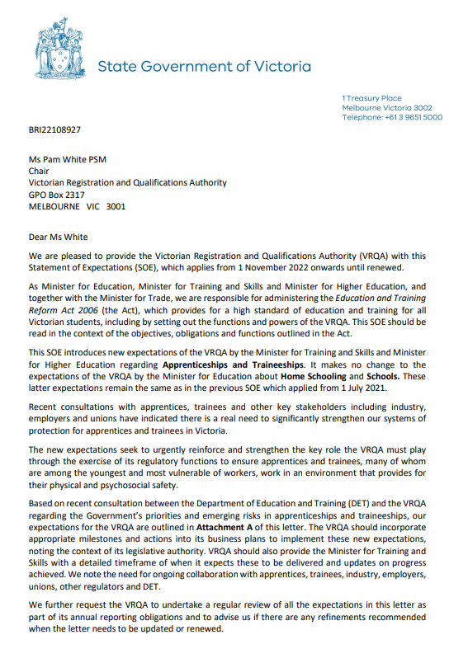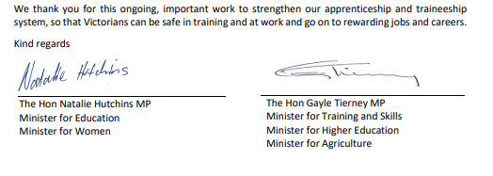

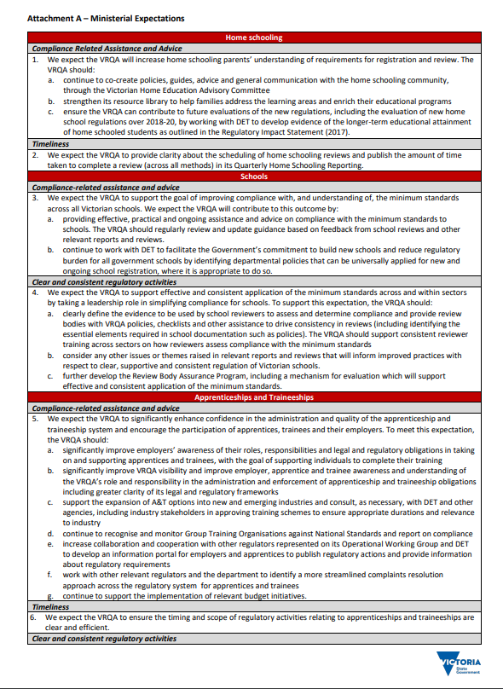

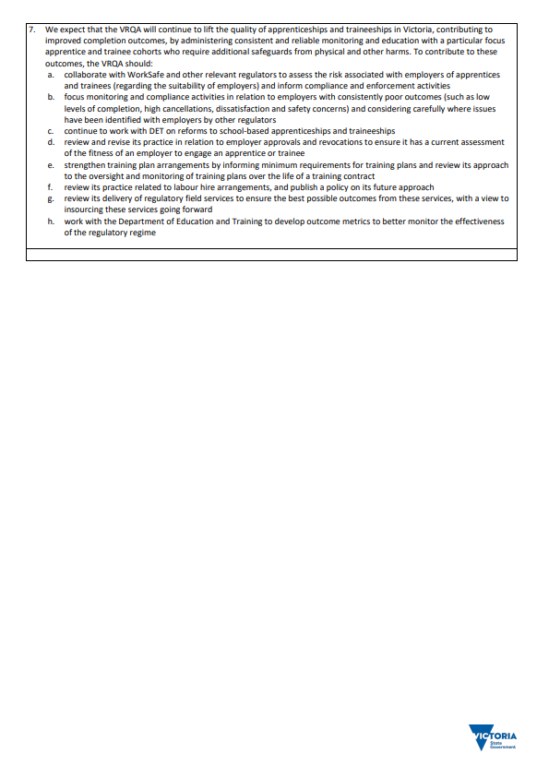

Appendix 3. Ministerial Directions for the VRQA
Section 5.2.1(5) of the Education and Training Reform Act 2006 requires the VRQA to include a copy of each Ministerial Direction given under the section in that year’s annual report.
In the financial year ending 30 June 2025, no Ministerial Directions were made.

Appendix 4. Acronyms and abbreviations
AAS | Australian Accounting Standards
AASB | Australian Accounting Standards Board
AMAF | Asset Management Accountability Framework
CCYP | Commission for Children and Young People
CRICOS | Commonwealth Register of Institutions and Courses for Overseas Students
the department | Department of Education
FOI | freedom of information
FOI Act | Freedom of Information Act 1982
FTE | full-time equivalent
GAICD | Graduate of the Australian Institute of Company Directors
GTO | group training organisation
KMP | Key Management Personnel
MBA | Master of Business Administration
MoU | Memorandum of Understanding
PSM | Public Service Medal
RAC | Risk Assessment Contact
RTO | registered training organisation
SBATs | School-based Apprentices and Trainees
SEO | student exchange organisation
SES | Senior Executive Service
SoE | Statement of Expectations
TAFE | technical and further education
VCE | Victorian Certificate of Education
VCEA | Victorian Catholic Education Authority
VPS | Victorian Public Service
VET | vocational education and training
VRQA | Victorian Registration and Qualifications Authority

