Home schooling Program Review
Parents can choose the approach to learning that suits the educational needs of their child. In a review, we do not review your learning approach or style however, communicating it helps to give context for the review.

Child’s name: Grug B
Age: 10 years 4 months
In our family, we follow a natural learning, child-led approach to home education. This review is therefore organised to reflect this integrative approach. | Indicates regular and efficient instruction.
1. Museum membership
We have a membership to Museum of Victoria. This enables us to attend the Museum and Scienceworks for free. This year we have attended both several times.
When we attend the museum, Grug’s favourite exhibits this year have been the geological section and the indigenous medicinal and food plant section.
Grug has been particularly fascinated with volcanic rocks and the minerals growing inside them. He has begun collecting volcanic rocks and crystals when we go to hiking in Philip Island and along the coast. He has spent time this year adding to his rock, shell and mineral collection. He spends time reading geology field guides to help with identifying and labelling rocks and minerals.  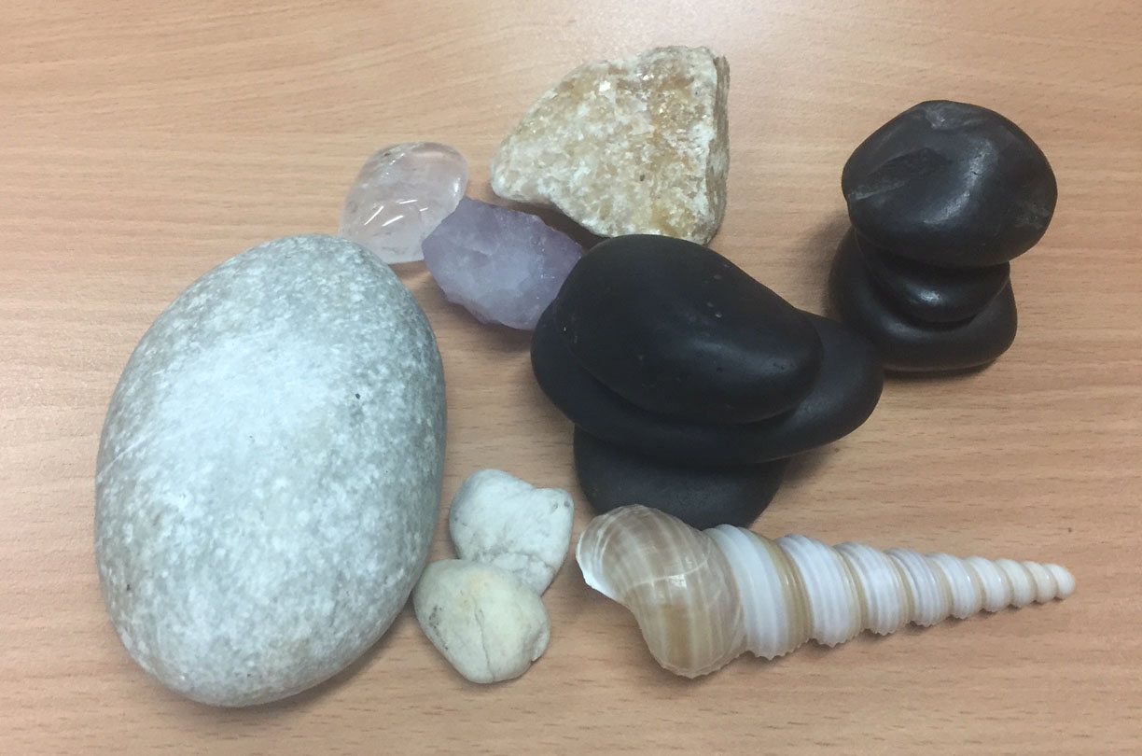 | Indicates integrated learning areas.  Detailing the activity provides evidence that:  - sciences  - humanities and social sciences (HSS) (geography)  - health and physical education (HPE)  are being substantially addressed.  This photo is evidence of a resources used (or in this case, found).  To satisfy that learning areas are being addressed, photo evidence of the labelled collection created by the child could be provided.
Part of Grug’s rocks, minerals and fossils collection
Labelling photos helps identify relevance in relation to the learning area/s.
When we are at the museum, Grug’s other favourite exhibit is the indigenous edible and medicinal plants exhibit. He spends a significant amount of time reading about each plant’s properties and uses, and is learning the indigenous names for familiar plants.

At Scienceworks, Grug is particularly fascinated by the Pumping Station, and every time we go he attends the engineering session. He asks questions and is intrigued by the workings of the steam pumps. He enjoys reading the blurbs that describe the history and science of the pumping station, and also loves calculating the volumes that were handled by the station.
KLAs: English, Sciences, Languages, Humanities and Social Sciences, Health and Physical Education, Technology, Mathematics
2. Drawing  Grug has recently contributed to saving up for a drafting table. He enjoys making technical drawings, and although his drawings are still rudimentary, he is exploring the use of perspective and elevation. He draws pictures of his own inventions and imaginings, such as how the engine in an alien’s UFO would work. | Photos (with labels) accompanied by descriptions show how learning areas are being addressed.  Here we see evidence in:  - ICTDT  - the arts  - mathematics.  Adding specific detail to descriptions provides evidence of how the learning area is being addressed.
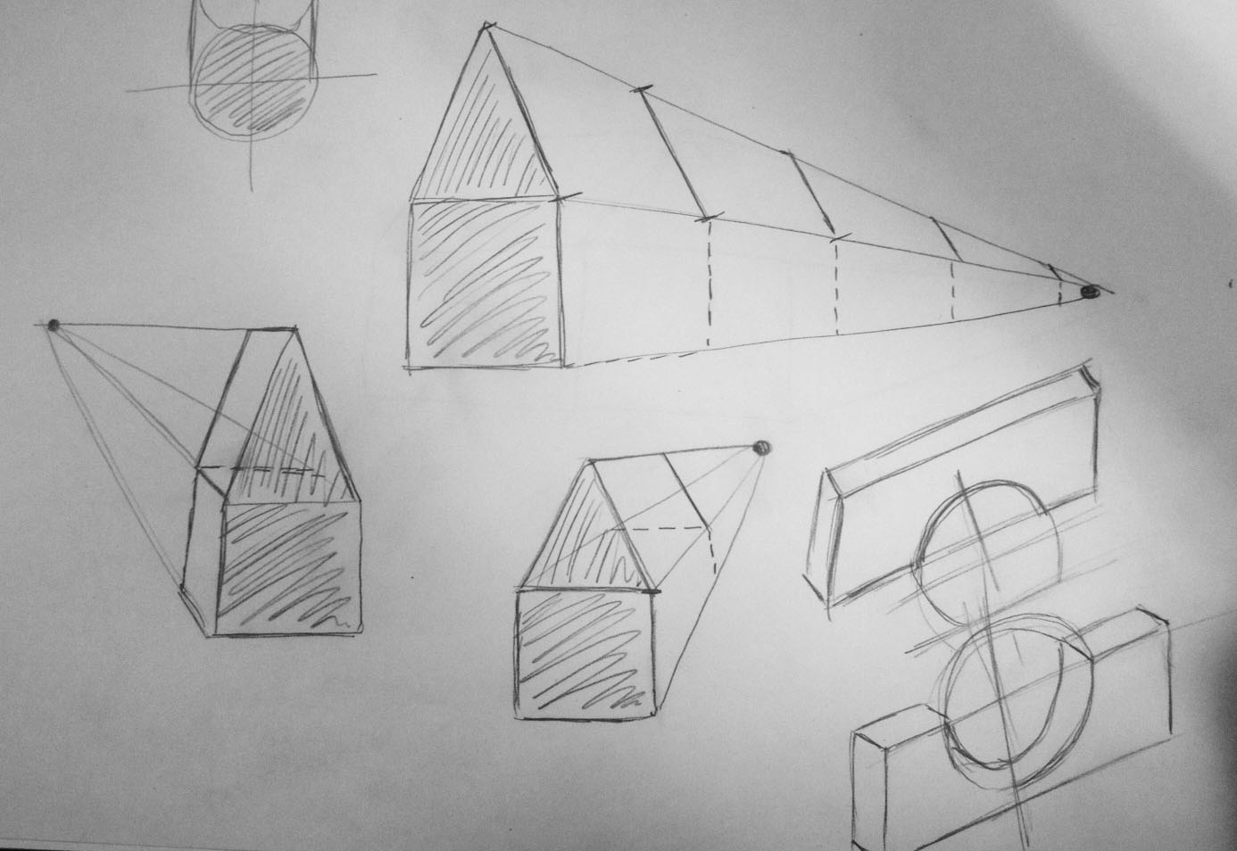
Example of technical drawing. Uncle Matt helped with the perspective drawing.
KLAs: The Arts, Technology, Sciences, Mathematics
Here, sciences would be addressed if accompanied by evidence that suggests specific application (such as the relationship of visual perception, light and perspective).
Implies that:
- English
- HSS
- sciences
- mathematics
- information and communication technology and design and technology (ICTDT)
are being addressed.
Further evidence could include work samples of the calculations.
Implies that:
- English
- HPE
- sciences
- HSS
- languages
are being addressed.
3. Reading and Telling stories
Indicates regular and efficient instruction in:
- English
- HSS (history).
Additional information on investigated languages would provide further evidence for languages.
Grug’s reading has come a long way this year. He is now reading short books independently. He thoroughly enjoys listening to audiobooks, and does so every time we are in the car travelling anywhere. We go to the library at least once a week on a Wednesday, and we borrow books about very diverse topics from the Junior Non-fiction area as well as story books to read independently and together. Grug enjoys stories about wolfs, but also about knights, dragons, and history. Sometimes we borrow books that are written in English with translations in another language and we investigate how different languages sound and are written.
Grug also enjoys telling his own stories, and will often use his technical drawings as a starting point to tell stories. He is starting to incorporate a lot of science and particularly physics concepts in his stories.  He is also interested in myths and animals. We frequently write these down together, then he illustrates them and we read them together. | Description provides evidence that:  - English  - sciences  - HSS  - the arts  are being substantially addressed.  This could be further supported with samples of the stories as evidence that English is being substantially addressed.
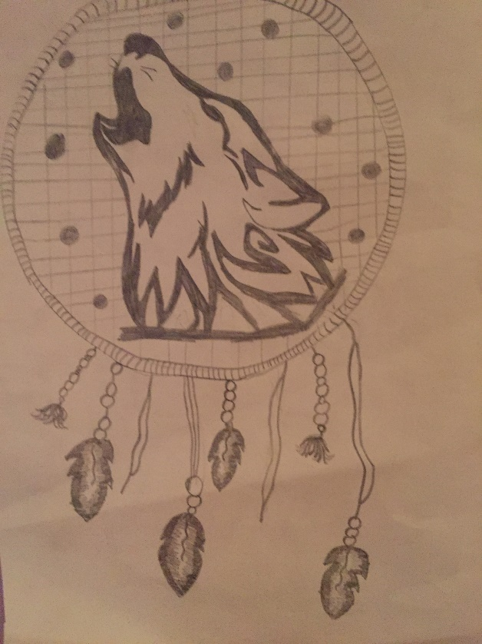  A dream catcher picture that illustrates one of Grug’s mythical stories  KLAs: English, Arts, Sciences, Languages, Humanities | The commentary with the photo establishes evidence that the arts is being substantially addressed.

4. Lego  Grug enjoys building complicated Lego Technic sets, and favours sets with motorised functions. Since January, he has built the tractor and the helicopter by himself. He also likes to freebuild with his enormous Lego collection. He likes experimenting with proportions, shapes, and balance, and creates complex builds that take several days to complete. His creativity when building with Lego has blossomed in the last 6 months. Grug is also playing with the Lego structures he builds, and tells stories about the minifigures who live and work in them. | Description provides evidence that:  - ICTDT  - mathematics  - sciences  - English  are being substantially addressed and that instruction is regular and efficient.
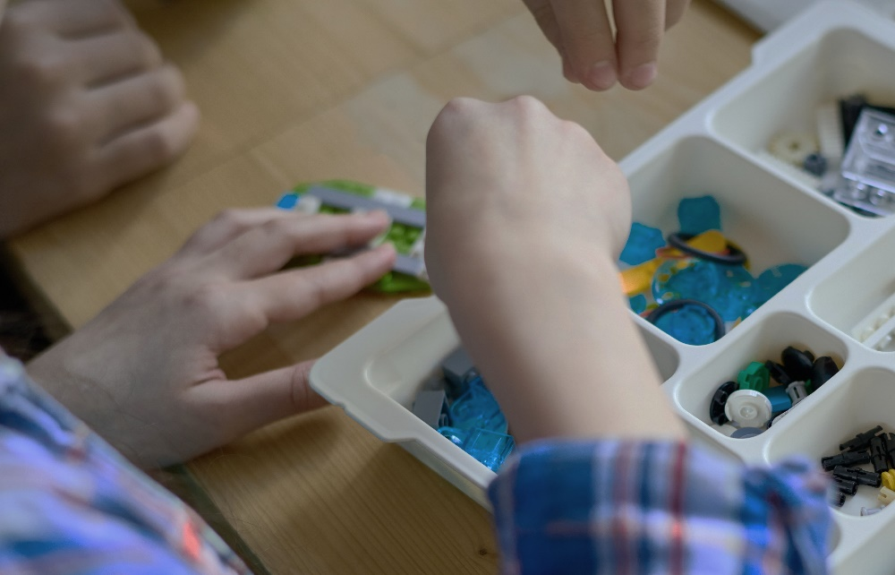
Lego Technic tractor disassembled for repairs
Labelling activities demonstrates how evidence is relevant to the learning areas.
KLAs: Technology, Mathematics, Science, English, Arts

5. Sporting activities  Grug plays basketball in our local team. This involves going to practice once a week, and then playing in a game on Saturday. He is an active member of the team, and participates with full enthusiasm. He also loves swimming, and we make sure to go to our local pool at least once a fortnight. We also take the dog for walks and go for bike rides regularly. | Your evidence does not need to include photos of your child engaging in the learning activities.  You can provide photos of completed activities and the resources used.
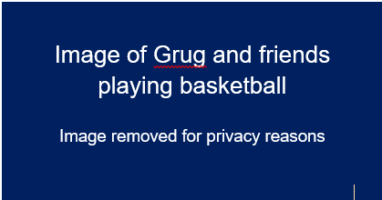  Grug playing basketball during a Saturday game  KLAs: Health and physical education | Engaging in external groups or classes suggests regular instruction is taking place. This section demonstrates that HPE is being substantially addressed.
6. Shopping & Cooking  Grug is becoming interested in food and healthy eating after watching a documentary on food production this year (“Food Inc”). As a family, we are trying to improve our diet, and reading about what different food groups do in our bodies, so we spend time at the shops talking and thinking about healthy eating, reading ingredient labels on products, and looking at the numbers in the Dietary Information panel and comparing with similar products of other brands. We are also investigating moving to a whole-food, sugar-free diet, so we are doing lots of reading and listening to podcasts about the subject, as a family - we want everyone on board!  We share cooking meals a lot, and Grug is learning to make simple dishes independently. He reads and interprets recipes with assistance, multiplies quantities if needed, measures and weighs ingredients, chops vegetables, and uses the stove independently (but supervised!). We are also learning about using Indigenous herbs in cooking (tying in with Grug’s interest in the indigenous plants exhibit at the Museum), and we experiment with the different flavours. A few months ago, we received a pasta maker as a gift, and we have even been experimenting with making our own pasta. | Attending a class and reinforcing it at home indicates regular and efficient instruction.  The photo, accompanied with the description, provides evidence that health and physical education and ICTDT are being addressed.  Detailed description demonstrates that:  - English  - HSS  - HPE  - mathematics  - ICTDT  are being substantially addressed

We went to a pasta making cooking class, and now we’re doing it at home
KLAs: English, Mathematics, Humanities/Social studies, Technology, Science, Health & physical education
There are many ways that cooking and shopping for food can directly apply to learning areas such as sciences and mathematics. However, there is no evidence in this section to demonstrate how the sciences are being addressed.

7. Science at home
Grug loves doing science experiments at home. We have recently bought a couple of books on the subject, including The Kids' Book of Everyday Science by Kelly Doudna, and The Everything Kids' Science Experiments Book : Boil Ice, Float Water, Measure Gravity-Challenge the World Around You! by Tom Robinson. He is enjoying reading them and then trying experiments here and there.
Grug is also exploring a few websites and using them regularly to do science experiments in his own time. He uses websites such as https://www.fizzicseducation.com.au/Free+experiments.html#experiment to find projects and experiments he wants to do, then asks for help to gather materials and do the experiment. His favourites (not surprisingly) are the messy, exploding ones, which we do outside!
Some examples of experiments Grug has done this year:
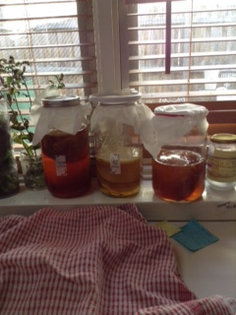 | Detailed labelling of photos provides further evidence of how learning areas are being addressed.
Experimenting with Milk Fireworks (milk, food colour and dish soap).
Grug made predictions about using water, different types of milk, and colorants
Where and When  As can be seen from the range of activities Grug does, learning is occurring every day. Being natural learners, and learning through exploring the world around us, we do not discriminate between weekdays and weekends. Grug is always questioning and exploring, and so the “when” happens whenever there are opportunities for learning.  This is also true of the “where”. Learning happens at home, at the local library, the pool, at basketball, in the backyard, at the museum, at workshops (e.g. cooking), and at the shops. | Describing the approach to learning gives context for how regular and efficient instruction is occurring.

