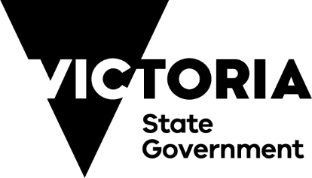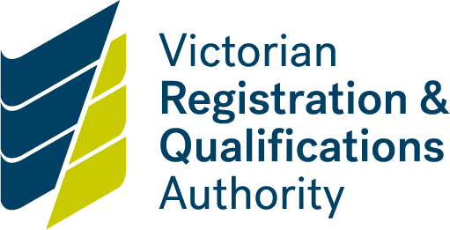

**Steering committee**

**Course content endorsement form**

**About this form**

The steering committee oversees the development of a course and validates the course content meets identified needs, including:

* the outcome(s), qualification, structure and content meet the needs of industry, enterprise/ community/education requirements
* the qualification level is appropriate to the needs and outcomes
* the course meets all relevant occupational health and safety regulations, licensing requirements and any other legislation appropriate to the course
* the foundation skills summary reflects the needs of the job role
* all risks associated with the course have been identified and addressed.

Each member of the steering committee must complete and sign a copy of this form to validate the course content meets the requirements specified.

|  |  |  |  |  |  |  |
| --- | --- | --- | --- | --- | --- | --- |
| **Proposed course title:** | |  | | | | |
| 1. | The outcomes and structure of the course meets the identified industry/enterprise | | Yes | No |  |
| 2. | The qualification level is appropriate to the needs and outcomes | | Yes | No |  |
| 3. | The proposed course meets all relevant occupational health and safety requirements for this industry/community | | Yes | No | Not applicable |
| 4. | The course meets any licensing/regulatory requirements for the industry/community | | Yes | No | Not applicable |
| 5. | The course complies with any relevant legislation specific to the industry/community | | Yes | No | Not applicable |
| 6. | The content of each unit reflects the knowledge and skills required to achieve the vocational outcome. | | Yes | No |  |

|  |
| --- |
| If you feel as a steering committee member that you cannot agree that one or more of the requirements listed in this document has been adequately addressed, please provide details of your concerns (attach additional pages if required). |

|  |  |  |
| --- | --- | --- |
| **Steering Committee Member name** | **Signature** | **Date** |
|  |  |  |