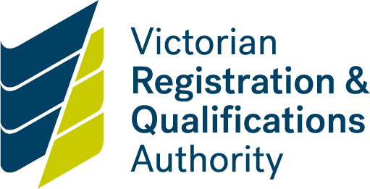

Risk assessment guide

Accreditation of courses with areas of potential high risk

Background

The VRQA regularly assesses the potential risk of courses as part of the course concept proposal process. Courses may be classified as low, medium or high risk. Course developers must ensure that all courses and qualifications submitted for accreditation address occupational health and safety risks in a relevant and appropriate manner.

If your course is potentially high-risk, complete and submit a risk assessment form with your course accreditation form available. See [Course accreditation | vrqa.vic.gov.au](https://www2.vrqa.vic.gov.au/course-accreditation) for more information.

|  |
| --- |
| What courses are seen as having areas of potential high risk? |

Qualifications and courses with areas of potential high risk are defined by the VRQA as those where there is a risk of potential physical or mental harm to course participants during the training period, or associated with the vocational outcomes, for example a course where the outcomes require the use of hazardous substances in the workplace, working with equipment that has the potential to cause injury or may impact on the health and safety of the public.

Qualifications and courses considered by the VRQA as having areas of potential high risk include those which involve any of the following:

* penetration of the skin
* possible invasive treatments
* risk of infection
* physical manipulation
* serious contra-indications may apply
* treatments that deal with or may impact on the mental or emotional health of a client
* possible financial impact on a client
* first aid treatments
* working in a dangerous or hazardous environment
* working with equipment that has the potential to cause injury
* working with animals
* working with children
* Working with individuals in vulnerable circumstances e.g. elderly, physically or intellectually disabled, mental illness, substance abuse, ATSI, family violence etc
* Impact on public safety e.g. emergency operations, firefighting, crowd control, security, etc.
* Use of firearms

|  |  |  |
| --- | --- | --- |
| **What should you do if you wish to accredit a course that might fall into the potential high-risk category?** | | |
| 1. | Course proposal declaration | Before completing and submitting the course proposal declaration, you must discuss your proposal with the VRQA.  The VRQA has general requirements for all courses or qualifications and will consider each course proposal submission on a case by case basis.  If the VRQA considers the course potentially high-risk, you must complete and submit a risk assessment form with your course accreditation submission. |
| 2. | Course accreditation submission | The VRQA has general requirements for all courses that comply with the [AQTF 2021 Standards for Accredited courses](https://www.dewr.gov.au/national-regulatory-framework/resources/aqtf2021-standards-accredited-courses).  Submission of courses with areas of potential high risk must be considered by the project steering committee members.  A risk assessment form signed by the Chairperson of the project steering committee must be included in the supporting documentation submitted with the course accreditation documentation. |