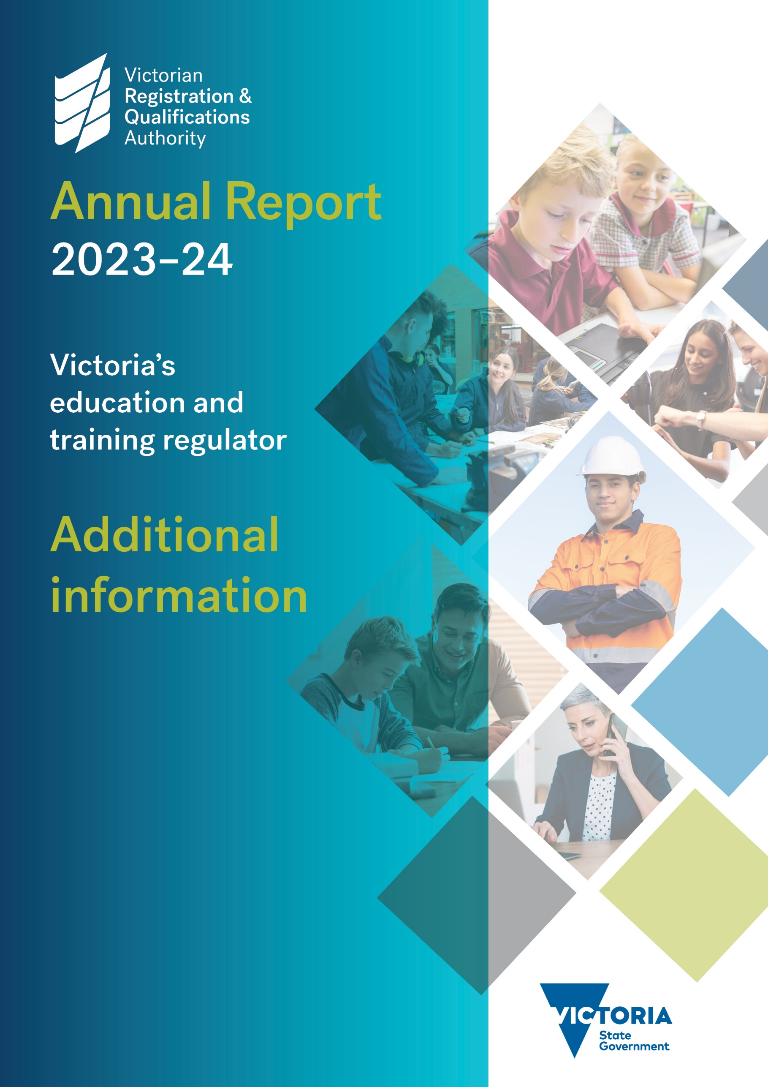

Contents

Contents 1

Reporting requirements 2

Pecuniary interests 2

Shares held by senior officers 2

Publications 3

Changes to prices, fees, charges, rates and levies 3

Major external reviews 4

Major research and development 4

Overseas travel 4

Major promotional, public relations and marketing activities 4

Occupational health and safety 4

Industrial relations 4

Major committees 4

Consultancies and contractors 4

Reporting requirements

Financial Reporting Direction 22H requires details of certain items, listed below, to be retained by the Accountable Officer and made available on request subject to the provisions of the *Freedom of Information Act 1982*.

* A statement that declarations of pecuniary interests have been duly completed by all relevant officers.
* Details of shares held by a senior officer as nominee or held beneficially in a statutory authority or subsidiary.
* Details of publications produced by the entity about the entity, and how these can be obtained.
* Details of changes in prices, fees, charges, rates and levies charged by the entity.
* Details of any major external reviews carried out on the entity.
* Details of major research and development activities undertaken by the entity.
* Details of overseas visits undertaken including a summary of the objectives and outcomes of each visit.
* Details of major promotional, public relations and marketing activities undertaken by the entity to develop community awareness of the entity and its services.
* Details of assessments and measures undertaken to improve the occupational health and safety of employees.
* A general statement on industrial relations within the entity and details of time lost through industrial accidents or disputes.
* A list of major committees sponsored by the entity, the purposes of each committee and the extent to which the purposes have been achieved.
* Details of all consultancies and contractors including consultants/contractors engaged; services provided; and expenditure committed for each engagement.

Some of the above information is reported in the *Victorian Registration and Qualifications Authority Annual Report 2023–24*. This statement refers to the VRQA Annual Report in such instances.

Pecuniary interests

Declarations of pecuniary interests have been duly completed by relevant officers.

Shares held by senior officers

No shares are held by any senior officer as a nominee or held beneficially in a statutory authority or subsidiary.

Publications

Details of publications produced by the VRQA and how these can be obtained are shown in Table 1.

**Table 1 – Publications produced by the VRQA**

|  |  |  |
| --- | --- | --- |
| Publication | Produced | Link |
| VRQA e-news | July 2023– June 2024 | [vrqa.vic.gov.au/vrqa-news](https://www2.vrqa.vic.gov.au/vrqa-news) |
| VRQA Annual Report 2022–23 | October 2023 | [vrqa.vic.gov.au/sites/default/files/2023-11/VRQA-Annual-Report-2022-23.docx](https://www2.vrqa.vic.gov.au/sites/default/files/2023-11/VRQA-Annual-Report-2022-23.docx) |
| 2023 Client and Stakeholder Satisfaction Research Report | February 2024 | [vrqa.vic.gov.au/sites/default/files/2024-02/Client-Stakeholder-Satisfaction-Research-Report-2023.pdf](https://www2.vrqa.vic.gov.au/sites/default/files/2024-02/Client-Stakeholder-Satisfaction-Research-Report-2023.pdf) |
| BuildUp campaign report | March 2024 | [vrqa.vic.gov.au/buildup-campaign-report](https://www2.vrqa.vic.gov.au/buildup-campaign-report) |

Changes to prices, fees, charges, rates and levies

VRQA fees and charges are set by ministerial order. These fees and charges cover:

* schools
* senior secondary courses
* senior secondary qualifications and accredited senior secondary courses
* vocational education and training (VET)
* accreditation of higher education courses
* overseas secondary student exchange organisations
* overseas students
* certificates issued to apprentices.

On 1 January 2013, Ministerial Order No. 615 came into effect, setting fees for 2013 and beyond. The setting of this order was subject to an extensive regulatory impact statement process.

Fees are revised each year to reflect changes in the consumer price index, as specified in Ministerial Order No. 615.

In December 2016, Ministerial Order No. 957 was made, fixing VET fees for VRQA-registered RTOs at 2014 levels. VET fees remain at those levels.

Details of current prices, fees, charges, rates and levies charged by VRQA, and the regulatory impact statement process and outcomes, are outlined on the VRQA website at [vrqa.vic.gov.au/fees](https://www2.vrqa.vic.gov.au/fees).

Major external reviews

Details of reviews are reported on in the VRQA Annual Report under ‘Reviews and studies expenditure’.

Major research and development

There was no major research or development activity carried out by the VRQA during the 2023–24 financial year.

Overseas travel

There were no instances of a VRQA officer travelling overseas for work during the 2023–24 financial year.

Major promotional, public relations and marketing activities

There was no major promotional, public relations or marketing activities undertaken by the VRQA in the 2023–24 financial year.

Occupational health and safety

Occupational health and safety is reported on in the VRQA Annual Report.

Industrial relations

Industrial relations are reported on in the VRQA Annual Report under ‘Workforce Data’. No time was lost to industrial relations action in 2023–24.

Major committees

All committee activities are reported in the VRQA Annual Report.

Consultancies and contractors

Consultancies and contractors are reported in the VRQA Annual Report.