

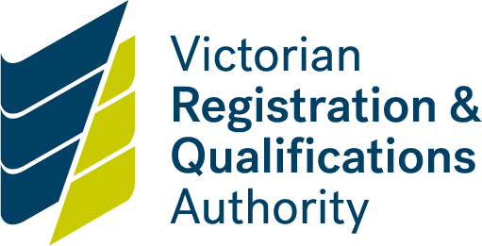

**Application for short-term renewal**

**VET accredited course**

About this form

Application for a short-term renewal will only be accepted by the course copyright owner as specified in the contact details listed on [training.gov.au](https://training.gov.au/Home/Tga).

The period of accreditation of a course may be renewed for no longer than 12 months (short -term renewal) in exceptional circumstances, such as:

* the outcomes of the accredited course that is due to expire are to be incorporated into a nationally endorsed training package that is due for endorsement shortly after the course expiry date
* the course leads to a legislative/regulatory/licensed outcome and it is specified that the course must be completed to achieve that outcome, and if the relevant legislation is under review and the review is expected to be finalised within a short time after the expiry date of the accredited course
* other rationale as determined appropriate by the Victorian Registration and Qualifications Authority.

There are to be no new enrolments in a course after the accreditation expiry date.

Students enrolled in a course prior to the expiry date may complete the course and receive that qualification. It is recommended students complete the course or are transitioned to the new course as soon as possible so they are not disadvantaged.

Fees for VRQA regulatory activities have been approved to apply to all accreditation applications received from 1 January 2013. These fees are set by Ministerial Order 615, which was made on 21 December 2012. This order was subject to the Regulatory Impact Statement (RIS) process.

Details of fees payable for the short-term renewal of the accreditation of a course can be found on the [VRQA website](https://www2.vrqa.vic.gov.au/fees)

When you lodge your application, an invoice will be sent for payment. There may be a reduction of the course renewal fee for each course for a short-term renewal if the VRQA costs are less than the maximum fee.

Fees are payable prior to any assessment or other services being provided by the VRQA. Once the accreditation fee has been paid, the VRQA will assess your application.

Submitting the declaration

Return your completed form by email to: [vrqa.vet@education.vic.gov.au](mailto:vrqa.vet@education.vic.gov.au) or post to:

VET and Industry Engagement Unit

Victorian Registration and Qualifications Authority

GPO Box 2317

Melbourne Vic 3001

**Privacy disclaimer**

All information collected in this form is required by State or Commonwealth legislation and associated regulatory frameworks.

The VRQA will only use this information in relation to its powers and functions under the *Education and Training Reform Act 2006*. To read the VRQA privacy policy, see:

* [Information Privacy Policy](https://www2.vrqa.vic.gov.au/vrqa-privacy-statement)

You are able to request access to personal information that we hold about you and request that it be corrected.

|  |  |
| --- | --- |
| **Course details** | |
| Course code |  |
| Course title |  |
| Current period of accreditation (start and end date) |  |
| Copyright owner |  |
| Proposed extension of accreditation period (start and end date, minimum 6 months, maximum 12 months from current course expiry date) |  |
| | Provide reasons for short term renewal | | --- | | Please provide details | | | Provide evidence of consultation and/or industry support for the short-term renewal | | --- | | Evidence may include Steering Committee Minutes, letters of support from relevant industry/community organisations, other consultation processes if appropriate. **I**nsert space between statements. | | Please provide details | |  | | | |

|  |  |  |  |
| --- | --- | --- | --- |
| **Declaration** | | | |
| I request that the Victorian Registration and Qualifications Authority considers this application for short-term renewal of the course. | | | |
| Name |  | | |
| Organisation |  | | |
| Position |  | | |
| Signed |  | | |
| Date | DD | MM | YYYY |