

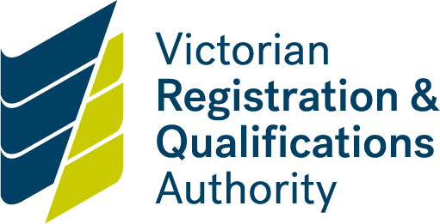

**Risk assessment form**

**Potential high-risk courses**

About this form

Please complete this form using the:

* [VRQA guide to accreditation of courses with areas of potential high risk](https://www2.vrqa.vic.gov.au/apply-course-accreditation-test/stage-3-course-development#highriskcourses).

This form is to be considered by members of the Steering Committee and signed by the Chairperson of the Steering Committee

The signed form must be attached as an appendix and submitted with the accreditation submission to two VRQA Accreditation Advisers before the accreditation panel meeting. This form is part of the final course submission documentation to the VRQA.

Please complete the form indicating whether the item is relevant to the course or courses being submitted in relation to the VRQA guide to accreditation of courses with areas of potential high risk, including details of how the potential risk is mitigated and where there is evidence of this in the course document and/or unit.

Privacy disclaimer

All information collected in this declaration is required by State or Commonwealth legislation and associated regulatory frameworks.

The VRQA will only use this information in relation to its powers and functions under the *Education and Training Reform Act 2006*. To read the VRQA privacy statement, see:

* [Information Privacy Policy](https://www.vrqa.vic.gov.au/Pages/privacy.aspx)

You are able to request access to the personal information that we hold about you and request that it be corrected.

|  |  |
| --- | --- |
| P**roposed course title:** |  |
|  | |

# For the course overall

| Item | **Yes** | **No** | **Details and location in course document** |
| --- | --- | --- | --- |
| Conflict of interest has been declared by steering committee members |  |  |  |
| Course is subject to licence, regulation, industry guidelines and codes of practice |  |  |  |
| Entry requirements for the course have been identified in competencies and/or experience |  |  |  |
| Treatment/therapy may require referrals to other health practitioners |  |  |  |
| Circumstances identified when the treatment/therapy should NOT be given |  |  |  |
| Competency must be clearly demonstrated through demonstration in a clinical situation with real clients or through simulated activity |  |  |  |
| Intended vocational outcomes verified as appropriate by relevant industry body/bodies or regulatory authorities |  |  |  |

# Risk management as**sessme**nt

| **Risk factors** | **Yes** | **No** | **Risk mitigation identified and location in document** |
| --- | --- | --- | --- |
| Involves skin penetration |  |  |  |
| Possible invasive treatments |  |  |  |
| Risk of infection |  |  |  |
| Involves physical manipulation |  |  |  |
| Serious contra-indications may apply |  |  |  |
| Treatments that may deal with or impact on the mental or emotional health of a client |  |  |  |

|  |  |  |  |  |
| --- | --- | --- | --- | --- |
| **Risk factors** | **Yes** | | **No** | **Risk mitigation identified and location in document** |
| Possible financial impact on a client |  |  | |  |
| First aid treatments |  |  | |  |
| Working in a dangerous or hazardous environment |  |  | |  |
| Working with equipment that has the potential to cause injury |  |  | |  |
| Work with animals |  |  | |  |
| Working with children |  |  | |  |
| Working with individuals in vulnerable circumstances e.g. elderly, physically or intellectually disabled, mental illness, substance abuse, ATSI, family violence etc |  |  | |  |
| Impact on public safety e.g. emergency operations, firefighting, crowd control, security, etc. |  |  | |  |
| Use of firearms |  |  | |  |

|  |  |  |  |
| --- | --- | --- | --- |
| Letters of support have been provided by the relevant industry body/bodies or regulatory authorities | | Yes | No |
| There is a match between vocational outcomes, AQF level and entry requirements | | Yes | No |
| 1. Signature of the chairperson of the steering committee | | | |
| Name |  | | |
| Signed |  | | |
| Date |  | | |

1. Support and outcomes