**Enforceable Undertaking**

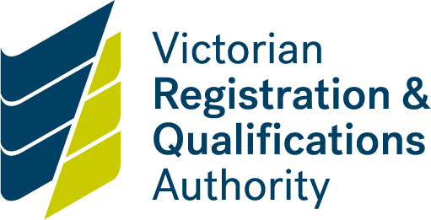

**Policy**

**What is an enforceable undertaking?**

An enforceable undertaking is a written agreement between the VRQA and a registered school that is the subject of a review or the VRQA and a Registered Training Organisation (RTO), regulated by the *Education and Training Reform Act 2006* (the Act)*.*

For undertakings by schools, see sections 4.3.3A to 4.3.3D of the Act. For undertakings by RTOs, see sections 5.8.3V to 5.8.3Y of the Act.

An enforceable written undertaking by a school (provided by the proprietor or principal) or an RTO will usually include:

* an admission that the school or RTO has not complied or is not currently fully compliant with:
* one or more prescribed minimum standards for registration (in the case of a school), or
* one or more RTO standards including the Australian Quality Training Framework (AQTF) and VRQA VET Guidelines (in the case of an RTO), or
* one or more requirements for approval to offer a course of study to overseas students (in the case of a school or RTO)
* steps that the school or RTO will take to reach compliance, such as rectification work (including updating or redeveloping a policy or procedure), retraining and /or assessment
* an acknowledgement that the school or RTO has had an opportunity to seek legal, commercial or financial advice (as may be relevant)
* an admission that the school or RTO has contravened another part of the Act under which the VRQA has a power or function
* an acknowledgement by the school or RTO that failure to take the steps set out in the enforceable undertaking may lead to further action by the VRQA.

Once a school or RTO has entered into an enforceable undertaking, it may only be withdrawn or varied with the VRQA’s consent. Importantly, an undertaking will not automatically be withdrawn just because a school or RTO has complied with it.

**Why use enforceable undertakings?**

The VRQA will consider using enforceable undertakings in circumstances where:

* the instances of non-compliance identified by a school or RTO are not so significant to warrant other action such as the imposition of conditions, suspension or cancellation of registration and the VRQA is confident that the undertaking will be implemented
* a school or RTO has demonstrated significant non-compliance with a standard but is genuinely prepared to admit and rectify the non-compliance to the VRQA’s satisfaction
* the VRQA seeks outcomes that may not necessarily be available through other sanctions open to the VRQA including through cancellation or suspension of registration, or through the imposition of conditions on registration.

**What is the effect of not complying with an enforceable undertaking?**

If the VRQA considers that there has been a breach of any of the terms of an undertaking, the VRQA has the power to apply to the Magistrates’ Court for an order that can:

* direct the RTO or person on behalf of a school to comply with the term of the undertaking
* direct the RTO to pay to the State an amount up to the amount of any financial benefit that the RTO has obtained directly or indirectly through the breach.
* this possible order is not specifically noted in the legislation for enforceable undertakings related to schools. However, the Magistrates’ Court could make such an order if it considers it appropriate to do so under subsection 4.3.3D(2)(b)
* direct the RTO to compensate any other person who has suffered loss, injury or damage as a result of the breach(as appropriate to do so under subsection 4.3.3D(2)(b)), or
* make any other order the Court considers appropriate.

The VRQA may also open a new review of a school or new audit of an RTO should it feel that the enforceable undertaking has not been complied with and may seek to take further action in respect of the school’s or RTO’s registration.

**Lessons for schools and RTOs**

Where appropriate, agreeing to an enforceable undertaking can provide a school or RTO with an efficient and cost effective way of resolving contraventions to the Act. However, a school or RTO should consider obtaining independent legal advice before agreeing to an enforceable undertaking, to ensure that the undertaking does not create more problems for the school or RTO than is sought to be resolved.