

Published and authorised by  
the Victorian Registration and Qualifications Authority (VRQA)  
Level 4 Casselden  
2 Lonsdale Street  
Melbourne Vic 3000

GPO Box 2317  
Melbourne Vic 3001

Tel: (03) 9637 2806  
vrqa@edumail.vic.gov.au  
www.vrqa.vic.gov.au

September 2018

© State of Victoria (VRQA) 2018

[Creative Commons logo](http://creativecommons.org/licenses/by/3.0/au/)

*Victorian Registration and Qualifications Authority Annual Report 2017–18* is licensed under a [Creative Commons Attribution 4.0 licence](http://creativecommons.org/licenses/by/4.0/). You are free to re‑use the work under that licence on the condition that you credit the State of Victoria (VRQA), indicate if changes were made and comply with the other licence terms available [here](http://creativecommons.org/licenses/by/4.0/deed.en). The licence does not apply to:

* any trademarks or branding, including the Victorian Government logo and the VRQA logo
* images or photographs or other content supplied by third parties.

Copyright queries may be directed to vrqa[@edumail.vic.gov.au](mailto:copyright@edumail.vic.gov.au)

ISSN 2204-0463 (Print) ISSN 2204-0471 (Online)

If you would like to receive this publication in an accessible format such  
as large print or audio, please telephone 1800 809 834 or email edline@vic.gov.au

This document is also available in Microsoft Word format at www.vrqa.vic.gov.au

The Hon. James Merlino MP  
Minister for Education

The Hon. Gayle Tierney MLC

Minister for Training and Skills

The Hon. Philip Dalidakis MLC  
Minister for Trade and Investment

Dear Ministers

In accordance with the *Financial Management Act 1994* and the *Education and Training Reform Act 2006*, I am pleased to present the Victorian Registration and Qualifications Authority Annual Report for the year ended 30 June 2018.

Yours sincerely

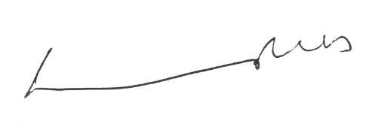

Michonne van Rees  
Board Member  
Victorian Registration and Qualifications Authority

September 2018

Contents

Report of operations—year in review 1

The VRQA’s purpose 1

The VRQA’s values 1

Report of the Chair 2

Report of the Chief Executive Officer (Director) 3

About this report 4

Purpose and functions 4

Strategic priorities and key achievements 5

Progress towards objectives and indicators 7

Year in financial review 22

Report of operations—governance and organisational structure 23

Ministers 23

The VRQA Board 24

Organisational structure at 30 June 2018 32

Report of operations—workforce data 33

Occupational health and safety 33

Comparative workforce data 34

Executive officers 37

Report of operations—other disclosures 38

Victorian Industry Participation Policy 38

Major consultancies and contracts 38

Freedom of information 38

Compliance with the *Building Act 1993* 39

National Competition Policy 39

Compliance with the *Protected Disclosure Act 2012* 39

Compliance with the *Carers Recognition Act 2012* 40

Office-based environmental impacts 40

Fees and charges 41

Additional information available on request 41

Compliance with DataVic Access Policy 42

Attestation for compliance with the Ministerial Standing Direction 5.1.4 43

Financial statements 44

Accountable Officers’ and Chief Finance Officer’s declaration 44

Independent Audit Report 45

Comprehensive operating statement for the financial year ended 30 June 2018 47

Balance sheet as at 30 June 2018 48

Statement of changes in equity for the financial year ended 30 June 2018 48

Cash flow statement for the financial year ended 30 June 2018 49

Notes to the financial statements 50

Appendices 77

Report of operations—year in review

The VRQA’s purpose

To regulate for quality learning outcomes in safe and well-governed environments.

The VRQA’s values

The VRQA upholds the Victorian Public Sector values and the VRQA RITE values are embedded in all levels of our organisation. Our values underpin our interactions with staff, stakeholders and the community.

The RITE values are:

R: respect and diversity

I: integrity

T: transparency

E: empowerment.

Report of the Chair

The VRQA Board is acutely aware of the important role we play in Victoria’s education and training system. In undertaking our task, we are privileged to work with the diverse range of individuals and entities that make up this system. These range from large multi-campus schools, community-based training organisations and small rural schools; to the approximately 25,000 employers of 77,000 apprentices/trainees in training scattered right across the state, and more than 3,200 individual home schooling parents and guardians. One-in-six Victorians is enrolled, or participating, in education and training in Victoria.

The VRQA plays an important role in making sure the organisations and individuals delivering education and training generate positive experiences and equip participants with the skills they need to succeed in our economy and society.

This was a year of transition and action. We shifted from supporting the Department of Education and Training’s work to review and remake the regulations, to fully implementing the new regime.

To guide us, in January 2018 we received our fourth Ministerial Statement of Expectations, which provides the Board and office with a clear agenda under the remade regulations. It covers continued improvements to the effectiveness and efficiency of regulatory practice, home schooling, apprenticeships and traineeships, expulsions reform, and evaluation.

For me, a highlight was the new partnership with the Victorian home schooling community, through the Deputy Premier’s Victorian Home Education Advisory Committee (VHEAC). I thank the VHEAC’s home schooling representatives. They supported VRQA staff to inform home schooling parents about the changes. They also generously shared their expertise, which shaped a range of new VRQA policies, guides and procedures in home schooling regulation.

The forward agenda is challenging. We strive to ensure that students go to institutions that are well-governed, safe and high-achieving, and/or take up apprenticeship and traineeship pathways that prepare them for great jobs and careers. We will build on the work we have started in home schooling regulation. Most importantly, we will continue to undertake our work in a transparent and consultative manner.

I thank the VRQA Board for their work throughout the year and for their contributions to Victoria’s high-quality education and training system. I welcome Dr Jim Watterston and Ms Maria Peters to the Board. They are both highly distinguished and recognised in education and training, here and abroad. Finally, I acknowledge the work of the VRQA’s Chief Executive Officer, Lynn Glover, as well as the VRQA staff for their professionalism and expertise, which has once again shaped Victoria’s education and training sector.

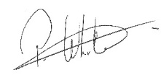

**Pam White PSM  
Chair**

Report of the Chief Executive Officer (Director)

As I reported last year, the Education and Training Reform Regulations were revised, and this year we have focused our attention on implementation in two key areas:

* home schooling, now including new learning plan requirements for registration and annual reviews of up to 10 per cent of the cohort
* strengthened probity and not-for-profit requirements for new school registrations and for existing non-government schools from 1 July 2018.

To ensure these changes are implemented effectively, the VRQA has undertaken an extensive public consultation program. We conducted 13 roadshows in partnership with representatives from the VHEAC. It was pleasing to see more than 1100 home schooling community members attending either a face-to-face or online session.

In response to the Commonwealth Government’s review of the *Education Services for Overseas Students National Code*, we have developed the *Guidelines for Enrolment of Overseas Students Aged Under 18.* The guidelines make certain that any school approved to deliver education to under 18-year-old international students will ensure the highest standards of safety and care.

We appreciate—and do not take for granted—the high opinions our stakeholders and clients reported about their interactions with us in the *2017 VRQA Client and Stakeholder Research Report* (see page 21). The VRQA has continued to modernise our communications through a significant website upgrade that now includes education and guidance materials across all our key areas of regulation. Following the success of our animations, used to communicate key Child Safe Standards material, we have now extended this into the home schooling area.

Throughout 2017, one-in-three registered schools actively engaged in various forms of assessment against the Child Safe Standards. Following feedback on this work, the VRQA initiated two projects with key education stakeholders that aim to develop targeted resources to ensure schools are able to confirm children are safe in boarding facilities and specialist education settings.

I am pleased to advise that after an extensive public procurement process, we have contracted BUSY At Work for a further 3-year period to provide apprenticeship field services. The contract will introduce risk-assessment tools to ensure our apprentices and trainees are receiving quality on-and off-the-job training.

This year we have introduced a co-regulatory model for recognising group training organisations. All existing group training organisations have completed a self-assessment process and financial viability assessments.

I welcome Simon Thorn to the role of Executive Manager, Skills and Training. Simon has wide experience in the public sector which he will now apply in the regulation of vocational education and training.

I thank Pam White for her role as chair of the VRQA Board, and all members who served on the Board this year. Their participation and contribution makes my job easier and protects the interests of Victorians participating in the Victorian education and training system. Thank you also to the stakeholders who give us their valuable time, and to our Department of Education and Training colleagues.

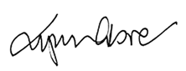

**Lynn Glover  
Chief Executive Officer (Director)**

About this report

In accordance with Ministerial Financial Reporting Direction 30B, that annual reports be ‘reports of the financial and business operations of an entity, produced to comply with relevant Victorian legislation and pronouncements’, material not required under relevant legislation and pronouncements is not included in this report.

An index at Appendix 1 identifies the VRQA’s compliance with statutory disclosure requirements.

Purpose and functions

Strategic purpose

Regulation is a tool of government to create environments to achieve public policy goals.

The VRQA supports the Victorian Government’s education and training goals. We contribute to the portfolio-wide efforts of the Department of Education and Training (DET), to help Victorians gain the skills and knowledge they need to thrive and participate in a complex and challenging economy and society.

The VRQA contributes to quality learning and work environments by regulating home schooling, schools and registered training organisations; as well as the learning and work taking place in the apprenticeship and traineeship system. Our role is to help build, maintain and improve these environments by ensuring that schools, registered training organisations and employers meet the required standards for participating in Victoria’s high-quality education and training system.

We do this through our regulatory frameworks that cover information provision, education, registration, monitoring and enforcement. These services protect Victorians from substandard practices and help create learning and work environments conducive to the broader goal of supporting Victorians to gain the skills and knowledge they need to thrive.

We define success as achieving safe, well-governed learning and work environments that are led by appropriately-qualified people who contribute to quality outcomes for learners.

Functions

The VRQA is a statutory authority established under the *Education and Training Reform Act 2006* (the Act) and is responsible to the Minister for Education, the Minister for Training and Skills, and the Minister for Trade and Investment. We register:

* vocational education and training (VET) providers that deliver accredited training to domestic students in Victoria only, or Victoria and Western Australia only
* school education providers, including approval on the Commonwealth Register of Institutions and Courses for Overseas Students (CRICOS) for courses delivered by schools
* senior secondary education providers (both school and non-school providers) including approval on CRICOS for school sector courses
* children for home schooling in Victoria.

We also:

* regulate apprenticeships and traineeships in Victoria
* monitor group training organisations (GTOs) in Victoria
* approve school and non-school providers as overseas secondary student exchange organisations
* accredit courses and register qualifications for our registered providers and Victorian senior secondary courses and qualifications
* investigate complaints against our registered providers
* maintain a register of all education and registered training organisations and the accredited courses they deliver.

Strategic priorities and key achievements

The VRQA Board developed the *VRQA Strategic Plan 2016–18* in the reporting period. The plan sets out four main directions:

1. **implement government directions**—implement government regulatory directions and work to explore further reform opportunities
2. **strengthen governance**—achieve recognition as a regulator that meets the highest level of integrity and contemporary governance standards
3. **modernise regulatory functions**—improve the efficiency and effectiveness of our regulatory activities
4. **achieve financial sustainability**—ensure that we are appropriately resourced to carry out our legislative and regulatory functions.

Progress on the VRQA’s achievements against the strategic plan is reported quarterly to the VRQA Board. A number of significant achievements against the plan are shown in Table 1, with further achievements provided throughout the Report of operations.

The Victorian Government's expectations of the VRQA as a regulator are outlined in statements from the Minister for Education and the Minister for Training and Skills. The current statement of expectations (SoE) is the fourth issued by Ministers and sets expectations in the areas of:

* home schooling
* apprenticeships and traineeships
* expulsions reform
* evaluation.

The SoE issued on 9 January 2018 replaced the one provided to the VRQA on 4 August 2015. The current and previous SoE’s are available at Appendix 2.

Table 1 highlights the key achievements against the strategic plan and how we have met the Ministerial Expectations.

**Table 1—Key achievements against the VRQA Strategic Plan 2017–18**

| Priority | Key achievements | SoE activity |
| --- | --- | --- |
| 1. Implement government directions | Effectively implemented new home schooling regulations in the sector | Yes |
| Supported schools through the Education and Training Reform (ETR) Regulations 2017 transition period | Yes |
| Continued implementing the Child Safe Standards and incorporated them into the school registration and review processes; completed the Child Safe Standards Feedback Project | Yes |
| Collaborated with DET on apprenticeship reform and State Budget outcomes as part of the government’s VET reform agenda | Yes |
| Developed the GTO Policy and Procedures to outline responsibilities under the Act, and the National Standards for Group Training Organisations | Yes |
| 2. Strengthen governance | Finalised the appointment process for new Board members | Yes |
| Implemented an information technology schedule as part of the Shared Services Agreement with DET | Yes |
| Aligned VRQA staff competency and capability framework with the Victorian Public Sector Commission standards | Yes |
| VRQA People Matters Action Plan aligned with the Victorian Public Sector Commission standards and values | Yes |
| Maintained currency of MoU with key stakeholders, including school review bodies: DET and the Catholic Education Commission of Victoria (CECV) | Yes |
| 3. Modernise regulatory functions | Developed a targeted communications and engagement strategy for the home schooling stakeholder group, and published resources to help home schooling families meet new regulatory requirements | Yes |
|  | Conducted a public procurement process and contracted BUSY At Work for a further 3-years to provide apprenticeship field services | Yes |
|  | Collaborated with DET and the Victorian home schooling community to develop new home schooling regulatory policies and processes | Yes |
|  | Revised the Apprenticeship Dispute Resolution Policy to enable disputes to be resolved in a timelier manner | Yes |
| Finalised the VRQA website’s redevelopment and introduced a real-time news feature | Yes |
| Developed and published an online complaints triage tool, halving the number of out-of-jurisdiction complaints registered | Yes |
| Completed an upgrade of the State Register | Yes |
| 4. Achieve financial sustainability | Reviewed major service contracts including tendering for the regulatory field services, and identified an effective and efficient future model | Yes |
|  | Reviewed the VRQA fee schedule | Yes |
|  | Developed a 4-year budget plan and continued funding consultation with DET | Yes |
|  | Secured ongoing funding for the home schooling regulatory function | Yes |

Progress towards objectives and indicators

School and senior secondary education

##### Significant activities and achievements

**Child Safe Standards**

On Friday 15 December 2017, the Royal Commission into Institutional Responses to Child Sexual Abuse released its final report and recommendations. The VRQA continued to support schools to embed a culture of child safety and developed a discussion tool linking the requirements of Ministerial Order No. 870 with case studies from the Royal Commission. The discussion tool helps schools continue open and ongoing dialogue about child safety with their staff, councils/boards, and leadership teams.

The Child Safe Standards Implementation Feedback Project received responses from more than 200 Victorian school principals on how they were implementing the Child Safe Standards and Ministerial Order No. 870 requirements at their schools. The project found that schools invested significant resources in implementing the standards and indicated a need for further support.

The Reportable Conduct Scheme commenced on 1 July 2017. The scheme is overseen by the Commission for Children and Young People (CCYP). With the CCYP, the VRQA produced two videos to help schools understand their new obligations and how the scheme works with the Child Safe Standards.

The VRQA initiated a project to identify the status in specialist schools of the Child Safe Standards implementation. The project aims to identify support needs and opportunities where the VRQA could further assist specialist schools, such as by providing additional resources to help them implement the Child Safe Standards.

Consultation with stakeholders commenced in April 2018, with the project due for completion in the next reporting period. Once complete, the findings and recommendations will be provided to the VRQA Board.

The VRQA also commenced a boarding facilities project, aimed to better understand and support the work of schools in managing the risk of child abuse within boarding facilities. The stakeholder consultation period commenced in June 2018 and the project is due for completion in the next reporting period.

It is anticipated the project findings will identify opportunities for the VRQA to provide advice, guidance and customised support materials to help schools with boarding facilities meet the Child Safe Standards requirements.

Key VRQA staff, whose roles mean they potentially have contact with children, obtained Working With Children Checks. This helps staff fulfil their responsibilities and demonstrates best practice under the Child Safe Standards.

Other activities

The reporting period marked the close of the 2017 ETR Regulations transition period for schools registered before the new regulations commenced. As the transition period drew to a close, the VRQA provided schools with a fact sheet to help them understand how to navigate the regulatory changes.

Using Engage Victoria’s digital platform, the VRQA commenced consultation with the education community to review the:

* *Guidelines to the Minimum Standards and Other Requirements of the Registration of Schools Including Those Offering Senior Secondary Courses*
* *Guidelines for Non-school Senior Secondary Education Providers: Minimum Standards for Registration to Provide an Accredited Senior Secondary Course*

Consultation will continue into the next reporting period, when the guidelines will be published.

The VRQA accredits senior secondary qualifications and courses in Victoria. The VRQA also registers organisations to award senior secondary qualifications. In the reporting period, the VRQA started work on re-accrediting the International Baccalaureate Diploma as a senior secondary qualification. Work also started on re-registering the International Baccalaureate organisation as a senior secondary awarding body.

The VRQA undertook cyclical reviews of 39 schools in 2018 as part of its annual compliance monitoring. The VRQA also commenced general or specific reviews of five schools.

The review program also conducted 18 ‘hot reviews’ of government and Catholic schools, consistent with the VRQA, DET and CECV arrangements for review bodies.

To help independent schools prepare for review, the VRQA published a review-readiness tool to help them assess their compliance with the minimum standards for school registration. The VRQA also held three information sessions to support independent schools preparing for cyclical review, and to explain the review process.

In addition, the VRQA conducted seminars to inform organisations about requirements for registration as a school. Two seminars on ‘Practical Financial Governance Skills for Independent Schools’ were also conducted for interested schools and organisations.

The VRQA registered 17 new schools in 2017–18: 11 primary schools, four secondary schools, and two specialist schools. Eight new schools are located in regional Victoria and nine in metropolitan Melbourne. There were nine schools that closed.

The number of registered non-school senior secondary providers declined with one voluntary cancellation.

**Table 2—Number of registered schools at 30 June 2018**(a)

|  |  |  |
| --- | --- | --- |
| **School type** | **2018** | **2017** |
| Government | 1,549 | 1,543 |
| Catholic | 494 | 492 |
| Independent | 219 | 219 |
| **Total** | **2,262** | **2,254** |

Notes:

(a) DET’s census date for registered schools is February; VRQA’s census date is June. Unlike DET’s data, VRQA data includes schools with temporary populations such as hospitals.

**Figure 1—Registered schools by sector at 30 June 2018**

**Table 3—School registration activity 2017–18**

|  |  |  |  |  |
| --- | --- | --- | --- | --- |
| **Registration type** | **Government** | **Catholic** | **Independent** | **Total** |
| **New school** |  |  |  |  |
| Primary | 6 | 5 | - | 11 |
| Secondary | 4 | - | - | 4 |
| Primary/secondary | - | - | - | - |
| Specialist | 2 | - | - | 2 |
| **Additions and amalgamations** |  |  |  |  |
| School amalgamations | - | - | - | - |
| Additional campuses | 4 | 2 | 5 | 11 |
| Additional secondary year levels | 5 | 1 | 14 | 20 |
| Additional primary year levels | 2 | - | - | 2 |
| Relocations | 5 | - | 2 | 7 |
| Senior secondary registration | 3 | 1 | 4 | 8 |
| **Closures** |  |  |  |  |
| Schools closed | 6 | 2 | 1 | 9 |

**Table 4—Non-school senior secondary providers at 30 June 2018**

|  |  |  |
| --- | --- | --- |
| **Organisation type** | **2018** | **2017** |
| Community-based adult education provider | 18 | 18 |
| TAFE institute | 17 | 17 |
| Education/training business or centre | 3 | 4 |
| Adult education institution | 1 | 1 |
| Other | 4 | 4 |
| **Total** | **43** | **44** |

International education

##### Significant activities and achievements

On 1 January 2018 the *National Code of Practice for Providers of Education and Training to Overseas Students 2018* revised the minimum standards for all education providers delivering courses to international students. The VRQA helped develop fact sheets on the requirements for providers, and together with the Commonwealth Department of Education and Training presented to schools on the National Code requirements.

In response to the changes, the VRQA consulted with the sector on *the VRQA Guidelines for the Enrolment of Overseas Students Aged Under 18,* whichreplaces the *VRQA Homestay Guidelines* in the next reporting period.

The VRQA presented the new guidelines at a series of information sessions hosted by peak bodies and ran a digital communication campaign to advise providers of the new requirements.

The VRQA hosted an information seminar for overseas secondary student exchange organisations (OSSEOs), providing updates on duty-of-care obligations and requirements for host family selection and screening.

##### Other activities

The VRQA is a member of the state/Commonwealth under 18 working party and continues to contribute to policy development for international students under the age of 18.

The VRQA kept the education community up-to-date on VRQA-approved student exchange organisations to ensure schools understand the need to work with approved organisations.

The VRQA conducted one review and completed 18 re-approvals against the standards for education providers delivering courses to international students. Three providers were assessed for amendments to their existing registration to deliver to overseas students.

**Table 5—Education services for overseas students (ESOS) approval activity, 2017–18**

|  |  |  |  |  |
| --- | --- | --- | --- | --- |
| Approval type | **Government** | **Catholic** | **Independent** | **Total** |
| ESOS approvals | n/a | - | - | - |
| Re-approvals | n/a | 1 | 17 | 18 |

**Table 6—Overseas secondary student exchange organisations, 30 June 2018**

|  |  |  |
| --- | --- | --- |
| Approved student exchange organisations | **2018** | **2017** |
| Government school | 10 | 10 |
| Non-government school | 7 | 6 |
| Community organisation | 4 | 4 |
| Non-school organisation | 7 | 9 |
| **Total** | **28** | **29** |

**Table 7—Overseas secondary student exchange student activity**

|  |  |
| --- | --- |
| **Inbound exchange students—country of origin** | **2017–18** |
| Germany | 126 |
| France | 89 |
| Italy | 36 |
| Japan | 24 |
| Denmark | 20 |
| Sweden | 18 |
| Finland | 18 |
| Belgium | 10 |
| Other Countries | 35 |
| **Total** | **376** |

Home schooling

##### Significant activities and achievements

On 1 January 2018, a new home schooling regulatory regime commenced. The new regime includes learning plan requirements as part of the application for registration, and annual reviews of up to 10 per cent of the cohort.

The Statement of Expectations outlined expected efficiencies around the time spent assessing applications and quarterly reporting requirements to DET. Information about application assessment timeframes is at Table 9.

In October 2017, the Minister for Education launched *Education@Home*, the VRQA’s home schooling newsletter. The VRQA circulates the newsletter to every home schooling family who has provided an email address. It communicates important information about the new regulatory requirements, and links families to support and guidance material. The VRQA distributed three editions of *Education@Home* in the reporting period.

To help the sector prepare for the new regulations, the VRQA, with the VHEAC, hosted 13 roadshow sessions across the state. More than 1100 participants attended the roadshows, which included a webcast session so that more than 200 home schooling families could participate remotely.

Two additional review-focused information sessions were held and an online broadcast was made available.

The VRQA expanded the home schooling web presence and published resources to help families develop learning plans and prepare for and participate in reviews. In total, the VRQA developed and published 20 resources including a number of videos, and progressively published a library covering the learning areas to help families incorporate all learning areas into their educational program.

At the end of the reporting period, the VRQA’s resource library had given families access to learning resources and materials covering all eight learning areas.

The number of home schooling registrations grew by 11 per cent, with 5333 children registered in 3214 households (Table 8), up from 4785 children in 2017.

The VRQA received 538 home schooling applications and registered 478 children from  
1 January 2018 to 30 June 2018 (Table 9). There were a number of home schooling applications still being assessed at the close of the reporting period.

Eleven applications were refused. The most common reasons for a refusal were:

* the applicant’s learning plan did not demonstrate that the learning areas would be substantially addressed
* an administrative error, such as the form not being signed or appropriate documentation not attached.

In all cases, the VRQA issued a request for further information.

The VRQA granted 60 exemptions from one or more of the learning areas (Table 9). The main reasons cited as to why families sought an exemption were to accommodate children with additional or special learning needs. Another reason was the irrelevance of the learning area(s) for the child’s future study or career goals. The VRQA approved all exemption applications for the reporting period.

**Table 8—Home schooling registrations at 30 June 2018**

|  |  |  |
| --- | --- | --- |
|  | **2018** | **2017** |
| Children | 5333 | 4785 |
| Households | 3214 | 3014 |

**Table 9—Metrics from the Statement of Expectations from 1 January – 30 June 2018**

|  |  |
| --- | --- |
| Application assessment timeframes | **2018** |
| Registrations | 478 |
| Applications received | 538 |
| Incomplete applications received | 152 |
| Days taken to notify of incomplete application | 7 |
| Days taken to notify of complete application | 6 |
| Applications seeking an exemption from one or more learning area | 68 |
| Exemptions from learning area(s) granted | 60 |
| Applications refused | 11 |
| Registrations reviewed | 34 |
| Registrations cancelled | 0 |
| VRQA registration decisions resulting in internal review request | 0 |
| VRQA registration decisions resulting in applicant seeking review at VCAT | 0 |

Vocational education and training

##### Significant activities and achievements

Victoria’s regulatory framework for VET providers comprises the *Australian Quality Training Framework* and the *VRQA’s* *Guidelines for VET Providers*.

In April 2016, the Training and Education Training Package was updated. The following core units were added to the Certificate IV in Training and Assessment qualification:

• TAEASS502 Design and Develop Assessment Tools

• TAELLN411 Address Adult Language, Literacy and Numeracy (LLN) Skills.

The national *Standards for Registered Training Organisations 2015* were amended to reflect the additions.

To maintain consistency at national level, in April 2018 the VRQA amended its *Guidelines for VET Providers* to reflect the updated training package.

##### Other activities

The VRQA identifies registered training organisation (RTO) closures as a key risk that can leave students exposed and vulnerable. Throughout 2016 and 2017, a number of high-profile RTOs closed due to insolvency.

The VRQA drew on its 2017 risk mitigation strategy and undertook an abridged financial viability assessment (FVA) of RTOs not granted funding in 2018. The VRQA worked with DET and identified six RTOs whose 2018 funding applications were unsuccessful.

Of the six RTOs where 2018 funding was not approved:

* two were scheduled for re-registration in 2018 and will undergo a full FVA as part of the re-registration process
* two had successfully operated the previous year without funding and were therefore not required to undergo the FVA
* two underwent the abridged FVA and had their financial positions determined as reasonable.

The VRQA continued its accreditation function; addressing knowledge and skill requirements for industry, enterprises and the community, where these are not covered in nationally endorsed training packages. The VRQA accreditation function also ensures courses are nationally recognised and meet an established industry, enterprise, education, legislative or community need.

Before accrediting a course, the VRQA receives course concept proposals. The process seeks evidence that the proposed course is needed and does not duplicate existing training packages, qualifications, units, or Victorian Crown copyright courses.

In the reporting period, the VRQA accredited 16 new courses, and conducted eight pre-audit workshops and two pre-registration sessions for VET providers.

**VET registration**

**Table 10—Number of VRQA-registered RTOs by type at 30 June 2018**

|  |  |  |
| --- | --- | --- |
| Organisation type | **2018** | **2017** |
| Education/training business or centre | 75 | 91 |
| Community-based adult education provider | 70 | 77 |
| Industry association | 12 | 13 |
| Professional association | 1 | 1 |
| Enterprise—non-government | 5 | 5 |
| Enterprise—government | 10 | 11 |
| School—government | 23 | 24 |
| School—independent | 24 | 24 |
| School—Catholic | 7 | 7 |
| Other—not elsewhere classified | 1 | 2 |
| **Total** | **228** | **255** |

**Table 11—Number of new VRQA-registered RTOs by type**

|  |  |  |  |
| --- | --- | --- | --- |
| Organisation type |  | **2017–18** | **2016–17** |
| Education/training business or centre |  | 1 | 5 |
| Enterprise—government |  | 1 | - |
| School—independent |  | - | 1 |

**Table 12—VET registration activity**

|  |  |  |
| --- | --- | --- |
| Registration activity | 2017–18 | 2016–17 |
| New registration | 2 | 6 |
| Cancellation | 16 | 13 |
| Renew registration | 22 | 32 |
| Amendment to scope | 185 | 443 |

#### VET accreditation

**Table 13—Course accreditation activity**

|  |  |  |
| --- | --- | --- |
| Activity type | 2017–18 | 2016–17 |
| New courses accredited | 16 | 5 |
| Courses re-accredited | 23 | 17 |
| Course modifications | 14 | 8 |
| Course accreditations extended (for maximum 12 months) | 21 | 12 |
| Courses expired/deleted | 23 | 29 |

**Table 14—VRQA-accredited courses by qualification type at 30 June 2018**

|  |  |  |
| --- | --- | --- |
| Qualification type | 2018 | 2017 |
| Short courses | 48 | 46 |
| Certificate I | 9 | 9 |
| Certificate II | 16 | 15 |
| Certificate III | 15 | 13 |
| Certificate IV | 16 | 19 |
| Diploma | 16 | 14 |
| Advanced Diploma | 9 | 7 |
| Graduate Certificate | 5 | 5 |
| Graduate Diploma | 4 | 4 |
| **Total** | **138** | **132** |

**Table 15—Training packages reviewed 2017–18**

|  |  |  |
| --- | --- | --- |
|  | 2017–18 | 2016–17 |
| Training packages reviewed | 16 | 16 |

Apprenticeship and traineeship regulatory field services

#### Regulatory campaigns

The VRQA conducts campaigns to investigate potential regulatory issues in the apprenticeship and traineeship market. Campaign targets are identified using feedback from industry stakeholders, field intelligence, and data analysis.

In 2017–18, VRQA authorised officers conducted 444 campaign workplace visits to make sure employers, apprentices and trainees were meeting their regulatory obligations. Key campaigns involved hospitality apprentices, trainees providing in-home care, and automotive electrical apprentices.

The VRQA has responded to campaign findings by informing employers about their obligations and, where appropriate, removing their approval to employ apprentices and trainees and cancelling their training contracts. In 2017–18, campaign activities resulted in 19 employers having their approval to employ apprentices and trainees revoked, and 19 training contracts were cancelled.

Working closely with other agencies, the VRQA shared campaign information with the Victorian and Commonwealth Departments of Education and Training, the Victorian Skills Commissioner (VSC), the Australian Skills Quality Authority, Worksafe Victoria and the Fair Work Ombudsman.

The VRQA contracts a training agent to provide its regulatory field services and conduct authorised officer visits. In 2017–18, BUSY At Work, the regulatory field services provider, conducted 3784 workplace visits on behalf of the VRQA.

The VRQA undertook an extensive public procurement process for the provision of apprenticeship and traineeship regulatory field services. In June 2018, the VRQA announced that BUSY At Work had been contracted for a further 3-year period to provide apprenticeship field services. The contract will see risk assessment tools introduced to ensure Victorian apprentices and trainees are receiving quality training, on- and off-the-job.

#### Other significant activities and achievements

The VRQA restructured, aligning its vocational education and training function with the apprenticeship and traineeship function, under the one division led by the Executive Manager, Skills and Training. This approach enables the similar functions to work closely and achieve better outcomes for their respective sectors.

In 2017, the VRQA signed an MoU titled [*Cooperative arrangements on industry advice and apprenticeship regulation*](http://www.vrqa.vic.gov.au/Documents/mouvscvrqa.pdf) thatformalised existing arrangements with the VSC. The MoU represents a collaborative approach to regulation and formalises information-sharing between the VSC and the VRQA. It cements both agencies' commitments to engaging industry and to ensuring apprentices and trainees receive more focused, job-ready skills development.

The VRQA amended its GTO Policy and Procedures to highlight GTOs' responsibilities under the Commonwealth's *National Standards for Group Training Organisations*. The updated policy also provides clarity on GTO recognition and audit processes. In February, an MoU was signed with the Apprenticeship Employment Network to co-regulate its member GTOs in conducting annual self-assessments.

The Dispute Resolution Policy was also updated. Revised processes help apprentices, trainees and their employers unable to resolve differences over training contract obligations, to resolve matters in a timelier manner.

VRQA CEO, Lynn Glover, was a member of the Apprenticeship and Traineeship Taskforce chaired by the Victorian Skills Commissioner. The taskforce wound up its work, having examined opportunities and barriers to the uptake of apprenticeships and traineeships in Victoria, and released its report with recommendations underpinned by three themes:

* build a culture of co-investment by supporting employers who invest in apprenticeships and traineeships
* renew the focus on quality by investing in training and assessment based on industry demand
* elevate the status of apprenticeships and traineeships by promoting the benefits to employers, young people and the broader community.

The VRQA had prepared for the Epsilon system’s introduction to replace the DELTA system for managing training contracts between employers, apprentices, trainees and RTOs. Delayed delivery of the Commonwealth’s apprenticeship and traineeship system hindered Epsilon’s delivery until the Commonwealth DET announced, on 18 May 2018, that it was completely withdrawing its project.

The VRQA is working to have Epsilon integrate with the existing Commonwealth system, and at the reporting period’s close, work was ongoing. Epsilon will provide a secure register for apprentices and trainees and shorten the time taken to approve contracts.

The number of VRQA registered training contracts continued to decline, consistent with national trends. The degree of variation between apprentice cancellations in 2017–18 and 2016–17 could be due to several factors such as a fluctuating market, apprentices changing employers, or businesses ceasing operations. However, the data collected by VRQA was not able to determine the root cause (Table 16).

**Table 16—Apprenticeship and traineeship activity**

|  |  |  |
| --- | --- | --- |
| Activity type | 2017–18 | 2016–17 |
| Training contracts registered(a) | 36,637 | 39,841 |
| Employer approvals | 4,771 | 5,655 |
| Employer approvals revoked | 19 | 55 |
| Training schemes approved | 10 | 29 |
| Apprentice cancellations | 10,756 | 9,677 |
| Trainee cancellations | 8,597 | 10,455 |
| Formal disputes listed | 20 | 12 |
| Delegate as guardian on training contract | 2 | 5 |
| Apprentices reduced training durations | 6 | 11 |
| Delegate ordered cancellations or withdrawals | 19 | 163 |

Notes: (a) The number of apprenticeships and traineeships that commenced in the period.

**Table 17—Apprenticeship and traineeship regulatory field services activity**

|  |  |  |
| --- | --- | --- |
| Activity type | 2017–18 | 2016–17 |
| Planned visits | 3596 | 3615 |
| Disputes | 61 | 61 |
| Term adjustments | 127 | 127 |
| **Total** | **3784** | **3803** |

Complaints

The VRQA’s complaints investigation role is set out in the ETR Regulations2017.

In March 2018, the VRQA released an online complaints triage tool. The tool acts as a click-through decision tree to help complainants determine if the VRQA is the delegated agency to manage their complaint, or if their complaint has been through the process required for the VRQA to register it. When complaints are out of the VRQA’s scope, the tool directs complainants to the appropriate agency.

Complaints against RTOs are investigated against the *Australian Quality Training Framework* and the *VRQA Guidelines for VET Providers*.

Complaints against OSSEOs are investigated against the VRQA’s *Guidelines, Conditions and Application Forms for the Approval of Overseas Secondary Student Exchange Organisations*. Complaints in relation to independent schools are investigated against the *Guidelines to The Minimum Standards and Other Requirements for the Registration of Schools Including Those Offering Senior Secondary Courses*. Complaints against government schools and Catholic schools are investigated by DET and CECV respectively.

In the case of complaints received against the VRQA, these are assessed and investigated in the context of the relevant VRQA policies, procedures and business rules. If complaints relate to specific staff members, they are also investigated in relation to the *Code of Conduct for Victorian Public Sector Employees* and, in the case of external contractors, the terms of the relevant contract.

The VRQA received 182 complaints in 2017–18, a decrease of 18 per cent compared to 2016–17 (Table 18). The decrease is primarily due to reduced ASQA-related complaints and is attributed to the redeveloped website and to having introduced the complaints triage tool.

**Table 18—Number of complaints received**

|  |  |  |  |  |  |  |  |  |  |  |
| --- | --- | --- | --- | --- | --- | --- | --- | --- | --- | --- |
| Year | VET-VRQA | VET-ASQA | School | VRQA | Senior secondary | OSSEO | Home- school | Apprentice-ships | Other | Total |
| 2017–18 | 36 | 45 | 71 | 2 | 3 | 2 | 4 | 8 | 11 | **182** |
| 2016–17 | 31 | 91 | 63 | 3 | 10 | 4 | 7 | 9 | 4 | **222** |

Monitoring of compliance with the Child Safe Standards in 2017

The CCYP is responsible for reporting compliance with the Child Safe Standards under the C*hild Wellbeing and Safety Amendment (Oversight and Enforcement of the Child Safe Standards) Act 2016*.

Table 19 represents data collected by the VRQA and its school review bodies.

**Table 19—Monitoring of compliance with the Child Safe Standards**

| **1 January 2018 to 30 June 2018** | No. | %  assessed as not compliant | % as not compliant following rectification (a) |
| --- | --- | --- | --- |
| **School reviews** |  |  |  |
| General reviews against the Child Safe Standards | 634 | 34 | - |
| Specific reviews against the Child Safe Standards | 50 | 28 | - |
| **Non review investigations (schools)** |  |  |  |
| Investigations against the Child Safe Standards | 4 | 25 | - |
| **NSSSP reviews** |  |  |  |
| General reviews against the Child Safe Standards | - | - | - |
| **OSSEO reviews** |  |  |  |
| General reviews against the Child Safe Standards | 3 | - | - |
| **Registration activity including assessment of compliance against the Child Safe Standards** |  |  |  |
| Schools | 32 | - | - |
| NSSSP | 6 | - | - |
| **Complaints – all sectors** |  |  |  |
| Complaint investigations against the Child Safe Standards | 13 | 31 | - |
| Referral from CCYP (b) | 7 | 29 | - |
| **Sanctions** |  |  |  |
| Sanctions imposed relating to the Child Safe Standards | - | - | - |
| Enforceable undertakings relating to the Child Safe Standards | - | - | - |
| **Total** | **749** |  |  |
| Notes:  (a) Rectification action was still underway at the reporting date for a number of reviews.  (b) Where complaints have been referred by CCYP to multiple agencies they have only been counted once. | | | |

Access to Information

##### VRQA Website

In January 2018, the VRQA launched a redeveloped website, www.vrqa.vic.gov.au

Updated information architecture and improved content was progressively implemented to give clients and stakeholders better access to information and guidance materials across VRQA regulatory areas.

In 2017–18, the VRQA website recorded 389,712 unique page views by 102,242 users, of which 38 per cent of website users were accessing the VRQA site on mobile devices.

The VRQA published six editions of the VRQA e-news in the reporting period.

In December 2017, the Minister for Education launched the VRQA’s home schooling newsletter*, Education@Home*, a key channel for communicating to Victoria’s home schooling community.

At the end of the reporting period, three editions of the VRQA’s *Education@Home* had been distributed to families registered for home schooling.

##### State Register

The VRQA’s State Register provides consumer access to quality information on VRQA-registered education and training providers, as well as the qualifications and courses they deliver. The State Register also provides information about VRQA-accredited courses as well as each Victorian school’s annual report.

In August, the VRQA upgraded the State Register to improve data quality and efficiency.

The State Register recorded 52,708 sessions in 2017–18.

##### Information sheets

The VRQA publishes information sheets on emerging trends in the education and training sector. In 2017–18, the VRQA published four information sheets on:

* registered schools
* vocational education and training
* home schooling
* international students in Victorian schools.

Working with stakeholders

The VRQA recognises that effective stakeholder engagement improves our regulation.

Stakeholder engagement is a strategic VRQA priority. The *VRQA Stakeholder Engagement Strategy 2017–18* supports the VRQA Strategic Plan’s directions and initiatives. The strategy outlines four key stakeholder engagement priorities:

1. ensure effective stakeholder engagement underpins the implementation of reform projects
2. communicate the purpose and benefits of VRQA regulation
3. continuously improve engagement activities
4. commit to digital-first communications.

The annual VRQA Board and stakeholder breakfast on 4 May 2018 hosted 78 participants from Victoria’s education and training sector. The breakfast incorporated presentations and targeted discussions on the themes of:

* how the VRQA can further support its stakeholders
* emerging sectoral and environmental issues and their impact
* what worked well in the sector during 2017–18.

The VRQA hosted targeted stakeholder events in the home schooling sector. Dedicated and consistent stakeholder engagement was central to successfully implementing the home schooling regulations, as part of the ETR Regulations 2017.

Stakeholder events were also organised in the apprenticeship and traineeship sector, and the school and senior secondary sector, to strengthen relations and improve regulatory processes.

Client and stakeholder research

The VRQA’s annual client and stakeholder research measures aspects of provider and stakeholder satisfaction with the VRQA and its regulatory processes.

The 2017 research program comprised a mix of quantitative and qualitative research. Results are published on the VRQA website and findings include:

* 99 per cent of schools and 92 per cent of RTOs surveyed perceive the VRQA as an effective regulator
* 82 per cent of education providers (schools and RTOs) surveyed are satisfied with the VRQA and its services
* contributing reasons for high satisfaction are customer service and proactivity. Staff approachability and in-depth industry knowledge are also particularly valuable
* VRQA visibility remains low in the apprenticeship and traineeship sector
* four out of 10 schools require further VRQA help in relation to the Child Safe Standards.

The research also found continued reports of high satisfaction levels among education providers. School providers and RTOs however, somewhat differ in their sentiments; with RTOs less likely to report high ratings of VRQA performance and processes—an identified area for the VRQA to improve.

The VRQA uses research findings to update services and improve its regulatory activities.

Year in financial review

This is the VRQA’s eleventh year of operation. Table 20 summarises 2017–18 financial information and compares it with that of previous years.

In 2017–18, total income from transactions increased by $0.14 million to $13.07 million. VRQA’s major sources of revenue are grants and resources received free-of-charge from State and Commonwealth Government, representing 89.4 per cent of the total. Fees represent 9.3 per cent, and interest and other income represent 1.3 per cent.

Total expenses from transactions increased by $1.28 million to $14.06 million.

The VRQA ended the year with a net deficit of $0.98 million compared to the surplus of $0.16 million in 2016–17.

Total assets decreased by $1.19 million to $11.85 million.

Total liabilities decreased $0.20 million to $1.36 million.

**Table 20—Five-year financial summary**

|  | 2018 $ | 2017 $ | 2016 $ | 2015 $ | 2014 $ |
| --- | --- | --- | --- | --- | --- |
| Total income from transactions | 13,071,013 | 12,933,069 | 15,995,039 | 12,943,861 | 16,749,319 |
| Total expenses from transactions | 14,055,054 | 12,777,780 | 12,374,293 | 12,889,737 | 14,589,631 |
| **Net result from transactions** | **(984,041)** | **155,289** | **3,620,746** | **54,124** | **2,159,688** |
| Net gain/loss on non-financial assets | – | – | (2,451) | – | (1,822,330) |
| **Comprehensive result** | **(984,041)** | **155,289** | **3,618,295** | **54,124** | **337,358** |
| **Net cash flow from (used) operating activities** | **(598,181)** | **273,943** | **3,720,286** | **384,030** | **3,429,065** |
| **Total assets** | **11,853,833** | **13,040,658** | **12,810,463** | **9,422,253** | **9,342,916** |
| Total liabilities | 1,360,855 | 1,563,639 | 1,488,733 | 1,718,818 | 1,693,605 |

Report of operations—governance and organisational structure

Ministers

Deputy Premier, Minister for Education and Minister for Emergency Services  
The Hon. James Merlino MP

The Hon. James Merlino MP is Deputy Premier, Minister for Education and Minister for Emergency Services with responsibility for Victoria’s schooling system, which educates almost 900,000 Victorian students in government, Catholic, and independent schools. This includes responsibility for improving Victoria’s educational outcomes in literacy, numeracy, science and the arts; students’ wellbeing and engagement; school infrastructure and capital funding; support for developing the expertise of the teaching and education support workforces and school leadership; and support for Victoria’s priority student cohorts.

Minister Merlino is committed to establishing Victoria as the Education State, ensuring access to great schools in every community, excellent learning and teaching in every classroom, and the promise of a bright future for every child, where success does not depend on background, circumstance, or postcode.

Together with his ministerial colleagues, the Hon. Jenny Mikakos MP, and the Hon. Gayle Tierney MLC, Minister Merlino shares responsibility for improving Victoria’s education, development and training system, from birth through to adulthood.

Minister for Training and Skills

The Hon. Gayle Tierney MLC

The Hon. Gayle Tierney MLC has been Minister for Training and Skills since November 2016. She is also the Minister for Corrections and was elected to the Victorian Parliament as the Member for Western Victoria in 2006.

Minister Tierney is committed to delivering the government’s *Skills First* reform program, which guarantees funding to secure the future of TAFE, ensures quality training, and will make sure Victorians have the right skills for the jobs of the future.

Her responsibilities include making sure Victoria has a strong and stable vocational education and training system that meets the needs of individuals, industry and employers, and that funding is directed to areas of skills shortage.

Minister for Trade and Investment

The Hon. Philip Dalidakis MLC

The Hon. Philip Dalidakis MLC is the Minister for Trade and Investment, Innovation and the Digital Economy; and Small Business in the State Government of Victoria.

Minister Dalidakis was elected to the Victorian Parliament as the member for Southern Metropolitan region in November 2014 and rose to the Ministry in July 2015.

Minister Dalidakis is looking to grow Victoria’s global reputation for quality education and training and to maintain Victoria’s place as one of the best student cities in the world. He wants to ensure that international students have an outstanding student experience while studying in Victoria.

International education is Victoria’s largest services export sector attracting more than 200,000 students in 2017. Minister Dalidakis is committed to the sector and wants to see that it goes from strength to strength into the future.

The VRQA Board

On 5 June 2018, Ms Maria Peters and Dr Jim Watterston joined the VRQA Board, replacing Dr Sara Glover who resigned on 8 December 2017.

VRQA Board membership is by ministerial nomination and appointment is by the Governor in Council. Section 4.2.4 of the *Education and Training Reform Act* *2006* sets out criteria to which the Minister has regard when considering nominees. Nominations aim to ensure the Board incorporates appropriate skills and experience from relevant fields including education (school education; VET; and adult, community and further education), apprenticeships and traineeships, quality assurance, business management, institutional governance, law, finance and industry. The VRQA Board’s composition is a fair and balanced reflection of the community’s diversity and reflects both metropolitan and regional interests.

The VRQA consults with the Minister for Trade and Investment on appointments to the VRQA Board, and matters related to international education.

The Board met six times during the reporting period (every second month) including a strategic planning session.

Ms Pam White PSM  
Chair

Ms Pam White PSM has had more than 30 years’ experience in senior management and leadership positions in the Victorian Public Service, both in policy development and operations. She has worked in child protection, disability, housing, youth justice and emergency management. For two years, she led the State Services Authority (now the Victorian Public Sector Commission), the body responsible for public sector administration, governance, service delivery, and workforce management and development.

In 2012, Ms White was awarded the Public Service Medal for her work improving services for vulnerable children and emergency management recovery services.

Ms Elizabeth Alexander AM, BCom, FCPA, FCA, FAICD  
Member

Ms Elizabeth Alexander AM is the former Chancellor of the University of Melbourne, immediate past Chairman of CSL, Chair of Medibank Private and an adviser to Ashurst’s corporate team. She was the independent Chair of the Department of Education and Early Childhood Development (DEECD) Portfolio Audit Committee (2003–10) and the Audit and Risk Committee of the Australian Prudential Regulations Authority (APRA) (2002–10).

Dr Julie Caldecott MBBS, MBA

Member

Dr Julie Caldecott has more than 20 years' experience as a consultant to the public and private sectors with Boston Consulting Group (BCG) where she was a Director and Partner until 2011. She trained as a medical practitioner prior to joining BCG and has an MBA from Melbourne Business School, University of Melbourne. Her previous board memberships include non-executive directorships at the Royal Children's Hospital, Melbourne; the Transport Accident Commission, Victoria; and the Institute for Safety, Compensation and Recovery Research. Dr Caldecott is also a non-executive Director of St John of God Healthcare Ltd and Chair of its Audit and Risk Management Committee, a member of the Victorian Major Transport Infrastructure Board where she also chairs their Audit and Risk Management Committee, and a board member for Blue Cross Aged Care.

Ms Gill Callister BA, BSW(Hons)  
Ex officio member

Ms Gill Callister commenced as Secretary of DET on 1 January 2015.

Previously Ms Callister was Secretary of the Department of Human Services (2009–14) where she led policy, legislative and service delivery reform in an organisation of more than 11,000 staff with an annual budget of approximately $4 billion.

Ms Callister began her career in the community sector serving disadvantaged Victorians. She was responsible for the delivery of child protection, disability, youth, housing, and family violence services within the Department of Human Services and in 2009 was Deputy Secretary at Skills Victoria.

Ms Callister is President of the Institute of Public Administration Australia (Victoria). In 2013, she was included in the *Australian Financial Review*’s 100 Women of Influence, recognising her public policy leadership. The same year, she received a Sir James Wolfensohn Public Service Scholarship to attend the Harvard University Kennedy School of Government. In October 2014, Ms Callister was awarded the IPAA National Fellowship award and a Monash University Fellowship.

Mr Stephen Elder OAM, BEd, DipEd  
Member

Mr Stephen Elder OAM is the Executive Director of Catholic Education Melbourne and Executive Director of the Catholic Education Commission of Victoria. He is also Director and Company Secretary of Catholic Capital Grants (Vic) Ltd. Mr Elder is a member of the National Catholic Education Commission and a Senator of Australian Catholic University. He is a Director of Catholic Network Australia, a member of the board of the Catholic Development Fund and a director on the Mercy Health Foundation Board.

Mr Elder is also a director of the Australian Institute for Teaching and School Leadership.

Mr Elder was a member of the Victorian Legislative Assembly from 1988–99 in the Seat of Ballarat North and Ripon. During that time, he was the Parliamentary Secretary for Education.

Dr Sara Glover BEd, EdD

Member until 8 December 2017

Dr Sara Glover has been Director of the Mitchell Institute since October 2015, and was previously the institute’s education program director.

Dr Glover began her education career as a teacher, before moving into teacher education and curriculum development. Most recently, she was an executive director at the former Victorian DEECD where she was responsible for the strategic development of an integrated research and evaluation program to deliver a powerful evidence base for policy. For eight years prior, she was the Director of Education and Training and a principal researcher at the Centre for Adolescent Health, Royal Children’s Hospital/University of Melbourne.

Mr Michael Perry BCom, FCA, SAFSIA, MAICD  
Member

Mr Michael Perry is a retired chartered accountant. He has extensive experience in financial consulting services, with specialist skills in auditing, government services, public company floats and takeovers, the preparation of prospectuses, company valuations, corporate financing, risk management and internal audit structures. He is the current Chair of the Audit and Risk Committee at the Department of Economic Development, Jobs, Transport and Resources (DEDJTR).

Ms Maria Peters BA, DipEd, GradDipTESOL, HonDEd

Member from 5 June 2018

Ms Maria Peters has extensive experience in the vocational and tertiary sector, holding a wide range of management, leadership and governance roles. She is a passionate educator who worked in the school sector followed by the vocational sector for more than 30 years, including her most recent role from 2011–17.

Ms Peters has led significant educational innovation within the VET sector at state, national and international levels. Improving participation and ensuring strong student and industry outcomes and has been at the forefront of effective organisational change and management in the TAFE sector. Maria has participated in government committees both at a state and national level, in family violence prevention, aged care, the automotive industry, vocational and higher education.

In 2017 Ms Peters received the Lynne Kosky Lifetime Achievement Award for leading significant educational innovation within the VET sector by improving participation and ensuring strong student and industry outcomes. In 2018, for her outstanding leadership and commitment to vocational education, Ms Peters was awarded an Honorary Doctor of Education from Swinburne University.

Mr Rick Tudor OAM, BSc(Hons), MSc, DipEd, FACE, FACEL  
Member

Mr Rick Tudor OAM was Headmaster of Trinity Grammar School, Kew for 15 years. Previously he was Deputy Headmaster (Curriculum) at The Peninsula School, Deputy Headmaster and Head of Senior School of Melbourne Grammar School, and Headmaster of Beaconhills Christian College.

Mr Tudor has contributed to the broader educational arena through involvement in the Association of Heads of Independent Schools, the Council of the Centre for Strategic Education, the Anglican Co-ordinating Committee on Education and as Chair of the Victorian Branch of the Anglican Schools’ Network. He is currently Chair of the ConocoPhillips Science Experience, a board member of Ivanhoe Girls’ Grammar School, the King David School, the Anglican Diocesan Schools’ Commission, Trinity College (University of Melbourne), the Chapter of St Paul’s Cathedral and the Melbourne Indigenous Transition School. He was previously a member of the Royal Woman’s Hospital Ethics Committee and of the Anglicare Victoria Board.

Ms Michonne van Rees BA, DipEd, MA, GradDipMgt, GradDipGovLaw  
Member

Ms Michonne van Rees retired in 2011 as Regional Director (Gippsland) for DEECD, to establish a consultancy. Ms van Rees previously worked as a senior executive with Parks Victoria. She held senior leadership roles in a number of state government departments, focusing on public sector and organisational reform, including the Department of Premier and Cabinet. She also worked within the TAFE sector. Ms van Rees has held a number of board and committee positions, including membership of Monash University’s Gippsland Advisory Council.

Dr Jim Watterston DipEd, GradDipEd, MEd, EdD  
Member from 5 June 2018

From his first job as a teacher in a rural Indigenous classroom in his home state of Western Australia, to his recent appointment as the Dean of the Melbourne Graduate School of Education at the University of Melbourne, Dr Jim Watterston brings more than 35 years of experience across a diverse range of educational roles and sectors. Dr Watterston's previous roles include Regional Director in Western Australia and Victoria, Deputy Secretary in the Victorian Education Department, and Director General of the Australian Capital Territory and, more recently, the Queensland Department of Education and Training.

In addition to appointments to many educationally related boards, Dr Watterston has served for six years as the National President for the Australian Council for Education Leaders, and is recognised as an influential advocate for the education sector. His contribution to education has been acknowledged both nationally and internationally with awards from a number of professional bodies and educational institutions including the highly prestigious Order of the Palmes Académiques (Chevalier) by the French Government in 2014, for a distinguished contribution to education.

Mr Brian Welch AICD  
Member

Mr Brian Welch recently retired as the Executive Director of the Master Builders Association of Victoria after 19 years of service. He was involved long-term with accredited training for the building industry and brings strong industry and governance experience to the board. Mr Welch is currently a member of the Victorian Building Authority, was an inaugural member of the Building Advisory Council and is Secretary, Victorian Congress Employer Association.

Mr Jim Williamson BA, DipEd, BEd, MEd

Member

Mr Jim Williamson is the director of a public policy research and program development company that for more than 20 years provided specialised advice to business, government and community organisations. During that time, he held senior management responsibilities at the Brotherhood of St Laurence in Community Development, Employment and Training; and was a Senior Policy Manager, Youth Transition at Mission Australia.

Mr Williamson commenced as a secondary high school teacher, becoming a lecturer in education at the Melbourne College of Advanced Education. He then held senior policy officer roles at the Department of Education and Training, and the Victorian Department of Premier and Cabinet. He is currently on the school council of The Grange P–12 College.

Standing committee

The Board has one standing committee, the Audit and Risk Management Committee.

##### Audit and Risk Management Committee

* Michael Perry (Chair), VRQA Board, (independent)
* Elizabeth Alexander AM, VRQA Board, (independent)
* Rick Tudor OAM, VRQA Board, (independent)

The Audit and Risk Management Committee assists the VRQA Board to fulfil its monitoring and oversight responsibilities for governance, risk management, audit, integrity and business assurance activities, including monitoring board delegations. The committee exchanges minutes with the DET Portfolio Audit and Risk Committee.

The committee met four times during 2017–18.

Other subcommittees

The VRQA Board has subcommittees that provide advice and make recommendations to the Board on specific areas.

The following subcommittees convened during 2017–18.

##### Vocational Education and Training subcommittee

* Jim Williamson (Chair), VRQA Board
* Brian Welch, VRQA Board
* Maria Peters from 5 June 2018, VRQA Board
* Dr Jim Watterston from 5 June 2018, VRQA Board

The role of the subcommittee is to oversee VET regulation and the reform and modernisation of apprenticeship and traineeship regulation on behalf of the Board of  
the VRQA.

On Thursday 3 August 2017, the VRQA Board approved a revised Apprenticeships and Traineeships Subcommittee Charter to reflect the transfer of VET matters to the Apprenticeships and Traineeships subcommittee. Under the revised Charter the subcommittee’s name became Vocational Education and Training subcommittee.

The subcommittee met three times during 2017–18.

##### Compliance and Quality subcommittee

* Michonne van Rees (Chair), VRQA Board
* Stephen Elder OAM, VRQA Board
* Rick Tudor OAM, VRQA Board
* Dr Julie Caldecott, VRQA Board

The role of the subcommittee is to oversee providers’ compliance with relevant regulatory requirements. The subcommittee provides guidance on specific matters as they arise and periodically tests the VRQA’s regulatory framework to ensure the effectiveness of its quality assurance processes.

The subcommittee met five times in 2017–18.

##### Information Technology and Knowledge Management subcommittee

* Brian Welch (Chair), VRQA Board
* Jim Williamson, VRQA Board
* Dr Sara Glover until 8 December 2017, VRQA Board

The committee supports the VRQA Board’s governance obligation to major information technology development projects and emerging issues and opportunities in the VRQA’s use of information and technology, including business improvement.

The subcommittee met twice in 2017–18.

##### Home Schooling Review subcommittee

* Pam White (Chair), VRQA Board
* Michonne van Rees, VRQA Board
* Rick Tudor OAM, VRQA Board
* Dr Julie Caldecott, VRQA Board
* Michael Perry, VRQA Board

The role of the subcommittee is to provide an internal review mechanism for parents where an initial application for registration of their child for home schooling is refused, or they are advised of the VRQA’s intention to cancel their child’s registration following a review.

The committee formed in February 2018 and meets on an as-needs basis. It did not meet during the reporting period.

VRQA staff

VRQA staff are employees of DET. They perform the following functions, provide advice and report to the VRQA Board on:

* accreditation of courses and registration of education and training providers
* development and implementation of certification and registration procedures and processes
* quality assurance services related to−
* the Victorian minimum standards for school registration
* the provision of VET and compliance with national standards and protocols
* regulation of apprenticeships and traineeships
* regulation of home schooling
* quality of implementation of the VRQA directions by various institutions and agencies
* strategic planning and directions
* management of the VRQA’s resources.

Chief Executive Officer (Director)

The CEO (Director) is responsible to the VRQA Board for the effective and efficient implementation of the Board’s decisions, and to the DET Secretary for the organisation’s management and effective interaction with the Department.

Staff organisation

VRQA staffing was organised into 13 functional areas:

* home schooling
* communications
* information services
* complaints and student services
* finance
* school projects
* schools and senior secondary
* governance and corporate services
* legal
* regulatory projects
* apprenticeships field services and group training organisations
* apprenticeships and traineeships administration
* vocational education and training.

VRQA staff comprises a core establishment and additional staff are appointed through secondments or short-term contracts for work on specific projects.

Refer to the organisation chart for details of our organisational structure.

Delegations

Section 4.2.7 and clause 11 of Schedule 2 of the Act empower the VRQA Board to delegate functions. The VRQA Board has delegated the following functions and powers:

* all functions and powers of the VRQA, other than the power of delegation, to the VRQA CEO (Director)
* all functions and powers of the VRQA under Chapter 4, Part 5.5 and Chapter 6 of the Act, other than the power of delegation, to the Deputy CEO (Deputy Director)
* all functions and powers under Part 4 and Part 5.5 of the Act, other than the power of delegation to the Executive Manager, Skills and Training
* all functions and powers of the VRQA, other than the power of delegation, to the Manager, Governance and Corporate Services and Manager, Regulatory Projects, VRQA. These delegated powers are subject and subordinate to the Director or Deputy Director VRQA
* all functions and powers under sections 4.3.16, 4.3.19, 4.3.25 and 5.5.17 of the Act to the Manager, Quality Assurance VET, VRQA
* all functions and powers under sections 5.5.2 and 5.5.14 of the Act to the Manager, Apprenticeship Field Services Unit, VRQA
* all functions and powers under section 5.5.17 of the Act to the Principal Lawyer, VRQA
* all functions and powers under Part 4.5A of the Act other than the power of delegation, to the Manager, School Projects, VRQA
* all functions and powers under section 4.3.9(1)(a) of the Act and regulations 72, 73(1), 74, and 76 to 80 of the ETR 2017, other than the power of delegation, to the Manager Home Schooling, VRQA
* all functions and powers under section 4.3.9 of the Act and Part 6 of the ETR 2017,  
  other than the power of delegation, to the members of the Home Schooling Review Subcommittee
* functions and powers under section 5.5.24 of the Act relating to the payment of subsidies to apprentices were delegated to officers within the Higher Education and Skills Group, DET
* financial delegation to the management team within the VRQA.

A report on activities conducted under delegation is made at each board meeting to ensure that statutory responsibilities are being met.

Authorised officers

Part 5.8 of the Act provides for the appointment of authorised officers.

At 30 June 2018, there were 38 authorised officers: 27 approved VRQA office staff authorised officers and 11 authorised officers employed by an approved training agent.

All authorised officers are issued with identification cards. Where applicable, they receive a document setting out their powers in accordance with Part 5.8 of the Act.

Victorian Registration and Qualifications Authority

Figure 2—Organisational structure at 30 June 2018

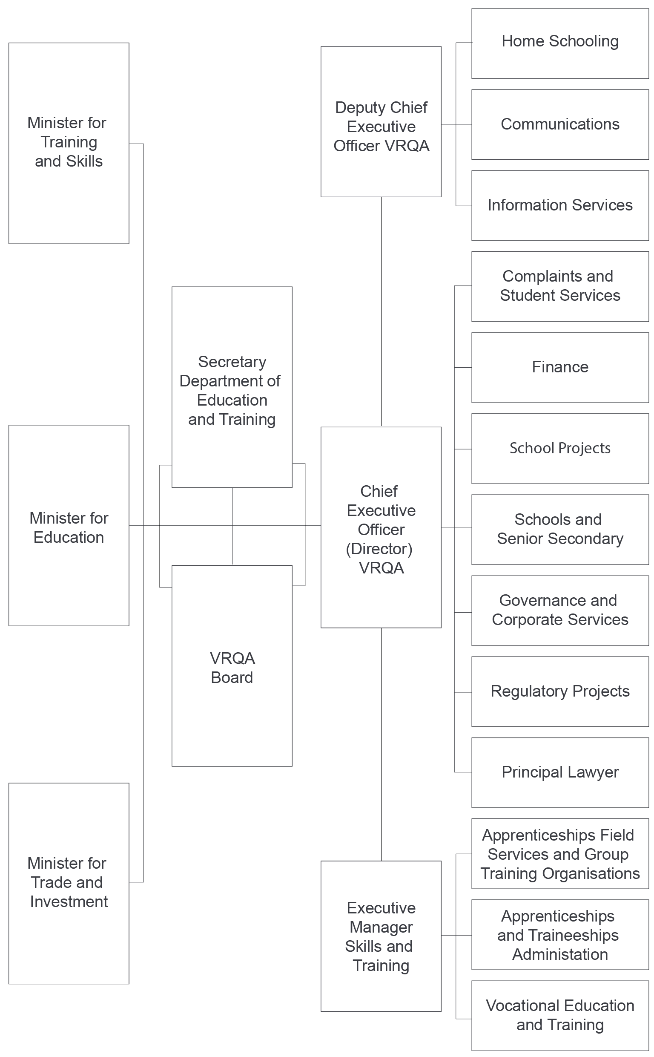

Report of operations—workforce data

The VRQA operates within the financial, asset, human resource and information technology policy frameworks of DET.

Public administration values and employment principles

The VRQA applies the employment principles issued by the Victorian Public Sector Commission (VSPC), which set out the essential requirements for managers to apply the public sector values and employment principles under the *Public Administration Act 2004*.

The employment principles stipulate that:

* employment decisions are based on merit
* public sector employees are treated fairly and reasonably
* equal employment opportunity is provided
* public sector employees have a reasonable avenue of redress against unfair or unreasonable treatment
* a career in the public service is fostered (in the case of public service bodies).

The VRQA’s human resources policies go beyond the minimum requirements set by these principles and reflect best practice, consistent with the VSPC’s non-binding guidelines.

The VRQA is committed to developing and supporting its workforce by:

* building leadership capacity
* building a future workforce by enhancing workforce capacity
* actively shaping supply and managing employee relations
* creating and supporting a culture of health, safety and wellbeing
* creating and supporting a performance and development culture
* implementing robust human resource management systems.

Occupational health and safety

The VRQA operates within DET infrastructure and abides by DET occupational health and safety policies and procedures (see the *Department of Education and Training Annual Report 2017–18* for more information).

Comparative workforce data

**Table 21—Full-time equivalent (FTE) staffing trends 2014–18** (a) (b)

|  |  |  |  |  |
| --- | --- | --- | --- | --- |
| 2018 | 2017 | 2016 | 2015 | 2014 |
| 59.2 | 55.0 | 59.7 | 51.7 | 55.5 |

**Table 22—Summary of employment levels in June of 2017 and 2018** (c) (d)

|  |  |  |  |  |  |
| --- | --- | --- | --- | --- | --- |
|  | Ongoing employees (headcount) | | | | Fixed-term and casual employees |
| Employees | Full-time | Part-time | FTE | FTE |
| June 2018 | 64 | 49 | 11 | 56.8 | 2.4 |
| June 2017 | 59 | 43 | 9 | 49.3 | 5.7 |

Notes:

Figures are for staff on pay during the last full pay period in June of each year and exclude those on leave without pay or absent on secondment, external contractors and consultants, temporary staff employed by employment agencies, and a small number of people who are not employees but appointees of a statutory office as defined in the *Public Administration Act 2004.*

Victorian Public Service comprises Executive Officers, VPSG-classified staff, Allied Health staff, Nurses, Senior Medical Advisors and Ministerial Transport Officers.

Figures are for staff on pay during the last full pay period in June of each year and exclude those on leave without pay or absent on secondment, external contractors and consultants, temporary staff employed by employment agencies, and a small number of people who are not employees but appointees of a statutory office as defined in the *Public Administration Act 2004.*

Victorian Public Service comprises Executive Officers, VPSG-classified staff, Allied Health staff, Nurses, Senior Medical Advisors and Ministerial Transport Officers.

**Table 23—VRQA Victorian Public Service staff employment levels, June 201****7 and 2018** (a) (b) (c) (d)

| VRQA | | June 2018 | | | | | | | June 2017 | | | | | | |
| --- | --- | --- | --- | --- | --- | --- | --- | --- | --- | --- | --- | --- | --- | --- | --- |
|  |  | All employees | | Ongoing | | | Fixed term and casual employees | | All employees | | Ongoing | | | Fixed term and casual employees | |
|  |  | Headcount (e) | FTE | Full-time (headcount) | Part-time (headcount) | FTE | Headcount | FTE | Headcount | FTE | Full-time (headcount) | Part-time (headcount) | FTE | Headcount | FTE |
| Demographic data | **Gender** |  |  |  |  |  |  |  |  |  |  |  |  |  |  |
| Male | 25 | 23.7 | 21 | 2 | 22.3 | 2 | 1.4 | 21 | 20.3 | 18 | 1 | 18.8 | 2 | 1.5 |
| Female | 39 | 35.5 | 28 | 9 | 34.5 | 2 | 1.0 | 38 | 34.6 | 25 | 8 | 30.5 | 5 | 4.1 |
| Self described | – | – | – | – | – | – | – | – | – | – | – | – | – | – |
| **Age** |  |  |  |  |  |  |  |  |  |  |  |  |  |  |
| Under 25 | 1 | 1.0 | – | – | – | 1 | 1.0 | – | – | – | – | – | – | – |
| 25–34 | 4 | 4.0 | 4 | – | 4.0 | – | – | 4 | 4.0 | 3 | – | 3.0 | 1 | 1.0 |
| 35–44 | 18 | 17.0 | 14 | 4 | 17.0 | – | – | 17 | 15.5 | 11 | 4 | 13.6 | 2 | 1.9 |
| 45–54 | 17 | 16.2 | 14 | 3 | 16.2 | – | – | 12 | 11.6 | 9 | 2 | 10.6 | 1 | 1.0 |
| 55–64 | 18 | 16.1 | 13 | 3 | 15.1 | 2 | 1.0 | 22 | 20.9 | 18 | 2 | 19.6 | 2 | 1.3 |
| Over 64 | 6 | 4.9 | 4 | 1 | 4.5 | 1 | 0.4 | 4 | 3.0 | 2 | 1 | 2.5 | 1 | 0.5 |
|  | **VPSG1–6** | **62** | **57.2** | **47** | **11** | **54.8** | **4** | **2.4** | **57** | **53.0** | **41** | **9** | **47.3** | **7** | **5.7** |
| Classification data | VPSG1 | – | – | – | – | – | – | – | – | – | – | – | – | – | – |
| VPSG2 | 9 | 8.3 | 6 | 2 | 7.4 | 1 | 0.9 | 9 | 8.4 | 7 | 2 | 8.4 | – | – |
| VPSG3 | 8 | 7.4 | 7 | – | 7.0 | 1 | 0.4 | 8 | 7.5 | 6 | – | 6.0 | 2 | 1.5 |
| VPSG4 | 12 | 12.0 | 11 | – | 11.0 | 1 | 1.0 | 10 | 9.7 | 8 | – | 8.0 | 2 | 1.7 |
| VPSG5 | 21 | 18.6 | 15 | 5 | 18.5 | 1 | 0.1 | 20 | 18.1 | 13 | 4 | 15.7 | 3 | 2.5 |
| VPSG6 | 12 | 10.9 | 8 | 4 | 10.9 | – | – | 10 | 9.2 | 7 | 3 | 9.2 | – | – |
|  |  |  |  |  |  |  |  |  |  |  |  |  |  |  |
|  | **Senior Employees** | 2 | 2.0 | 2 | – | 2.0 | – | – | 2 | 2.0 | 2 | – | 2.0 | – | – |
| STS | – | – | – | – | – | – | – | – | – | – | – | – | – | – |
| Executive Officers | 2 | 2.0 | 2 | – | 2.0 | – | – | 2 | 2.0 | 2 | – | 2.0 | – | – |
| Allied Health | – | – | – | – | – | – | – | – | – | – | – | – | – | – |
| Nurse | – | – | – | – | – | – | – | – | – | – | – | – | – | – |
| Other | – | – | – | – | – | – | – | – | – | – | – | – | – | – |
| **Total employees** | **64** | **59.2** | **49** | **11** | **56.8** | **4** | **2.4** | **59** | **55.0** | **43** | **9** | **49.3** | **7** | **5.7** |

Notes:

(a) Figures are for staff on pay during the last full pay period in June of each year and exclude those on leave without pay or absent on secondment, external contractors and consultants, temporary staff employed by employment agencies, and a small number of people who are not employees but appointees of a statutory office as defined in the *Public Administration Act 2004.*

(b) Victorian Public Service comprises Executive Officers, VPSG-classified, Allied Health staff, Nurses, Senior Medical Advisors and Ministerial Transport Officers.

(c) ‘Casual’ means a person who is subject to clause 25, Casual Employees—loading of the VPS Agreement 2006, or similar clauses in other relevant agreements. It includes a person employed on a seasonal basis where such provision is made under an applicable industrial agreement.

(d) ‘Age’ of staff calculated as at 30 June each year.

(e) ‘Headcount’ refers to the number of people employed where each person counts as an employee regardless of the number of hours engaged to work.

Executive officers

**Table 24—Number of executive officers classified in ‘ongoing’ and ‘special projects’**

|  |  |  |  |  |  |  |
| --- | --- | --- | --- | --- | --- | --- |
|  | All | | Ongoing | | Special projects | |
| Class | Number | Variance | Number | Variance | Number | Variance |
| EO-1 |  |  |  |  |  |  |
| EO-2 | 1 |  | 1 |  |  |  |
| EO-3 | 1 |  | 1 |  |  |  |
| **Total** | **2** |  | **2** |  |  |  |

**Table 25—Gender breakdown of executive officers in ‘ongoing’ and ‘special projects’**

|  |  |  |  |  |  |  |  |  |  |  |
| --- | --- | --- | --- | --- | --- | --- | --- | --- | --- | --- |
|  | Ongoing | | | | | Special projects | | | | |
|  | Male | | Female | | Vacancies | Male | | Female | | Vacancies |
| Class | No. | Var. | No. | Var. | Number | No. | Var. | No. | Var. | Number |
| EO-1 |  |  |  |  |  |  |  |  |  |  |
| EO-2 |  |  | 1 |  |  |  |  |  |  |  |
| EO-3 | 1 |  |  |  |  |  |  |  |  |  |
| **Total** | **1** |  | **1** |  |  |  |  |  |  |  |

**Table 26—Reconciliation of executive officer numbers**

|  |  |  |  |
| --- | --- | --- | --- |
|  |  | 2018 | 2017 |
|  | Executives with total remuneration over $100,000 (see Note 8.2.1) | 2 | 2 |
| Add | Vacancies | 1 | 1 |
|  | Executives employed with total remuneration less than $100,000 |  |  |
|  | Accountable Officer (Director, included above) |  |  |
| Less | Separations |  |  |
| Less | Portfolio entity executives |  |  |
|  | **Total executive numbers at 30 June** | **3** | **3** |

Report of operations—other disclosures

Victorian Industry Participation Policy

There were no contracts related to the Victorian Industry Participation Policy. Details of contracts that have been disclosed can be viewed at [www.contracts.vic.gov.au](http://www.contracts.vic.gov.au)

Major consultancies and contracts

There were no major consultancies over $10,000 for the period 1 July 2017–30 June 2018. The VRQA did not engage any consultancies costing less than $10,000 each during

2017–18.

Freedom of information

The *Freedom of Information Act 1982* (FOI Act) allows the public a right of access to documents held by the VRQA.

For the 12 months ended 30 June 2018, the VRQA received nine new freedom of information (FOI) applications with three matters carried over from 2016–17.

Of the 2017–18 new requests, all were from community members and none from media. Of the requests:

* one was withdrawn
* four were deemed not to be valid
* two were provided in full
* two were provided in part.

Of the matters carried over from 2016–17:

* one was released in part
* one had no documents discovered
* one applicant requested a review by the FOI Commissioner. The FOI Commissioner decided that the applicant be provided the document. The VRQA provided the redacted document to the applicant.

The information required to be published pursuant to section 7 of the FOI Act is contained elsewhere in this report or at [www.vrqa.vic.gov.au](http://www.vrqa.vic.gov.au)

Making a request

Access to documents may be obtained through written request to the relevant FOI officer as detailed in section 17 of the FOI Act.

In summary, FOI requests should:

* be in writing
* identify as clearly as possible which document is being requested
* be accompanied by the appropriate application fee (that may be waived in certain circumstances).

Requests for documents in the possession of the VRQA should be addressed to:

Freedom of Information OfficerVictorian Registration and Qualifications Authority  
GPO Box 2317  
Melbourne Vic 3001

Email: vrqa@edumail.vic.gov.au  
Telephone: (03) 9032 1554

Access charges may also apply once documents have been processed and a decision on access is made; for example, photocopying and search and retrieval charges.

Further information regarding freedom of information can be found at www.foi.vic.gov.au

Compliance with the *Building Act 1993*

The VRQA operates within DET infrastructure and abides by DET infrastructure policies and procedures (see the *Department of Education and Training Annual Report 2016–17* for more information).

National Competition Policy

The review of fees and charges indicated that the VRQA did not add any restrictions on competition between providers of accredited courses.

Compliance with the *Protected Disclosure Act 2012*

The *Protected Disclosure Act 2012* encourages and facilitates people making disclosures of:

* improper conduct by public officers and public bodies
* any detrimental action taken in reprisal for a person making a disclosure.

The Act also provides for the confidentiality of the content of those disclosures and the identity of the people making the disclosures.

Under the Act, disclosures made to the VRQA about improper or corrupt conduct are no longer protected.

To be protected, a disclosure must be made to the Independent Broad-based Anti-corruption Commission (IBAC).

The VRQA Board does not tolerate improper conduct by employees or reprisals against those who disclose such conduct. It is committed to ensuring transparency and accountability in its administrative and management practices and supports the making of disclosures that reveal corrupt conduct, conduct involving a substantial mismanagement of public resources, or conduct involving a substantial risk to public health and safety or the environment.

The VRQA Board will take all reasonable steps to protect people who make such disclosures from any detrimental action in reprisal for making the disclosure. It will also afford natural justice to the person who is the subject of the disclosure to the extent it is legally possible.

Making disclosures

For the disclosure to be protected pursuant to Sections 13 and 16 of the Act, disclosures of improper or corrupt conduct by the VRQA Board or its employees must be made directly to the Independent Broad-based Anti-corruption Commission or to the Victorian Ombudsman.

Independent Broad-based Anti-corruption Commission  
GPO Box 24234  
Melbourne Vic 3001

Toll-free telephone: 1300 735 135  
Website: www.ibac.vic.gov.au

Victorian Ombudsman  
Level 1, North Tower  
459 Collins Street  
Melbourne Vic 3000

Telephone: (03) 9613 6222  
Toll-free: 1800 806 314

Email: ombudvic@ombudsman.vic.gov.au  
Website: www.ombudsman.vic.gov.au

Disclosures of detrimental action taken in reprisal for making a protected disclosure by the VRQA Board or its employees may be made to:

The Protected Disclosure Coordinator  
Victorian Registration and Qualifications Authority  
GPO Box 2317  
Melbourne Vic 3001

Procedures under the *Protected Disclosure Act 1982*

The procedures for the protection of people from detrimental action in reprisal for making a protected disclosure are available upon request.

The VRQA Board did not receive disclosures of detrimental action taken in reprisal for the making of a protected disclosure in 2017–18.

Compliance with the *Carers Recognition Act 2012*

The VRQA operates within DET infrastructure and abides by DET human resources policies and procedures (see the *Department of Education and Training Annual Report 2017–18* for more information).

Office-based environmental impacts

The VRQA operates within DET infrastructure and abides by the DET Environmental Management System (see the *Department of Education and Training Annual Report 2017–18* for more information).

Fees and charges

Section 5.2.13 of the Education and Training Reform Act 200*6*enables ministers to fix fees and charges. Ministerial Order No. 957 held VET fees at 2014 levels.

All other fees were increased on 1 January 2018. Details of fees and charges are available on the VRQA website.

Additional information available on request

In compliance with the requirements of the Standing Directions of the Minister for Finance, details in respect of the items listed below have been retained by the VRQA and are available on request, subject to the provisions of the FOI Act:

* a statement that declarations of pecuniary interests have been duly completed by all relevant officers
* details of shares held by a senior officer as nominee or held beneficially in a statutory authority or subsidiary
* details of publications produced by the entity about the entity, and how these can be obtained
* details of changes in prices, fees, charges, rates and levies charged by the VRQA
* details of any major external reviews carried out on the VRQA
* details of major research and development activities undertaken by the VRQA
* details of overseas visits undertaken including a summary of the objectives and outcomes of each visit
* details of major promotional, public relations and marketing activities undertaken by the VRQA to develop community awareness of VRQA and its services
* details of assessments and measures undertaken to improve the occupational health and safety of employees
* a general statement on industrial relations within the VRQA and details of time lost through industrial accidents or disputes
* a list of major committees sponsored by the VRQA, the purposes of each committee and the extent to which the purposes have been achieved
* details of all consultancies and contractors including:
* consultants/contractors engaged
* services provided
* expenditure committed for each engagement.

This information is available on request from:

Manager, Governance and Corporate ServicesVRQA  
GPO Box 2317

Melbourne Vic 3001

Telephone: (03) 9032 1532

Compliance with DataVic Access Policy

Consistent with the DataVic Access Policy issued by the Victorian Government in 2012, information included in this annual report will be available at [DataVic](http://www.data.vic.gov.au) in machine-readable format.

The VRQA contributes to data sets published by DET to DataVic.

Attestation for financial management compliance with Ministerial Standing Direction 5.1.4

**Victorian Registration and Qualifications Authority Financial Management Compliance Attestation Statement**

I, Michonne van Rees, on behalf of the Responsible Body, certify that the Victorian Registration and Qualifications Authority has complied with the applicable Standing Directions of the Minister for Finance under the *Financial Management Act 1994* and Instructions.

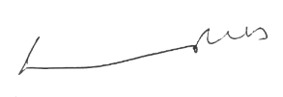

Michonne van Rees  
Board Member  
Victorian Registration and Qualifications Authority

27 August 2018

Financial statements

Accountable Officers’ and Chief Finance Officer’s declaration

The attached financial statements for the Victorian Registration and Qualifications Authority have been prepared in accordance with Standing Directions 5.2 of the *Financial Management Act 1994*, applicable Financial Reporting Directions, Australian Accounting Standards including interpretations and other mandatory professional reporting requirements.

We further state that, in our opinion, the information set out in the comprehensive operating statement, balance sheet, statement of changes in equity, cash flow statement and accompanying notes, presents fairly the financial transactions during the year ended 30 June 2018 and financial position of the Victorian Registration and Qualifications Authority at 30 June 2018.

At the time of signing, we are not aware of any circumstance which would render any particulars included in the financial statements to be misleading or inaccurate.

We authorise the attached financial statements for issue on 27 August 2018.



Michonne van Rees  
Board Member  
Victorian Registration and Qualifications Authority

Melbourne  
27 August 2018

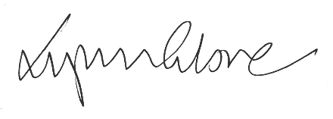

**Lynn Glover   
Chief Executive Officer (Director)  
Victorian Registration and Qualifications Authority**

Melbourne  
27 August 2018

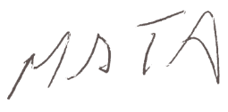

**Matthew Tibb  
Chief Finance Officer  
Victorian Registration and Qualifications Authority**

Melbourne  
27 August 2018

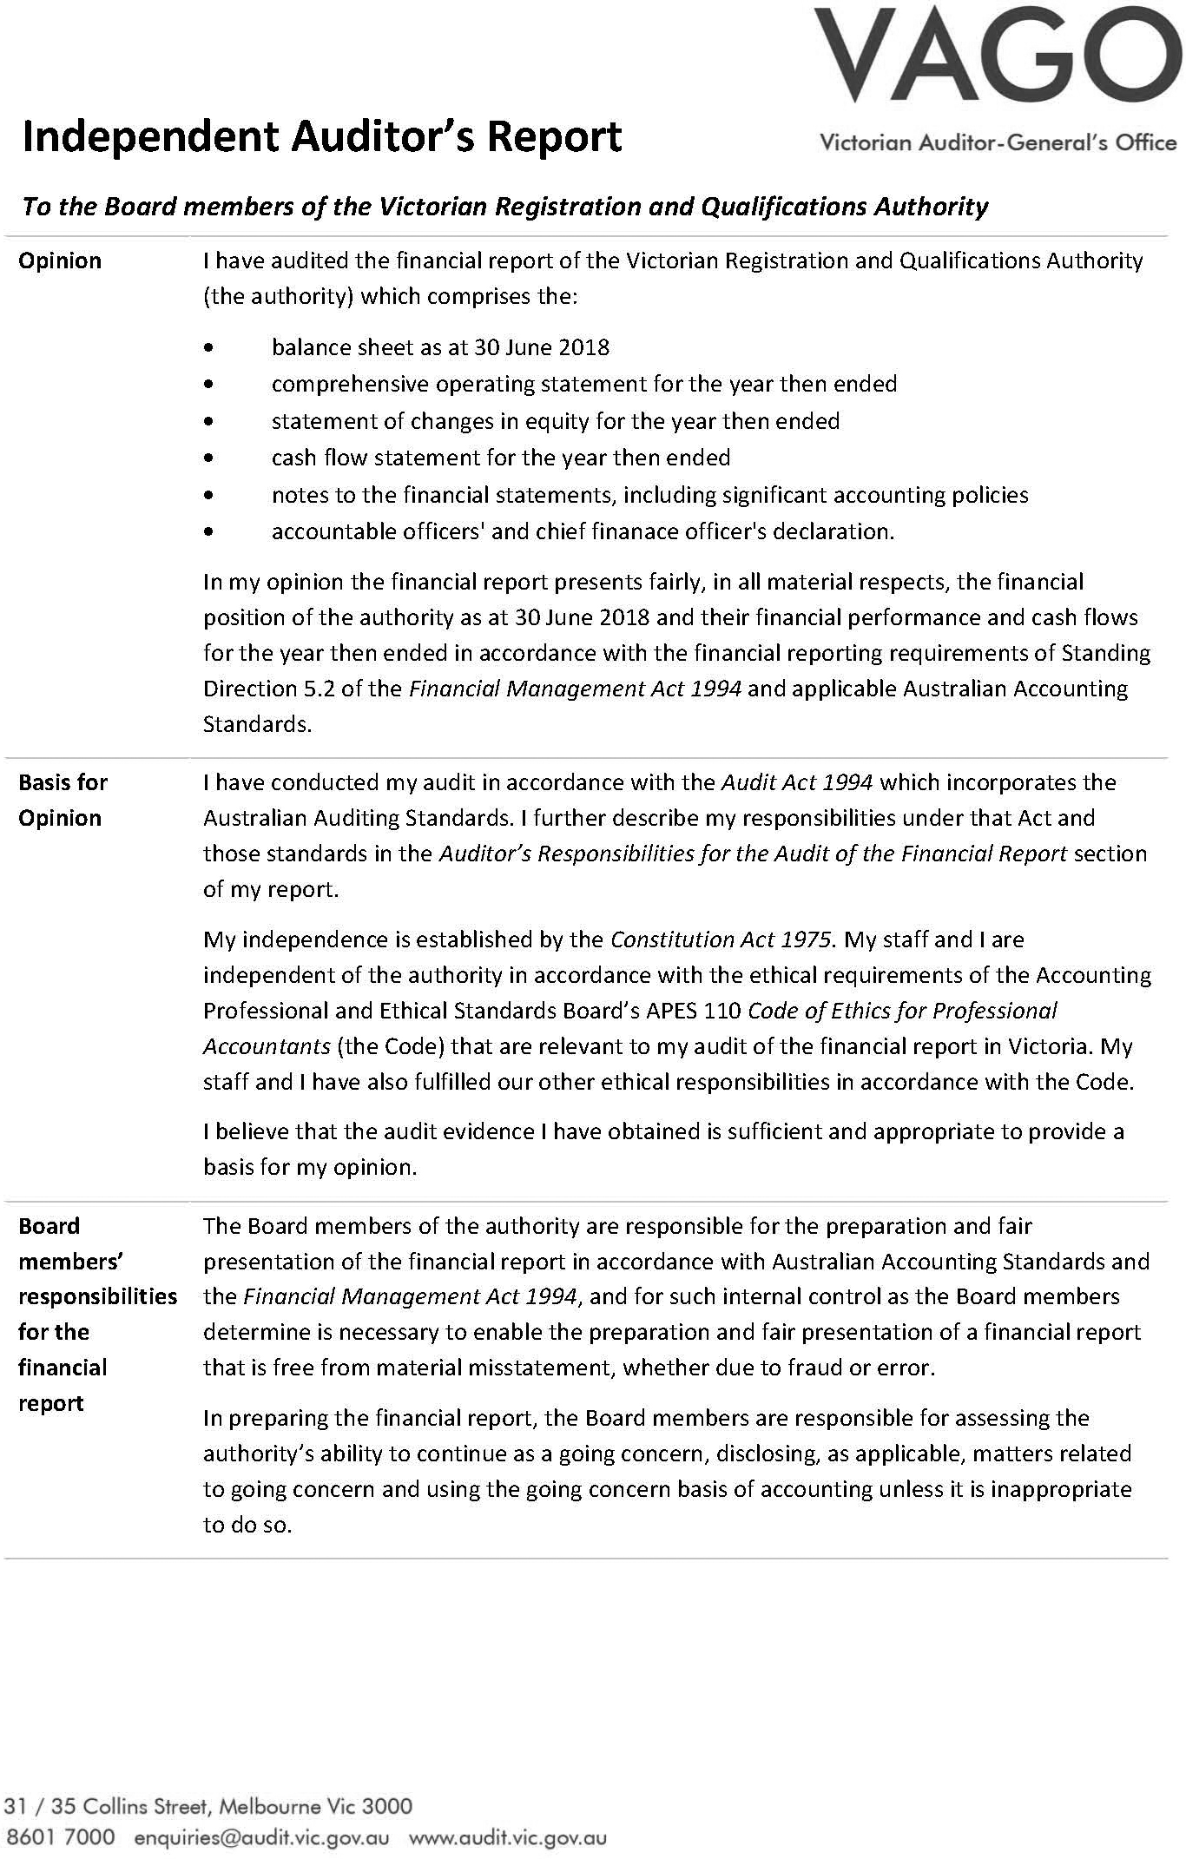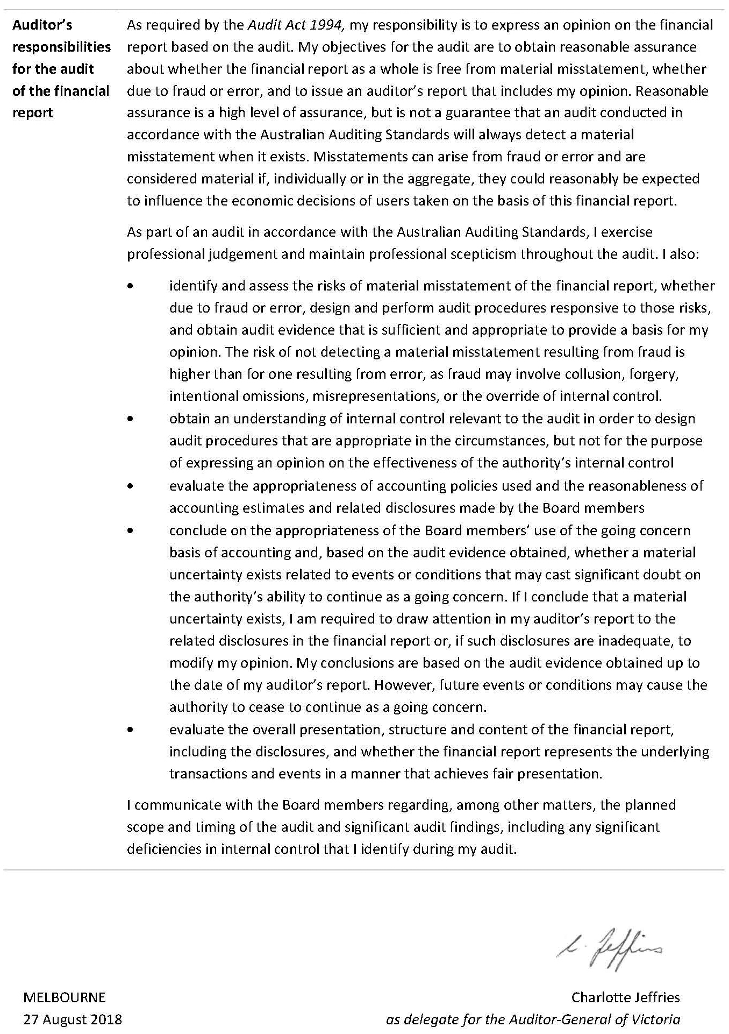

Comprehensive operating statement for the financial year ended 30 June 2018

|  |  |  |  |
| --- | --- | --- | --- |
|  | Notes | 2018 $ | 2017 $ |
| **Continuing operations** |  |  |  |
| **Income from transactions** |  |  |  |
| Grants | 2.1 | 11,168,586 | 10,767,798 |
| Registration and accreditation fees | 2.1 | 1,214,175 | 1,400,142 |
| Fair value of assets and services received free of charge or for nominal consideration | 2.1 | 515,298 | 560,849 |
| Interest | 2.1 | 172,759 | 204,130 |
| Other income | 2.1 | 195 | 150 |
| **Total income from transactions** |  | **13,071,013** | **12,933,069** |
| **Expenses from transactions** |  |  |  |
| Administrative expenses | 3.1 | 7,105,372 | 7,031,442 |
| Amortisation | 4.1 | 526,724 | 263,836 |
| Grants and other transfers | 3.1 | 9,064 | 8,500 |
| Contractors | 3.1 | 4,967,461 | 3,970,821 |
| Supplies and services | 3.1 | 1,446,433 | 1,503,181 |
| **Total expenses from transactions** |  | **14,055,054** | **12,777,780** |
| **Net result from transactions** |  | **(984,041)** | **155,289** |
| **Comprehensive result** |  | **(984,041)** | **155,289** |

Notes: The accompanying notes form part of these financial statements.

|  |  |  |  |
| --- | --- | --- | --- |
|  | Notes | 2018 $ | 2017 $ |
| **Assets** |  |  |  |
| **Financial assets** |  |  |  |
| Cash and deposits | 6.1 | 7,978,481 | 9,369,734 |
| Receivables | 5.1 | 86,174 | 148,094 |
| **Total financial assets** | **-** | **8,064,655** | **9,517,928** |
| **Non‑financial assets** |  |  |  |
| Intangible assets | 4.1 | 3,789,178 | 3,522,830 |
| **Total non‑financial assets** | **-** | **3,789,178** | **3,522,830** |
| **Total assets** | **-** | **11,853,833** | **13,040,658** |
| **Liabilities** |  |  |  |
| Payables | 5.2 | 1,360,855 | 1,563,639 |
| **Total liabilities** | **-** | **1,360,855** | **1,563,639** |
| **Net assets** | **-** | **10,492,978** | **11,477,019** |
| **Equity** |  |  |  |
| Accumulated surplus | - | 9,080,359 | 10,064,400 |
| Contributed capital | - | 1,412,619 | 1,412,619 |
| **Net worth** | **-** | **10,492,978** | **11,477,019** |

Balance sheet as at 30 June 2018

Notes: The accompanying notes form part of these financial statements.

Statement of changes in equity for the financial year ended 30 June 2018

|  |  |  |  |
| --- | --- | --- | --- |
|  | Contributed capital $ | Accumulated surplus $ | Total $ |
| **Balance at 1 July 2016** | **1,412,619** | **9,909,111** | **11,321,730** |
| Net result for the year | - | 155,289 | 155,289 |
| **Balance at 30 June 2017** | **1,412,619** | **10,064,400** | **11,477,019** |
| Net result for the year | - | (984,041) | (984,041) |
| **Balance at 30 June 2018** | **1,412,619** | **9,080,359** | **10,492,978** |

Notes: The accompanying notes form part of these financial statements.

Cash flow statement for the financial year ended  
30 June 2018

|  | Notes | 2018 $ | 2017 $ |
| --- | --- | --- | --- |
| **Cash flows from operating activities** |  |  |  |
| **Receipts** |  |  |  |
| Receipts from government |  | 11,168,586 | 10,803,798 |
| Receipts from other entities |  | 1,309,980 | 1,348,317 |
| Interest received |  | 172,759 | 204,130 |
| Goods and services tax recovered from the ATO (a) |  | 611,361 | 602,496 |
| **Total receipts** |  | **13,262,686** | **12,958,741** |
| **Payments** |  |  |  |
| Payments of grant expenses |  | (9,064) | (8,500) |
| Payments to suppliers and employees |  | (13,851,803) | (12,676,298) |
| **Total payments** |  | **(13,860,867)** | **(12,684,798)** |
| **Net cash flows from/(used in) operating activities** | 6 | (598,181) | 273,943 |
| **Cash flows from investing activities** |  |  |  |
| Purchases for non-financial assets |  | (793,072) | (2,103,699) |
| **Net cash flows from/(used in) investing activities** |  | **(793,072)** | **(2,103,699)** |
| **Net increase/(decrease) in cash and cash equivalents** |  | **(1,391,253)** | **(1,829,756)** |
| Cash and cash equivalents at the beginning of the financial year |  | 9,369,734 | 11,199,489 |
| **Cash and cash equivalents at the end of the financial year** |  | **7,978,481** | **9,369,734** |

The accompanying notes form part of these financial statements.

Notes: (a) GST recovered from the Australian Taxation Office is presented on a net basis.

Notes to the financial statements

|  |  |  |
| --- | --- | --- |
| Note 1. | About this report | 51 |
| Note 2. | Funding delivery of services | 52 |
| Note 3. | Cost of delivering services | 54 |
| Note 4. | Key assets available to support output delivery | 56 |
| Note 5. | Other assets and liabilities | 59 |
| Note 6. | Financing our operations | 61 |
| Note 7. | Risks, contingencies, commitments, and valuation judgements | 61 |
| Note 8. | Other disclosures | 67 |

Note 1. About this report

The VRQA is a state owned public authority established under the *Education and Training Reform Act 2006*. As an independent public authority, the VRQA is a separate legal entity and accountable for resources under its control. Section 4.2.8 of the Act requires the VRQA to maintain a fund to account for all money received and paid by the VRQA. Its principal address is:

Victorian Registration and Qualifications Authority

Level 4, Casselden, 2 Lonsdale Street

Melbourne Vic 3000

Basis of preparation

These financial statements are in Australian dollars and the historical cost convention is used unless a different measurement basis is specifically disclosed in the note associated with the item measured on a different basis.

The accrual basis of accounting has been applied in preparing these financial statements, whereby assets, liabilities, equity, income and expenses are recognised in the reporting period to which they relate, regardless of when cash is received or paid.

Consistent with the requirements of AASB 1004 *Contributions*, contributions by owners (that is, contributed capital and its repayment) are treated as equity transactions and, therefore, do not form part of the income and expenses of the VRQA.

Additions to net assets which have been designated as contributions by owners are recognised as contributed capital. Other transfers that are in the nature of contributions to, or distributions by, owners have also been designated as contributions by owners.

Transfers of net assets arising from administrative restructurings are treated as distributions to, or contributions by, owners. Transfers of net liabilities arising from administrative restructurings are treated as distributions to owners.

Judgements, estimates and assumptions are required to be made about financial information being presented. The significant judgements made in the preparation of these financial statements are disclosed in the notes where amounts affected by those judgements are disclosed. Estimates and associated assumptions are based on professional judgements derived from historical experience and various other factors that are believed to be reasonable under the circumstances. Actual results may differ from these estimates.

Revisions to accounting estimates are recognised in the period in which the estimate is revised and also in future periods that are affected by the revision. Judgements and assumptions made by management in applying Australian Accounting Standards (AAS) that have significant effects on the financial statements and estimates are disclosed in the notes under the heading: ‘Significant judgement or estimates’.

All amounts in the financial statements are presented in Australian dollars unless otherwise stated.

Compliance information

These general-purpose financial statements have been prepared in accordance with the Financial Management Act (FMA) and applicable AAS which include interpretations, issued by the Australian Accounting Standards Board (AASB). In particular, they are presented in a manner consistent with the requirements of AASB 1049 *Whole of Government and General Government Sector Financial Reporting*.

Where appropriate, those AASs paragraphs applicable to not-for-profit entities have been applied.

Accounting policies selected and applied in these financial statements ensure that the resulting financial information satisfies the concepts of relevance and reliability, thereby ensuring that the substance of the underlying transactions or other events is reported.

Note 2. Funding delivery of services

The VRQA’s objectives are to ensure:

* high standards of education and training of Victorian registered providers
* information concerning the performance of education and training providers is publicly available
* decisions of the VRQA have regard to the interests of students and the public
* regulatory processes are procedurally fair.

Economic dependence

To enable the VRQA to fulfil its objectives, it receives income from DET in the form of grant funding, upon which it is economically dependent. The VRQA holds a letter of financial support from the Secretary, DET. The VRQA also charges fees for registration of providers of education and training and accreditation of courses under the *Education and Training Reform Act 2006*. These fees and charges are set by Ministerial Order.

2.1 Summary of income that funds the delivery of our services

|  |  |  |  |  |  |
| --- | --- | --- | --- | --- | --- |
|  | **Notes** | | **2018 $** | **2017 $** | |
| Interest | 2.2.1 | | 172,759 | 204,130 | |
| Registration and accreditation fees | 2.2.2 | | 1,214,175 | 1,400,142 | |
| Grants | 2.2.3 | | 11,168,586 | 10,767,798 | |
| Fair value of assets and services received free of charge or for nominal consideration | 2.2.4 | | 515,298 | 560,849 | |
| Other income |  | | 195 | 150 | |
| **Total income from transactions** |  | | **13,071,013** | **12,933,069** | |
| Notes:  Income is recognised to the extent it is probable the economic benefits will flow to the entity and the income can be reliably measured at fair value. Where applicable, amounts disclosed as income are net of returns, allowances, duties and taxes. | | | | | |
| 2.2 Income from transactions | | | | | |
| 2.2.1 Interest income | | | | | |
|  | | **2018 $** | | | **2017 $** |
| **Interest from financial assets not at fair value through profit and loss** | |  | | |  |
| Interest on bank deposits | | 172,759 | | | 204,130 |
| **Total interest** | | **172,759** | | | **204,130** |

Notes:

Interest income includes interest received on bank term deposits and other investments. Interest income is recognised using the effective interest method, which allocates the interest over the relevant period.

|  |  |  |  |
| --- | --- | --- | --- |
| 2.2.2 Registration and accreditation fees | | | |
|  | **2018 $** | **2017 $** | |
| Registration and accreditation fees | 1,214,175 | 1,260,263 | |
| Supply of services | - | 139,879 | |
| **Total registration and  accreditation fees** | **1,214,175** | **1,400,142** | |
| Income from registration and accreditation fees is recognised when:   * the amount of income, and the costs incurred or to be incurred in respect of the transactions, can be reliably measured, and * it is probable that the economic benefits associated with the transaction will flow to the VRQA.   Income from the **supply of services** is recognised by reference to the stage of completion of the services being performed. The income is recognised when:   * the amount of the income, stage of completion and transaction costs incurred can be reliably measured, and * it is probable that the economic benefits associated with the transaction will flow to the VRQA.   Under this method, income is recognised by reference to labour hours supplied, or to labour hours supplied as a percentage of total services to be performed, in each annual reporting period. | | | |
| 2.2.3 Grants | | | |
|  | **2018 $** | | **2017 $** |
| General purpose | 11,168,586 | | 10,767,798 |
| **Total grants** | **11,168,586** | | **10,767,798** |
| **Grant income** arises from transactions in which a party provides goods or assets (or extinguishes a liability) to the VRQA without receiving approximately equal value in return.  While grants may result in the provision of some goods or services to the transferring party, they do not provide a claim to receive benefits directly of approximately equal value (and are termed ‘non-reciprocal’ transfers). Receipt and sacrifice of approximately equal value may occur, but only by coincidence. For non-reciprocal grants, the VRQA recognises revenue when the grant is receivable or received.  Grants can be received as **general-purpose grants**, which refers to grants which are not subject to conditions regarding their use. Alternatively, they may be received as **specific purpose grants**, which are paid for a particular purpose and/or have conditions attached regarding their use.  Some grants are **reciprocal** in nature (i.e. equal value is given back by the recipient of the grant to the provider). The VRQA recognises income when it has satisfied its performance obligations under the terms of the grant. | | | | |

|  |  |  |  |
| --- | --- | --- | --- |
| 2.2.4 Fair value of assets and services received free of charge or for nominal consideration | | | |
|  |  | **2018**  **$** | **2017**  **$** |
| Accommodation for Level 4, Casselden, 2 Lonsdale Street, Melbourne (a) | | 515,298 | 560,849 |
| **Total Fair value of assets and services received free of charge or for nominal consideration** | | **515,298** | **560,849** |
| Notes:  (a) The VRQA shares accommodation with DET, the cost of which is not charged to the VRQA. The amounts are recognised in the operating statement as an expense and offset to income as resources received free of charge. | | | |

Contributions of resources received free of charge or for nominal consideration are recognised at fair value when control is obtained over them, irrespective of whether these contributions are subject to restrictions or conditions over their use.

Contributions in the form of services are only recognised when a fair value can be reliably determined and the services would have been purchased if not received as a donation.

Note 3. The cost of delivering services

This section provides an account of the expenses incurred by the VRQA in delivering services and outputs. In Section 2, the funds that enable the provision of services were disclosed and in this note the cost associated with provision of services are recorded.

|  |  |  |  |
| --- | --- | --- | --- |
| 3.1 Expenses incurred in delivery of services | | | |
|  | **Notes** | **2018**  **$** | **2017**  **$** |
| Administrative expenses | 3.1.1 | 7,105,372 | 7,031,442 |
| Grants and other transfers | 3.1.2 | 9,064 | 8,500 |
| Contractors | 3.1.3 | 4,967,461 | 3,970,821 |
| Other operating expenses | 3.1.4 | 1,446,433 | 1,503,181 |
| **Total expenses incurred in delivery of services** |  | **13,528,330** | **12,513,944** |
| Expenses from transactions are recognised as they are incurred and reported in the financial year to which they relate. | | | |

|  |  |  |  |  |  |  |  |  |  |  |
| --- | --- | --- | --- | --- | --- | --- | --- | --- | --- | --- |
| 3.1.1 Administrative expenses | | | | | | | | | | |
|  | |  | | | **2018**  **$** | | | **2017**  **$** | | |
| Employee benefits for VRQA staff employed by DET | |  | | | 7,105,372 | | | 7,031,442 | | |
| **Total administrative expenses** | |  | | | **7,105,372** | | | **7,031,442** | | |
| Administrative expenses relate to employee benefits for VRQA staff who are employees of DET. The VRQA reimburses DET for all employee entitlements including wages and salaries, superannuation employer contributions, fringe benefits tax, leave entitlements, termination payments and WorkCover premiums. The costs are classified as administrative expenses in the comprehensive operating statement. | | | | | | | | | | |
| 3.1.2 Grant and other transfers | | | | | | | | | | | |
|  | | |  | | | **2018**  **$** | | **2017**  **$** | | | |
| General purpose grants to schools | |  | | | - | | | 3,500 | | | |
| General purpose grants to VCAA | |  | | | - | | | 5,000 | | | |
| General purpose grants to individuals | |  | | | 9,064 | | | - | | | |
| **Total grants and other expenses** | |  | | | **9,064** | | | **8,500** | | | |
| Grant expenses are contributions of the VRQA’s resources to another party for specific or general purposes where there is no expectation that the amount will be repaid in equal value (either by money, goods or services).  Grants can either be operating or capital in nature. Grants can be paid as general-purpose grants, which refer to grants that are not subject to conditions regarding their use. Alternatively, they may be paid as specific purpose grants which are paid for a particular purpose and/or have conditions attached regarding their use.  Grant expenses are recognised in the reporting period in which they are paid or payable. Grants can take the form of money, assets, goods, services or forgiveness of liabilities. | | | | | | | | | | | |
| 3.1.3 Contractors | | | | | | | | |
|  |  | | | **2018**  **$** | | | **2017**  **$** | | |
| Contractors |  | | | 4,357,829 | | | 3,970,821 | | |
| Impairment of work in progress - intangible assets |  | | | 609,632 | | | - | | |
| **Total contractors** |  | | | **4,967,461** | | | **3,970,821** | | |

Contractors represent the costs incurred in normal operations. It includes the hire of temporary staff, contractors used to undertake regulatory functions, and contractors used to provide other services.

Impairment of work in progress – intangible assets represents contractor costs associated with de-commissioning an interface between the VRQA (Epsilon system currently in construction) and Commonwealth (AAMS system discontinued) Apprenticeships and Traineeship databases.

|  |  |  |  |
| --- | --- | --- | --- |
| 3.1.4 Supplies and services | | | |
|  | **Notes** | **2018**  **$** | **2017**  **$** | |
| Purchase of supplies and consumables |  | 193,299 | 241,825 | |
| Board member fees |  | 211,993 | 229,509 | |
| Travel expenses |  | 26,674 | 16,483 | |
| Printing expenses |  | 77,026 | 100,251 | |
| Phone and postage |  | 163,089 | 157,705 | |
| Legal expenses |  | 100,454 | 73,443 | |
| Insurance |  | 24,760 | 26,448 | |
| Minor equipment assets |  | 48,810 | 37,671 | |
| Accommodation expenses |  | 515,298 | 560,849 | |
| Advertising |  | 54,230 | 28,997 | |
| Audit fees | 8.4 | 30,800 | 30,000 | |
| **Total supplies and services** |  | **1,446,433** | **1,503,181** | |

**Supplies and services** are recognised as an expense in the reporting period in which they are incurred.

Note 4. Key assets available to support output delivery

The VRQA controls infrastructure and other investments that are utilised in fulfilling its objectives and conducting its activities. They represent the resources that have been entrusted to the VRQA to be utilised for delivery of those outputs.

|  |  |  |
| --- | --- | --- |
| 4.1 Intangible assets | | |
|  | **2018**  **$** | **2017**  **$** |
| At cost | 5,869,521 | 5,869,521 |
| Retirements | (5,869,521) | - |
| Additions | 1,896,206 | - |
| Work in progress | 2,419,696 | 3,522,830 |
| Less: accumulated amortisation | (526,724) | (3,258,199) |
| Less: accumulated impairment | - | (2,611,322) |
| **Total intangible assets** | **3,789,178** | **3,522,830** |

|  |  |  |  |
| --- | --- | --- | --- |
| 4.1.1 Reconciliation of movements | | | |
| **At cost** | **Notes** | **2018 $** | **2017 $** |
| **Opening balance** | (a) | 5,869,521 | 5,869,521 |
| Retirements | (a) | (5,869,521) | - |
| Additions | (b) | 1,896,206 | - |
| **Closing balance** |  | **1,896,206** | **5,869,521** |
| **Work in progress** |  |  |  |
| **Opening balance** | (b), (c) | 3,522,830 | 1,186,112 |
| Additions | (c) | 793,072 | 2,336,718 |
| Transfer to At cost | (b) | (1,896,206) | - |
| **Closing balance** |  | **2,419,696** | **3,522,830** |
| **Accumulated amortisation** |  |  |  |
| **Opening balance** | (a) | **(3,258,199)** | (2,994,363) |
| Retirements | (a) | 3,258,199 |  |
| Amortisation of intangible assets | (b) | (526,724) | (263,836) |
| **Closing balance** |  | **(526,724)** | **(3,258,199)** |
| **Accumulated impairment** |  |  |  |
| **Opening balance** | (a) | **(2,611,322)** | **(2,611,322)** |
| Retirements | (a) | 2,611,322 |  |
| **Closing balance** |  | **-** | **(2,611,322)** |
| **Net book value at year end** | (b), (c) | **3,789,178** | **3,522,830** |

|  |
| --- |
| Notes:  (a) State Register  (b) State Register – upgrade  (c) Apprenticeships and Traineeships database – Epsilon Initial recognition When the recognition criteria in AASB 138 *Intangible Assets* is met, internally generated intangible assets are recognised at cost. Subsequently, intangible assets with finite useful lives are carried at cost less accumulated amortisation and accumulated impairment losses. Amortisation begins when the asset is available for use, that is, when it is in the location and condition necessary for it to be capable of operating in the manner intended by management.  An **internally generated intangible asset** arising from development (or from the development phase of an internal project) is recognised if, and only if, all of the following are demonstrated:   1. the technical feasibility of completing the intangible asset so that it will be available for use or sale 2. an intention to complete the intangible asset and use or sell it 3. the ability to use or sell the intangible asset 4. the intangible asset will generate probable future economic benefits 5. the availability of adequate technical, financial and other resources to complete the development and to use or sell the intangible asset |

|  |
| --- |
| 1. the ability to measure reliably the expenditure attributable to the intangible asset during its development.  Subsequent measurement Intangible produced assets with finite useful lives, are amortised as an ‘expense from transactions’ on a straight line basis over their useful lives. Produced intangible assets have useful lives of between 3 and 5 years.  Intangible non-produced assets with finite lives are amortised as an ‘other economic flow’ on a straight line basis over their useful lives. The amortisation period is 3 to 5 years. |
| Impairment of intangible assets Intangible assets not yet available for use are tested annually for impairment and whenever there is an indication that the asset may be impaired. Intangible assets with finite useful lives are tested for impairment whenever an indication of impairment is identified.  If there is an indication of impairment, the assets concerned are tested as to whether their carrying value exceeds their possible recoverable amount. Where an asset’s carrying value exceeds its recoverable amount, the difference is written off as another economic flow, except to the extent that the write-down can be debited to an asset revaluation reserve amount applicable to that class of asset.  If there is an indication that there has been a change in the estimate of an asset’s recoverable amount since the last impairment loss was recognised, the carrying amount shall be increased to its recoverable amount. This reversal of the impairment loss occurs only to the extent that the asset’s carrying amount does not exceed the carrying amount that would have been determined, net amortisation, if no impairment loss had been recognised in prior years.  It is deemed that, in the event of the loss or destruction of an asset, the future economic benefits arising from the use of the asset will be replaced unless a specific decision to the contrary has been made. The recoverable amount for most assets is measured at the higher of amortised replacement cost and fair value less costs to sell. Recoverable amount for assets held primarily to generate net cash inflows is measured at the higher of the present value of future cash flows expected to be obtained from the asset and fair value, less costs to sell. Significant intangible assets The VRQA has capitalised software development expenditure for the development of its State Register software. Work in progress represents current development expenditure on the Apprenticeships and Traineeships database. Amortisation Intangible produced assets with finite useful lives are amortised as an expense from transactions on a systematic (typically straight-line) basis over the asset’s useful life. Amortisation begins when the asset is available for use, that is, when it is in the location and condition necessary for it to be capable of operating in the manner intended by management. The estimated useful lives, residual values and amortisation method are reviewed at the end of each annual reporting period, and adjustments made where appropriate. |

|  |  |  |
| --- | --- | --- |
| The following estimated useful lives are used in the calculation of depreciation and amortisation: | | |
| **Asset** | **Useful life years** | |
| **2018** | **2017** |
| Intangible assets | 3 | 5 |
|  | | |

|  |  |  |  |  |  |  |  |  |  |  |  |  |  |
| --- | --- | --- | --- | --- | --- | --- | --- | --- | --- | --- | --- | --- | --- |
| Note 5. Other assets and liabilities | | | | | | | | | | | | | |
| This section sets out those assets and liabilities that arose from the VRQA’s controlled operations. | | | | | | | | | | | | | |
| 5.1 Receivables | | | | | | | | | | | | | |
| **Current receivables** | | | | | | **2018 $** | | | **2017 $** | | | | |
| **Contractual** | | | | | |  | | |  | | | | |
| Fees receivable | | | | | | 39,212 | | | 65,237 | | | | |
| **Statutory** | | | | | |  | | |  | | | | |
| GST input tax credit recoverable | | | | | | 46,962 | | | 82,857 | | | | |
| **Total receivables** | | | | | | **86,174** | | | **148,094** | | | | |
| **Contractual receivables** are classified as financial instruments and categorised as ‘loans and receivables’. They are initially recognised at fair value plus any directly attributable transaction costs. Subsequent to initial measurement they are measured at amortised cost using the effective interest method, less any impairment.  **Statutory receivables** do not arise from contracts and are recognised and measured similarly to contractual receivables (except for impairment) but are not classified as financial instruments. | | | | | | | | | | | | | |
| **Doubtful debts:** Receivables are assessed for bad and doubtful debts on a regular basis. A provision for doubtful debts is recognised when there is objective evidence that the debts may not be collected and bad debts are written off when identified. In assessing impairment of statutory (non-contractual) financial assets, which are not financial instruments, professional judgement is applied in assessing materiality using estimates, averages and other computational methods in accordance with AASB 136 *Impairment of* *Assets*.  A provision is made for estimated irrecoverable amounts from the sale of goods when there is objective evidence that an individual receivable is impaired. The increase in the provision for the year is recognised in the net result.  Bad debts considered as written off by mutual consent are classified as a transaction expense. Bad debts not written off, but included in the provision for doubtful debts, are classified as other economic flows in the net result. | | | | | | | | | | |
| 5.1.1 Ageing analysis of contractual receivables | | | | | | | | | | | | |
|  | | **Carrying amount** | **Not past due and not impaired** | **Less than  1 month** | **Past due but not impaired** | | | | | **Impaired** | | | |
| **1–3 months** | | **3 months to 1 year** | **1–5 years** | | |  | | |
| **2018** | |  |  |  |  | |  |  | | |  | | |
| Fees receivable | | 39,212 | 25,722 | 2,175 | 10,210 | | 1,105 | - | | | - | | |
| **Total** | | **39,212** | **25,722** | **2,175** | **10,210** | | **1,105** | **-** | | | **-** | | |
| **2017** | |  |  |  |  | |  |  | | |  | | |
| Fees receivable | | 65,237 | 48,373 | 8,836 | 4,733 | | 3,295 | - | | | - | | |
| **Total** | | **65,237** | **48,373** | **8,836** | **4,733** | | **3,295** | **-** | | | **-** | | |

Notes: The total amounts disclosed here exclude statutory receivables (e.g. amounts owing from Victorian Government and GST input tax credit recoverable).

|  |  |  |  |
| --- | --- | --- | --- |
| The average credit period for sales of goods/services and for other receivables is 30 days and no interest is charged.  There are no material financial assets that are individually determined to be impaired. Currently the VRQA does not hold any collateral as security nor credit enhancements relating to any of its financial assets.  There are no financial assets that have had their terms renegotiated so as to prevent them from being past due or impaired, and they are stated at the carrying amounts as indicated. | | | |
| 5.2 Payables | | | |
| **Current payables** | | **2018 $** | **2017 $** |
| **Contractual** | |  |  |
| Payables | | 151,488 | 135,304 |
| Amounts payable to government and agencies | | 262,734 | 155,612 |
| Unearned income | | 160,986 | 92,810 |
| Accrued expenses | | 785,647 | 1,179,913 |
| **Total payables** | | **1,360,855** | **1,563,639** |

Payables consist of:

* **contractual payables**—classified as financial instruments and measured at amortised cost. Accounts payable represent liabilities for goods and services provided to the VRQA prior to the end of the financial year that are unpaid
* **statutory payables**—recognised and measured similarly to contractual payables, but are not classified as financial instruments and not included in the category of financial liabilities at amortised cost, because they do not arise from contracts.

Payables for supplies and services have an average credit period of 30 days. No interest is charged on the ‘other payables’.

The terms and conditions of amounts payable to the government and agencies vary according to the particular agreements and as they are not legislative payables, they are not classified as financial instruments.

|  |  |  |  |  |
| --- | --- | --- | --- | --- |
| Note 6. Financing our operations | | | | |
| This section provides information on the sources of finance utilised by the VRQA during its operations, along with interest expenses (the cost of borrowings) and other information related to financing activities of the VRQA. | | | |
| 6.1 Cash flow information and balances | | | |
| Cash and deposits, including cash equivalents, comprise cash on hand and cash at bank, deposits at call and those highly liquid investments with an original maturity of three months or less, which are held for the purpose of meeting short-term cash commitments rather than for investment purposes, and which are readily convertible to known amounts of cash and are subject to an insignificant risk of changes in value.  For cash flow statement presentation purposes, cash and cash equivalents include bank overdrafts, which are included as current borrowings on the balance sheet, as indicated in the reconciliation below. | | | |
|  | | **2018 $** | **2017 $** | |
| Total cash and deposits disclosed in the balance sheet | | 7,978,481 | 9,369,734 | |
| **Balance as per cash flow statement** | | **7,978,481** | **9,369,734** | |

|  |  |  |
| --- | --- | --- |
|  | **2018 $** | **20167 $** |
| **Net result for the period** | **(984,041)** | **155,289** |
| **Non‑cash movements** |  |  |
| Amortisation of non‑current assets | 526,724 | 263,836 |
| **Movements in assets and liabilities** |  |  |
| (Increase)/decrease in receivables | 61,920 | 12,931 |
| Increase/(decrease) in unearned revenue | 68,176 | (76,544) |
| Increase/(decrease) in payables | (270,960) | (81,569) |
| **Net cash flows from/(used in) operating activities** | **(598,181)** | **273,943** |

Note 7. Risks, contingencies, commitments, and valuation judgements

|  |
| --- |
| The VRQA is exposed to risk from its activities and outside factors. In addition, it is often necessary to make judgements and estimates associated with recognition and measurement of items in the financial statements. This section sets out financial instrument specific information, (including exposures to financial risks) as well as those items that are contingent in nature or require a higher level of judgement to be applied, which for the VRQA, related mainly to fair value determination. |

|  |  |  |
| --- | --- | --- |
| 7.1 Financial instruments specific disclosures | | |
| Financial instruments arise out of contractual agreements that give rise to a financial asset of one entity and a financial liability or equity instrument of another entity. Due to the nature of the VRQA’s activities, certain assets and liabilities arise under statute rather than a contract (for example taxes, fines and penalties). Such assets and liabilities do not meet the definition of financial instruments in AASB 132 *Financial Instruments: Presentation.* Categories of financial instruments **Receivables and cash** are financial instrument assets with fixed and determinable payments that are not quoted on an active market. These assets and liabilities are initially recognised at fair value plus any directly attributable transaction costs. Subsequent to initial measurement, receivables are measured at amortised cost using the effective interest method (and for assets, less any impairment). The VRQA recognises the following assets in this category:   * cash and deposits * receivables (excluding statutory receivables).   **Financial liabilities at amortised cost** are initially recognised on the date they are originated. They are initially measured at fair value plus any directly attributable transaction costs. Subsequent to initial recognition, these financial instruments are measured at amortised cost with any difference between the initial recognised amount and the redemption value being recognised in profit and loss over the period of the interest bearing liability, using the effective interest rate method. The VRQA recognises the following liabilities in this category:   * Payables (excluding statutory payables) * Accrued expenses. | | |
| 7.1.1 Categorisation of financial instruments | | |
|  | **2018**  **$** | **2017**  **$** |
| **Contractual financial assets** |  |  |
| Cash and deposits | 7,978,481 | 9,369,734 |
| Receivables | 39,212 | 65,237 |
| **Total contractual financial assets** | **8,017,693** | **9,434,971** |
| **Contractual financial liabilities** |  |  |
| Payables | 151,488 | 135,304 |
| Accrued expenses | 785,647 | 1,179,913 |
| **Total contractual financial liabilities** | **937,135** | **1,315,217** |
| Notes:  The financial instruments are contractual financial assets/liabilities designated at fair value through profit/loss.  The total amounts disclosed here exclude statutory receivables and statutory payables (e.g. amounts owing from/to Victorian Government and GST input tax credit recoverable).  There are no net holding gains or losses on financial instruments. | | |

### Interest rate risk

Fair value interest rate risk is the risk that the fair value of a financial instrument will fluctuate because of changes in market interest rates. The VRQA does not hold any interest bearing financial instruments that are measured at fair value, and therefore has no exposure to fair value interest rate risk.

Cash flow interest rate risk is the risk that the future cash flows of a financial instrument will fluctuate because of changes in market interest rates. The VRQA has minimal exposure to cash flow interest rate risks through cash and deposits, term deposits and bank overdrafts that are at floating rate.

The VRQA manages this risk by mainly undertaking fixed rate or non-interest bearing financial instruments with relatively even maturity profiles, with only insignificant amounts of financial instruments at floating rate. Management has concluded for cash at bank and bank overdraft, as financial assets that can be left at floating rate without necessarily exposing the VRQA to significant bad risk, management monitors movement in interest rates on a daily basis.

The carrying amounts of financial assets and financial liabilities that are exposed to interest rates and the VRQA’s sensitivity to interest rate risk are set out in the table that follows.

|  |  |  |  |  |  |  |  |  |
| --- | --- | --- | --- | --- | --- | --- | --- | --- |
| Interest rate exposure | |  | |  | |  | |  |
|  | **Weighted average effective interest rate**  % | | **Carrying amount**  $ | | **Non-interest bearing**  $ | | **Variable  interest rate**  $ | | |
| **2018** |  | |  | |  | |  | | |
| **Financial assets** |  | |  | |  | |  | | |
| Cash and deposits | 1.71 | | 7,978,481 | | - | | 7,978,481 | | |
| Other receivables | - | | 39,212 | | 39,212 | | - | | |
| **Total financial assets** | **-** | | **8,017,693** | | **39,212** | | **7,978,481** | | |
| **Financial liabilities** |  | |  | |  | |  | | |
| Payables | - | | 151,488 | | 151,488 | | - | | |
| Accrued expenses | - | | 785,647 | | 785,647 | | - | | |
| **Total financial liabilities** | **-** | | **937,135** | | **937,135** | | **-** | | |
| **2017** |  | |  | |  | |  | | |
| **Financial assets** |  | |  | |  | |  | | |
| Cash and deposits | 1.70 | | 9,369,734 | | - | | 9,369,734 | | |
| Other receivables | - | | 65,237 | | 65,237 | | - | | |
| **Total financial assets** | **-** | | **9,434,971** | | **65,237** | | **9,369,734** | | |
| **Financial liabilities** |  | |  | |  | |  | | |
| Payables | - | | 135,304 | | 135,304 | | - | | |
| Accrued expenses | - | | 1,179,913 | | 1,179,913 | | - | | |
| **Total financial liabilities** | **-** | | **1,315,217** | | **1,315,217** | | **-** | | |

Credit risk

VRQA exposure to credit risk arises from the potential default of a counter party on their contractual obligations resulting in financial loss to the VRQA. Credit risk is measured at fair value and is monitored on a regular basis.

Credit risk associated with the VRQA’s contractual financial assets is minimal because the main debtor is the Victorian Government. For debtors other than the Government, it is the VRQA’s policy to only deal with entities with high credit ratings of a minimum triple-B rating and to obtain sufficient collateral or credit enhancements, where appropriate.

In addition, the VRQA does not engage in hedging for its contractual financial assets and mainly obtains contractual financial assets that are on fixed interest, except for cash and deposits, which are mainly cash at bank. As with the policy for debtors, the VRQA’s policy is to only deal with banks with high credit ratings.

Provision of impairment for contractual financial assets is recognised when there is objective evidence that the VRQA will not be able to collect a receivable. Objective evidence includes financial difficulties of the debtor, default payments, debts that are more than 60 days overdue, and changes in debtor credit ratings.

Except as otherwise detailed in the following table, the carrying amount of contractual financial assets recorded in the financial statements, net of any allowances for losses, represents the VRQA’s maximum exposure to credit risk without taking account of the value of any collateral obtained.

There has been no material change to the VRQA’s credit risk profile in 2017–18.

Market risk

The VRQA’s exposures to market risk are primarily through interest rate risk. Objectives, policies and processes used to manage each of these risks are disclosed below.

### Sensitivity disclosure analysis and assumptions

The VRQA’s sensitivity to market risk is determined based on the observed range of actual historical data for the preceding 5 year period, with all variables other than the primary risk variable held constant. The VRQA cannot be expected to predict movements in market rates and prices. Sensitivity analyses shown are for illustrative purposes only. The following movements are ‘reasonably possible’ over the next 12 months:

* a movement of 100 basis points up and 50 basis points down (2017: 100 basis points up and 50 basis points down) in market interest rates (AUD).

The tables that follow show the impact on the VRQA’s net result and equity for each category of financial instrument held by the VRQA at the end of the reporting period, if the above movements were to occur.

**Interest rate risk sensitivity**

|  |  |  |  |  |  |  |
| --- | --- | --- | --- | --- | --- | --- |
|  | | **Carrying amount $** | **Interest rate risk** | | | |
| **-0.5% Net result** | | **+1.0% Net result** | |
| **2018** | |  |  | |  | |
| **Financial assets** | |  |  | |  | |
| Cash and deposits | | 7,978,481 | (39,892) | | 79,785 | |
| Other receivables | | 39,212 | - | | - | |
| **Financial liabilities** | |  |  | |  | |
| Payables | | 937,135 |  | |  | |
| **Total impact** | |  | **(39,892)** | | **79,785** | |
| **2017** |  | |  | |  | |
| **Financial assets** | | **-** | **-** | | **-** | |
| Cash and deposits | | 9,369,734 | (46,849) | | 93,697 | |
| Other receivables | | 65,237 | - | | - | |
| **Financial liabilities** | | **-** | - | | - | |
| Payables | | 1,315,217 | - | | - | |
| **Total impact** | | **-** | **(46,849)** | | **93,697** | |

Notes:

Sensitivities of floating rate cash and cash equivalents are as follows:

2018—impact on net result due to a one per cent movement in market interest rate is $7,978,481 (+one per cent/-half per cent) = $79,785 / ($39,892).

2017— impact on net result due to a one per cent movement in market interest rate is $9,367,734 (+ one per cent /-half per cent) = $93,697 / ($46,849).

Liquidity risk

Liquidity risk arises from being unable to meet financial obligations as they fall due. The VRQA operates under the government fair payments policy of settling financial obligations within 30 days and in the event of a dispute, making payments within 30 days from the date of resolution.

The VRQA is exposed to liquidity risk mainly through the financial liabilities as disclosed in the face of the balance sheet and the amounts related to financial guarantees. The VRQA manages its liquidity risk by:

* maintaining an adequate level of uncommitted funds that can be drawn at short notice to meet its short-term obligations
* careful maturity planning of its financial obligations based on forecasts of future cash flows.

The VRQA’s exposure to liquidity risk is deemed insignificant based on prior periods’ data and current assessment of risk.

|  |
| --- |
| 7.2 Contingent assets and contingent liabilities |
| There are no known contingent assets and contingent liabilities to be disclosed in the financial period. (2017 nil). |

|  |  |  |  |  |
| --- | --- | --- | --- | --- |
| 7.3 Commitments for expenditure | | | | |
| Commitments for future expenditure include operating and capital commitments arising from contracts. These commitments are recorded below at their nominal value and inclusive of GST. Where it is considered appropriate and provides additional relevant information to users, the net present values of significant individual projects are stated. These future expenditures cease to be disclosed as commitments once the related liabilities are recognised in the balance sheet. | | | | |
| **Total commitments payable** | | | |
|  | **Less than 1 year** | **1–2 years** | **Total $** |
| **2018** |  |  |  |
| Nominal amounts |  |  |  |
| Intangible assets commitments payable | 642,442 | - | 642,442 |
| Other commitments payable | 1,030,201 | 131,500 | 1,161,701 |
| **Total commitments (inclusive of GST)** | **1,672,643** | **131,500** | **1,804,143** |
| Less GST recoverable | (152,058) | (11,955) | (164,013) |
| **Total commitments (exclusive of GST)** | **1,520,585** | **119,545** | **1,640,130** |
| **2017** |  |  |  |
| Nominal amounts |  |  |  |
| Intangible assets commitments payable | 1,336,573 | - | 1,336,573 |
| Other commitments payable | 1,832,468 | 342,500 | 2,174,968 |
| **Total commitments (inclusive of GST)** | **3,169,041** | **342,500** | **3,511,541** |
| Less GST recoverable | (288,095) | (31,136) | (319,231) |
| **Total commitments (exclusive of GST)** | **2,880,946** | **311,364** | **3,192,310** |

|  |  |  |
| --- | --- | --- |
| Note 8. Other disclosures | | |
| This section includes additional material disclosures required by accounting standards or otherwise, for the understanding of this financial report. | | |
| 8.1 Responsible persons | | |
| In accordance with the Ministerial Directions issued by the *Minister for Finance under the Financial Management Act 1994,* the following disclosures are made regarding responsible persons for the reporting period. | | | | |
| The persons who held the positions of Ministers and Accountable Officers in the VRQA are as follows: | | | |
| Minister for Education | The Hon. James Merlino, MP | 1 July 2017 to 30 June 2018 |
| Minister for Training and Skills | The Hon. Gayle Tierney, MLC | 1 July 2017 to 30 June 2018 |
| Minister for Trade and Investment | The Hon. Philip Dalidakis, MLC | 16 Oct. 2017 to 30 June 2018 |
| Director | Lynn Glover | 1 July 2017 to 30 June 2018 |
| Chairperson | Pam White PSM | 1 July 2017 to 30 June 2018 |
| Board members | Elizabeth Alexander AM | 1 July 2017 to 30 June 2018 |
|  | Gill Callister* | 1 July 2017 to 30 June 2018 |
|  | Julie Caldecott | 1 July 2017 to 30 June 2018 |
|  | Stephen Elder OAM | 1 July 2017 to 30 June 2018 |
|  | Sara Glover | 1 July 2017 to 8 Dec. 2017 |
|  | Michael Perry | 1 July 2017 to 30 June 2018 |
|  | Maria Peters | 5 June 2018 to 30 June 2018 |
|  | Richard Tudor OAM | 1 July 2017 to 30 June 2018 |
|  | Michonne van Rees | 1 July 2017 to 30 June 2018 |
|  | Jim Watterson | 5 June 2018 to 30 June 2018 |
|  | Brian Welch | 1 July 2017 to 30 June 2018 |
|  | Jim Williamson | 1 July 2017 to 30 June 2018 |

* Gill Callister is represented at Board meetings by Kate Rattigan, Deputy Secretary, People and Executive Services Group, DET.

|  |  |  |
| --- | --- | --- |
| 8.1.1 Remuneration of responsible persons (a) (b) | | |
| **Income band** | **2018 No.** | **2017 No.** |
| $0–$9,999 | 4 | 2 |
| $10,000–$19,999 | - | 3 |
| $20,000–$29,999 | 8 | 7 |
| $40,000–$49,999 | 1 | 1 |
| $260,000–$260,999 | - | 1 |
| $280,000–$280,999 | 1 | - |
| **Total** | **14** | **14** |
| **Total remuneration received, or due and receivable by responsible persons** | **515,288** | **526,662** |
| Notes:  (a) Ministers are reported in the financial report of the Department of Premier and Cabinet.  (b) Two members did not receive any remuneration. (2017: 1 member) | | |
| 8.2 Executive officers | | |
| The number of executive officers, other than ministers and accountable officers, and their total remuneration during the reporting period is shown in Table 8.2.1. Total annualised employee equivalents provides a measure of full time equivalent executive officers over the reporting period.  Remuneration comprises employee benefits in all forms of consideration paid, payable or provided by the entity, or on behalf of the entity, in exchange for services rendered, and is disclosed in the following categories. | | |
| **Short-term employee benefits** include amounts such as wages, salaries, annual leave or sick leave that are usually paid or payable on a regular basis, as well as non-monetary benefits such as allowances and free or subsidised goods or services. | | |
| **Post-employment benefits** include pensions and other retirement benefits paid or payable on a discrete basis when employment has ceased. | | |
| **Other long-term benefits** include long service leave, other long service benefits or deferred compensation. | | |
| **Termination benefits** include termination of employment payments, such as severance packages. | | |

|  |  |  |
| --- | --- | --- |
| 8.2.1 Remuneration of executive officers | | |
| **Income band** | **2018**  **$** | **2017**  **$** |
| Short-term employee benefits | 338,342 | 329,307 |
| Post-employment benefits | 31,164 | 31,284 |
| Other long-term benefits | 8,628 | 7,867 |
| **Total remuneration (a) (b)** | **378,134** | **368,458** |
| **Total annualised employee equivalents** | **2.0** | **2.0** |

Notes:

1. The total number of executive officers includes persons who meet the definition of Key Management Personnel (KMP) of the entity under AASB 124 Related Party Disclosures and are also reported within the related parties note disclosure (Note 8.3).
2. Annualised employee equivalent is based on the time fraction worked over the reporting period.

8.3 Related parties

The VRQA is a wholly owned and controlled entity of the State of Victoria.

Related parties of the VRQA include:

* all key management personnel and their close family members and personal business interests
* all cabinet ministers and their close family members.

All related party transactions have been entered into on an arm’s length basis.

Significant transactions with government-related entities

The VRQA received income from transactions of $11,168,586 (2017: $10,767,798) and resources free of charge of $515,298 (2017: $560,849) from DET and made payments of $7,105,372 (2017: $7,031,442) for administrative expenses to DET.

**Key management personnel** of the VRQA include the Portfolio Ministers; The Hon. James Merlino, MP, the Hon, Gayle Tierney, MLC, the Chief Executive Officer (Director), Lynn Glover, members of the Board and members of the senior executive team.

The compensation detailed below excludes the salaries and benefits the portfolio minister receives. The Minister’s remuneration and allowances is set by the *Parliamentary Salaries and Superannuation Act 1968* and is reported within the Department of Parliamentary Services’ Financial Report.

| **Compensation of KMPs** | **2018**  **$** | **2017**  **$** | |
| --- | --- | --- | --- |
| Short-term employee benefits (a) | 803,256 | | 804,204 | |
| Post-employment benefits | 74,247 | | 77,025 | |
| Other long-term benefits | 15,919 | | 13,891 | |
| Total (b) | 893,422 | | 895,120 | |

Notes:

1. Total remuneration paid to KMPs employed includes one employee acting as an executive officer during the period July 2017 to June 2018. (2017: January 2017 to June 2017)
2. Note that KMPs are also reported in the disclosure of remuneration of executive officers. (Note 8.2.1)

**Transactions and balances with key management personnel and other related parties**

Given the breadth and depth of State government activities, related parties transact with the Victorian public sector in a manner consistent with other members of the public e.g. stamp duty and other government fees and charges. Further employment of processes within the Victorian public sector occur on terms and conditions consistent with the *Public Administration Act* *2004* and Codes of Conduct and Standards issued by the Victorian Public Sector Commission.

Procurement processes occur on terms and conditions consistent with the Victorian Government Procurement Board requirements.

Outside of normal citizen type transactions with the VRQA, there were no related party transactions that involved key management personnel, their close family members and their personal business interests. No provision has been required, nor any expense recognised, for impairment of receivables from related parties.

All other transactions that have occurred with KMP and their related parties were conducted at arms-length basis in the ordinary course of business. They have not been considered material for disclosure. In this context, transactions are only disclosed when they are considered necessary to draw attention to the possibility that the VRQA’s financial position and profit or loss may have been affected by the existence of related parties, and by transactions and outstanding balances, including commitments, with such parties.

|  |  |  |
| --- | --- | --- |
| 8.4 Remuneration of auditors | | |
| **Victorian Auditor‑General’s Office** | **2018 $** | **2017 $** |
| Victorian Auditor-General’s Office | 30,800 | 30,000 |
| **Total remuneration of auditors** | **30,800** | **30,000** |
| 8.5 Subsequent events | | |
| There are no known subsequent events that will have a material impact on the financial statements. | | |
| 8.6 Other accounting policies | | |
| Contributions by owners Consistent with the requirements of AASB 1004 *Contributions*, contributions by owners (that is, contributed capital and its repayment) are treated as equity transactions and, therefore, do not form part of the income and expenses of the VRQA.  Additions to net assets that have been designated as contributions by owners are recognised as contributed capital. Other transfers that are in the nature of contributions to or distributions by owners have also been designated as contributions by owners.  Transfers of net assets arising from administrative restructurings are treated as distributions to or contributions by owners. Transfers of net liabilities arising from administrative restructurings are treated as distributions to owners. | | |

|  |
| --- |
| 8.7 Australian Accounting Standards issued that are not yet effective |
| The following Australian Accounting Standards (AASs) become effective for reporting periods commencing after the operative dates stated:  Certain new AASs have been published which are not mandatory for the 30 June 2018 reporting period. DTF assesses the impact of all these new standards and advises the VRQA of their applicability and early adoption where applicable. |

|  |  |  |
| --- | --- | --- |
| Standard / interpretation | **Summary** | **Applicable from** |
| AASB 9 *Financial Instruments* | The key changes introduced by AASB 9 include the simplified requirements for the classification and measurement of financial assets, a new hedging accounting model and a revised impairment loss model to recognise impairment losses earlier, as opposed to the current approach that recognises impairment only when incurred. | 1 Jan 2018 |
| AASB 2014‑1 *Amendments to Australian Accounting Standards [Part E Financial Instruments]* | Amends various AASs to reflect the AASB’s decision to defer the mandatory application date of AASB 9 to annual reporting periods beginning on or after 1 January 2018; as a consequence of Chapter 6; and to amend reduced disclosure requirements. | 1 Jan 2018 |
| AASB 2014‑5 *Amendments to Australian Accounting Standards arising from AASB 15* | Amends the measurement of trade receivables and the recognition of dividends. Trade receivables that do not have a significant financing component, are to be measured at their transaction price, at initial recognition. Dividends are recognised in the profit and loss only when:   * the entity’s right to receive payment of the dividend is established * it is probable that the economic benefits associated with the dividend will flow to the entity; and the amount can be measured reliably. | 1 Jan 2017, except amendments to AASB 9 (Dec 2009) and AASB 9 (Dec 2010) apply 1 Jan 2018 |
| AASB 15 *Revenue from Contracts with Customers* | The core principle of AASB 15 requires an entity to recognise revenue when the entity satisfies a performance obligation by transferring a promised good or service to a customer. Note that amending standard AASB 2015‑8 *Amendments to Australian Accounting Standards – Effective Date of AASB 15* has deferred the effective date of AASB 15 to annual reporting periods beginning on or after 1 January 2018, instead of 1 January 2017. | 1 Jan 2018 |
| AASB 2015-8 *Amendments to Australian Accounting Standards – Effective Date of AASB 15* | This standard defers the mandatory effective date of AASB 15 from 1 January 2017 to 1 January 2018. | 1 Jan 2018 |

|  |  |  |
| --- | --- | --- |
| Standard / interpretation | **Summary** | **Applicable from** |
| AASB 2016-7 Amendments to Australian Accounting Standards – *Deferral of AASB 15 for Not-for-Profit Entities* | This standard defers the mandatory effective date of AASB 15 for not-for-profit entities from 1 January 2018 to 1 January 2019. | 1 Jan 2017 |
| AASB 2016-3 Amendments to Australian Accounting Standards – *Clarifications to AASB 15* | This Standard amends AASB 15 to clarify requirements on identifying performance obligations, principal versus agent considerations and the timing of recognising revenue from granting a licence.  The amendments require:   * a promise to transfer to a customer a good or service that is ‘distinct’ to be recognised as a separate performance obligation * for items purchased online, the entity is a principal if it obtains control of the good or service prior to transferring to the customer * for licences identified as being distinct from other goods or services in a contract, entities need to determine whether the licence transfers to the customer over time (right to use) or at a point in time (right to access). | 1 Jan 2018 |
| AASB 1058 *Income of Not-for-Profit Entities* | AASB 1058 standard will replace the majority of income recognition in relation to government grants and other types of contributions requirements relating to public sector not-for-profit entities, previously in AASB 1004 *Contributions.*  The restructure of administrative arrangement will remain under AASB 1004 and will be restricted to government entities and contributions by owners in a public sector context,  AASB 1058 establishes principles for transactions that are not within the scope of AASB 15, where the consideration to acquire an asset is significantly less than fair value to enable not-for-profit entities to further their objective. | 1 Jan 2019 |
| AASB 2016-8 Amendments to Australian Accounting Standards – *Australian Implementation Guidance for Not-for-Profit Entities* | This Standard amends AASB 9 and AASB 15 to include requirements and implementation guidance to assist not-for-profit entities in applying the respective standards to particular transactions and events. | 1 Jan 2019 |

## 

|  |
| --- |
| 8.8 Glossary of technical terms |
| The following is a summary of the major technical terms used in this report. |
| Amortisation  Amortisation is the expense that results from the consumption, extraction or use over time of a non-produced physical or intangible asset. |
| Commitments  Commitments include those operating, capital and other outsourcing commitments arising from non-cancellable contractual or statutory sources. |
| Comprehensive result  Comprehensive result is the amount included in the operating statement representing total change in net worth other than transactions with owners as owners. |
| Current grants  Current grants are amounts payable or receivable for current purposes for which no economic benefits of equal value are receivable or payable in return. |
| Effective interest method  Effective interest method is the method used to calculate the amortised cost of a financial asset and of allocating interest income over the relevant period. The effective interest rate is the rate that exactly discounts estimated future cash receipts through the expected life of the financial asset or, where appropriate, a shorter period. |
| Financial asset  Financial asset is any asset that is:   * cash * an equity instrument of another entity * a contractual right− * to receive cash or another financial asset from another entity * to exchange financial assets or financial liabilities with another entity under conditions that are potentially favourable to the entity * a contract that will or may be settled in the entity’s own equity instruments and is− * a non-derivative for which the entity is or may be obliged to receive a variable number of the entity’s own equity instruments * a derivative that will or may be settled other than by the exchange of a fixed amount of cash or another financial asset for a fixed number of the entity’s own equity instruments. |

|  |
| --- |
| Financial liability   * Financial liability is any liability that is:a contractual obligation− * to deliver cash or another financial asset to another entity * to exchange financial assets or financial liabilities with another entity under conditions that are potentially unfavourable to the entity * a contract that will or may be settled in the entity’s own equity instruments and is− * a non-derivative for which the entity is or may be obliged to deliver a variable number of the entity’s own equity instruments * a derivative that will or may be settled other than by the exchange of a fixed amount of cash or another financial asset for a fixed number of the entity’s own equity instruments. For this purpose, the entity’s own equity instruments do not include instruments that are themselves contracts for the future receipt or delivery of the entity’s own equity instruments. |
| Financial statements  Financial statements in the Model Report comprise:   * a balance sheet as at the end of the period * a comprehensive operating statement for the period * a statement of changes in equity for the period * a cash flow statement for the period * notes, comprising a summary of significant accounting policies and other explanatory information * comparative information in respect of the preceding period as specified in paragraph 38 of AASB 101 *Presentation of Financial Statements* * a statement of financial position as at the beginning of the preceding period when an entity applies an accounting policy retrospectively or makes a retrospective restatement of items in its financial statements, or when it reclassifies items in its financial statements in accordance with paragraphs 41 of AASB 101.   General government sector  General government sector comprises all government departments, offices and other bodies engaged in providing services free of charge or at prices significantly below their cost of production. General government services include those that are mainly non-market in nature, those that are largely for collective consumption by the community and those that involve the transfer or redistribution of income. These services are financed mainly through taxes, or other compulsory levies and user charges |

|  |
| --- |
| Grant expenses and other transfers  Grant expenses and other transfers are transactions in which one unit provides goods, services, assets (or extinguishes a liability) or labour to another unit without receiving approximately equal value in return. Grants can either be operating or capital in nature.  While grants to governments may result in the provision of some goods or services to the transferor, they do not give the transferor a claim to receive directly benefits of approximately equal value. For this reason, grants are referred to by the AASB as involuntary transfers and are termed non-reciprocal transfers. Receipt and sacrifice of approximately equal value may occur, but only by coincidence. For example, governments are not obliged to provide commensurate benefits, in the form of goods or services, to particular taxpayers in return for their taxes.  Grants can be paid as general-purpose grants, which refer to grants that are not subject to conditions regarding their use. Alternatively, they may be paid as specific purpose grants, which are paid for a particular purpose and/or have conditions attached regarding their use. |
| Interest income  Interest income includes unwinding over time of discounts on financial assets and interest received on bank term deposits and other investments. |
| Net financial worth  Net financial worth is equal to financial assets minus liabilities. It is a broader measure than net debt as it incorporates provisions made (such as superannuation, but excluding depreciation and bad debts) as well as holdings of equity. Net financial worth includes all classes of financial assets and liabilities, only some of which are included in net debt.  Net result  Net result is a measure of financial performance of the operations for the period. It is the net result of items of revenue, gains and expenses (including losses) recognised for the period, excluding those classified as ‘other non-owner movements in equity’. |
| Non-financial assets  Non-financial assets are all assets that are not financial assets. It includes inventories, land, buildings, infrastructure, road networks, land under roads, plant and equipment, cultural and heritage assets, intangibles and biological assets such as commercial forests. |
| Payables  Payables includes short and long-term trade debt and accounts payable, grants, taxes and interest payable. |

Produced assets

Produced assets include buildings, plant and equipment, inventories, cultivated assets and certain intangible assets. Intangible produced assets may include computer software, motion picture films and research and development costs (which does not include the start-up costs associated with capital projects).

|  |
| --- |
| Receivables  Receivables include amounts owing from government through appropriation receivable, short and long-term trade credit and accounts receivable, accrued investment income, grants, taxes and interest receivable. |
| Sales of goods and services  Sales of goods and services refers to income from the direct provision of goods and services and includes fees and charges for services rendered, sales of goods and services, fees from regulatory services and work done as an agent for private enterprises. It also includes rental income under operating leases and on produced assets such as buildings and entertainment, but excludes rent income from the use of non-produced assets such as land. User charges includes sale of goods and services income. |
| Supplies and services  Supplies and services generally represent cost of goods sold and the day to day running costs, including maintenance costs, incurred in the normal operations of the VRQA. |
| Transactions  Transactions are those economic flows that are considered to arise as a result of policy decisions, usually an interaction between two entities by mutual agreement. They also include flows into an entity such as depreciation, where the owner is simultaneously acting as the owner of the depreciating asset and as the consumer of the service provided by the asset. Taxation is regarded as mutually agreed interactions between the government and taxpayers. Transactions can be in kind (e.g. assets provided/given free of charge or for nominal consideration) or where the final consideration is cash. In simple terms, transactions arise from the policy decisions of the government. |
| 8.9 Style conventions |
| Figures in the tables and in the text have been rounded. Discrepancies in tables between totals and sums of components reflect rounding. Percentage variations in all tables are based on the underlying unrounded amounts.  The notation used in the tables is as follows:   |  |  | | --- | --- | | - | zero, or rounded to zero | | (xxx.x) | negative numbers | | 200x | year period | | 200x 0x | year period |   The financial statements and notes are presented based on the illustration for a government department in the 2017–18 Model Report for Victorian Government Departments. The presentation of other disclosures is generally consistent with the other disclosures made in earlier publications of the VRQA’s annual reports. |

Appendices

Appendix 1—Disclosure index

The annual report of the VRQA is prepared in accordance with all relevant Victorian legislations and pronouncements. This index has been prepared to facilitate identification of the VRQA’s compliance with statutory disclosure requirements.

| Ministerial direction | | Requirement | Page |
| --- | --- | --- | --- |
| Report of operations—Financial reporting direction guidance | | | |
| Charter and purpose | | | |
| FRD 22H | Manner of establishment and the relevant Ministers | | 3 |
| FRD 22H | Purpose, functions, powers and duties | | 3 |
| FRD 22H | Initiatives and key achievements | | 5 |
| FRD 22H | Nature and range of services provided | | 4 |
| Management and structure | | | |
| FRD 22H | Organisational structure | | 32 |
| Financial and other information | | | |
| FRD 10A | Disclosure index | | 77 |
| FRD 12B | Disclosure of major contracts | | 38 |
| FRD 15D | Executive officer disclosures | | 3 |
| FRD 22H | Employment and conduct principles | | 33 |
| FRD 22H | Occupational health and safety policy | | 33 |
| FRD 22H | Summary of the financial results for the year | | 22 |
| FRD 22H | Significant changes in financial position during the year | | 22 |
| FRD 22H | Subsequent events | | 70 |
| Financial Report | | | |
| FRD 22H | Application and operation of *Freedom of Information Act 1982* | | 38 |
| FRD 22H | Compliance with building and maintenance provisions of *Building Act 1993* | | 39 |
| FRD 22H | Statement on National Competition Policy | | 39 |
| FRD 22H | Application and operation of the *Protected Disclosure Act 2012* | | 39 |
| FRD 22H | Application and operation of the *Carers Recognition Act 2012* | | 40 |
| FRD 22H | Details of consultancies over $10,000 | | 38 |
| FRD 22H | Details of consultancies under $10,000 | | 38 |
| FRD 22H | Statement of availability of other information | | 41 |
| FRD 24C | Reporting of office‑based environmental impacts | | 40 |
| FRD 25C | Victorian Industry Participation Policy disclosures | | 38 |
| FRD 29B | Workforce Data disclosures | | 34 |
| SD 5.2 | Specific requirements under Standing Directions 5.2 | | 44 |
| SD 3.7.1 | Risk management compliance attestation | | 43 |
| SD 5.2.2 | | Sign‑off requirements | 44 |

|  |  |  |
| --- | --- | --- |
| Financial Report continued | | |
| Other requirements under Standing Directions 5.2 | | |
| SD 5.2.1(a) | Compliance with Australian accounting standards, other authoritative pronouncements | 51 |
| SD 5.2.2 | Accountable officers’ declaration | 44 |
| Other disclosures as required by FRDs in notes to the financial statements | | |
| FRD 21C | Disclosures of responsible persons, executive officers and other personnel (contractors with significant management responsibilities) in the financial report | 67 |
| FRD 103F | Non‑financial physical assets | 65 |
| FRD 106A | Impairment of assets | 58 |
| FRD 109A | Intangible assets | 56 |
| FRD 110A | Cash flow statements | 49 |
| FRD 114B | Financial instruments—general government entities and public non-financial corporations | 62 |
| FRD 119A | Transfers through contributed capital | 49 |

|  |  |
| --- | --- |
| Legislation | |
| *Freedom of Information Act 1982* | 38 |
| *Building Act 1993* | 39 |
| *Protected Disclosure Act 2012* | 39 |
| *Carers Recognition Act 2012* | 40 |
| *Victorian Industry Participation Policy Act 2003* | 38 |
| *Financial Management Act 1994* | 44 |

Appendix 2—Ministerial Statement of Expectations for the VRQA

In response to the Victorian Competition and Efficiency Commission’s 2011 [Inquiry into Victoria’s Regulatory Framework](http://www.vcec.vic.gov.au/Inquiries/Completed-inquiries/Victorias-regulatory-framework), the Victorian Government agreed to issue Ministerial Statements of Expectations (SoEs) to Victorian regulators.

In January 2018, the Minister for Education and the Minister for Training and Skills issued a new Statement of Expectation (SoE) for the VRQA. The new SoE sets expectations in the areas of:

* home schooling
* apprenticeships and traineeships
* expulsions reform
* evaluation.

This SoE replaces the August 2015 Statement of Expectation.

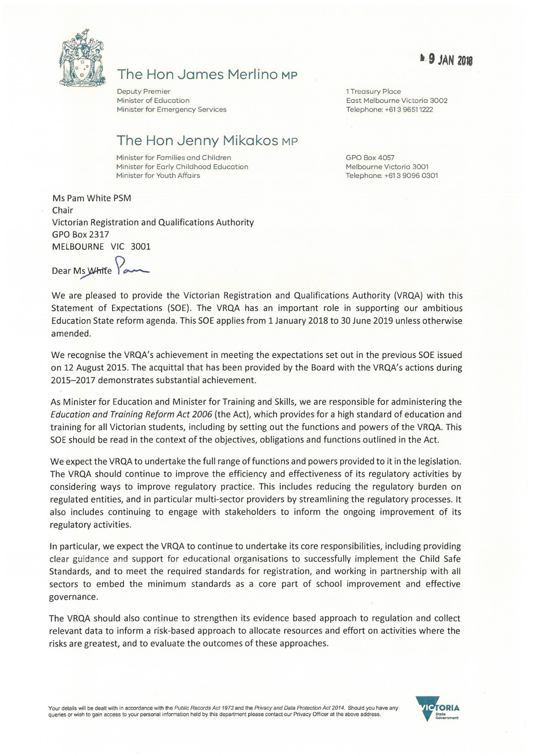

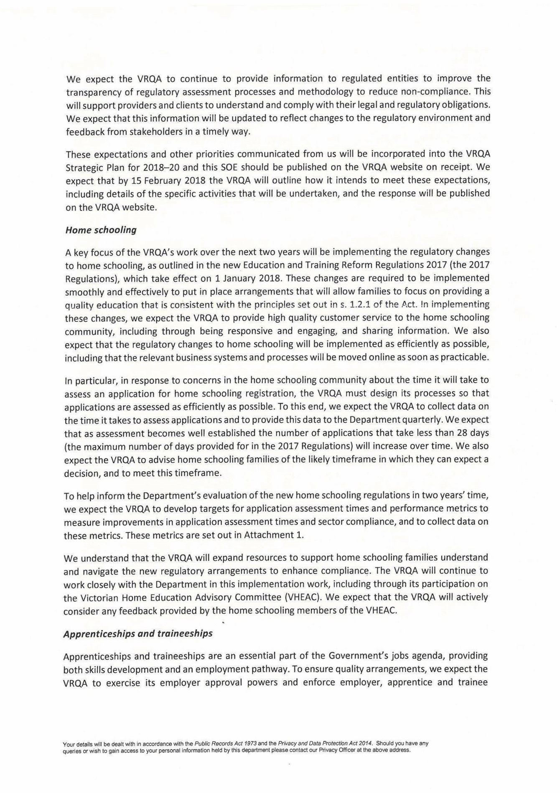

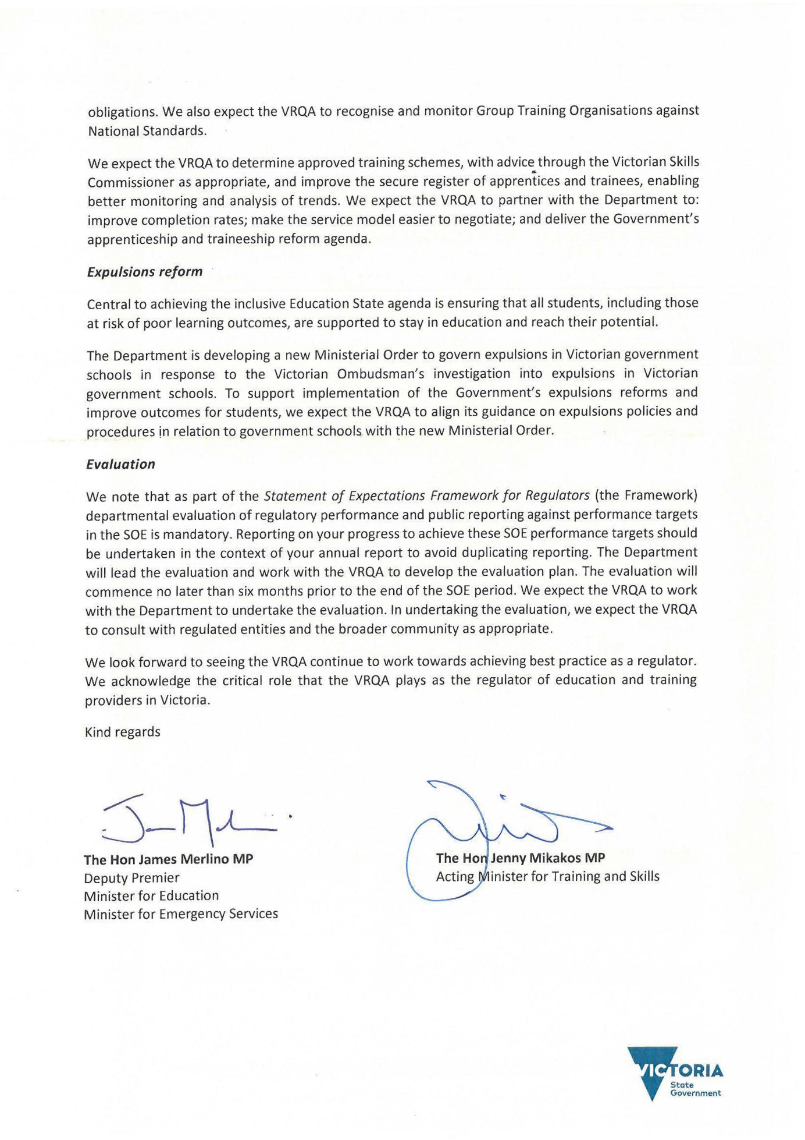

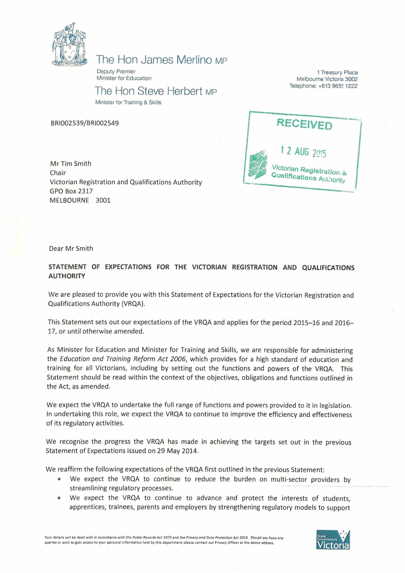

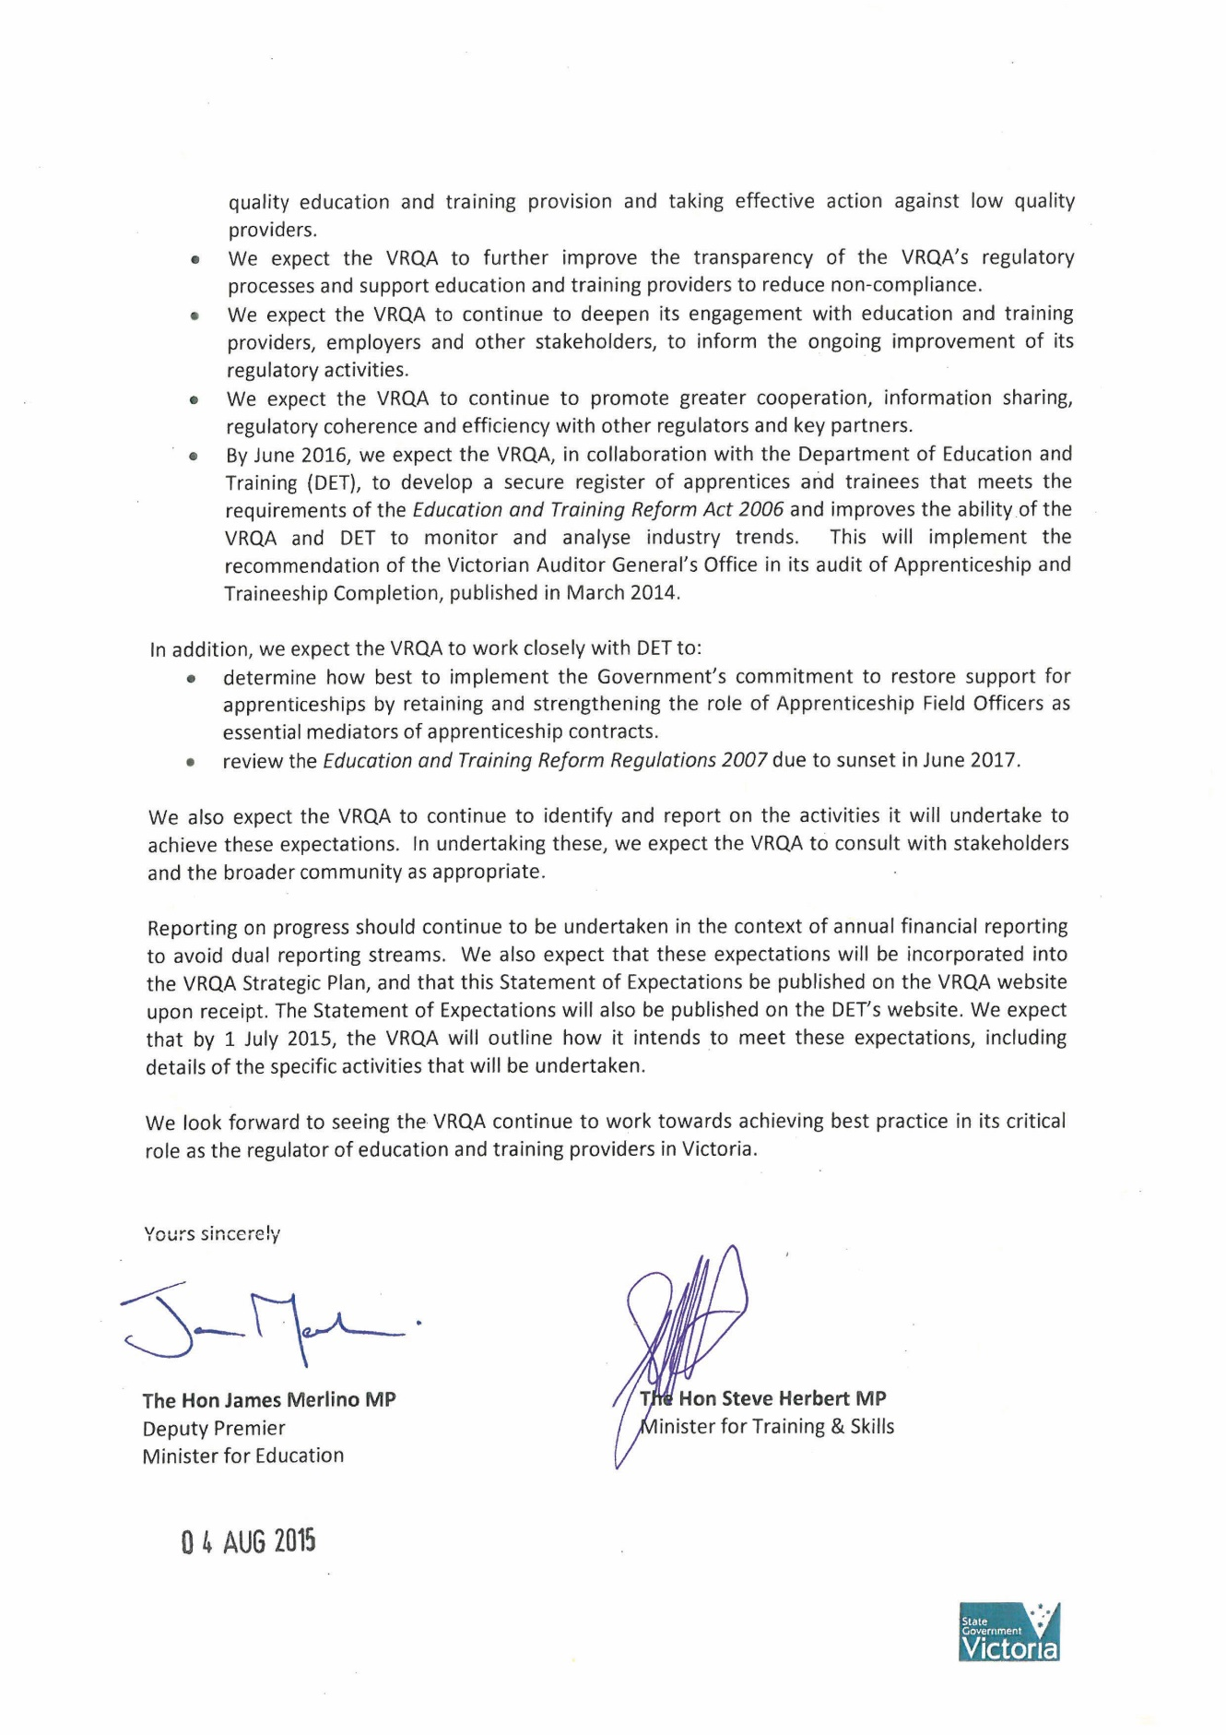

Appendix 3—Acronyms and abbreviations

|  |  |
| --- | --- |
| ACARA | Australian Curriculum, Assessment and Reporting Authority |
| ACECQA | Australian Children’s Education and Care Quality Authority |
| AQTF | Australian Quality Training Framework |
| ASQA | Australian Skills Quality Authority |
| COAG | Council of Australian Governments |
| CRICOS | Commonwealth Register of Institutions and Courses for Overseas Students |
| DET | Department of Education and Training |
| ESOS | Education services for overseas students |
| GTO | Group training organisations |
| OSSEO | Overseas Secondary Student Exchange Organisation |
| RTO | Registered training organisation |
| TAE | Training and Education |
| TAFE | Technical and further education |
| TEQSA | Tertiary Education Quality and Standards Agency |
| VCAA | Victorian Curriculum and Assessment Authority |
| VCAL | Victorian Certificate of Applied Learning |
| VCE | Victorian Certificate of Education |
| VET | Vocational education and training |
| VRQA | Victorian Registration and Qualifications Authority |