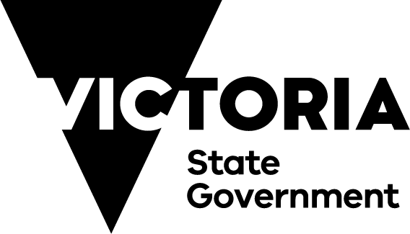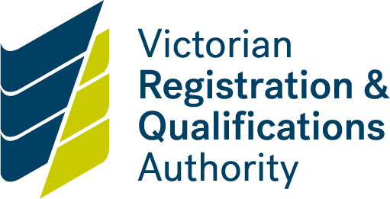

Home Schooling Policy

**Purpose**

The Home Schooling Policy outlines the role of the Victorian Registration and Qualifications Authority (VRQA) in regulating home schooling. It is a guide to the VRQA’s responsibilities under the *Education and Training Reform Act 2006* (Act), *Education and Training Reform Regulations 201*7 (Regulations), and the *Charter of Human Rights and Responsibilities Act 2006* (Charter). It informs the VRQA’s operations and engagement with home schooling families and its relationships with other organisations, like registered schools, that may be able to help home schooling families. It also outlines what is required of parents who wish to register their child for home schooling.

**Policy Statement**

The VRQA acknowledges parents* as the first educators of their children. The VRQA will ensure that the regulation of home schooling respects parents’ right to home school and to design an educational program that meets their child’s needs.

The VRQA expects its Home Schooling Unit to provide an efficient and effective service for managing registration and review of home schooling arrangements.

*The term ‘parent’ in relation to a child, includes a guardian and every person who has parental responsibility for the child including parental responsibility under the *Family Law Act 1975* (Cth)

**Who is eligible for home schooling?**

Parents residing in Victoria may apply to have their child registered for home schooling if their child is of compulsory school age or if they will turn six in their first year of home schooling. The compulsory school age is 6–17 years.

**What constitutes an application for home schooling?**

Parents must apply using the VRQA form Application to Register for Home Schooling. Parents must attach details of their child’s proposed educational program comprising:

* a learning plan
* the educational materials and resources to be used.

**What is instruction in home schooling?**

It is a requirement of registration that a home schooled child receives regular and efficient instruction that:

1. taken as a whole, substantially addresses the eight learning areas listed below (unless the VRQA grants an exemption); and
2. is consistent with the principles and practice of Australian democracy (see Appendix 1).

Parents can design their child’s education program drawing on a range of learning approaches and styles.

**What are the learning areas?**

There are eight learning areas listed in Schedule 1 of the Act:

* English
* mathematics
* sciences (including physics, chemistry and biology)
* humanities and social sciences (including history, geography, economics, business, civics and citizenship)
* the arts
* languages
* health and physical education
* information and communication technology and design and technology.

**What is a learning plan?**

Parents must submit a learning plan that is appropriate to the educational needs of the child with their application for registration. A learning plan specifies when and where instruction will take place and the subject matter that will be covered during the first year of registration. An application for registration must also detail what educational materials and resources parents will use and how their child’s learning outcomes will be recorded. The VRQA provides learning plan templates but their use is optional. A learning plan must be in English.

The VRQA acknowledges that parents are best placed to understand their child’s needs and determine the most appropriate form of instruction for their child.

Parents may apply to the VRQA for an exemption for their child from receiving instruction in one or more of the learning areas. Parents may seek an exemption with the initial application, or at any time after application.

The VRQA will grant an exemption if it receives an application and is satisfied that it would be unreasonable to require the child to receive instruction in the relevant learning area/s. The grounds upon which a parent may satisfy the VRQA are not limited. Before applying for an exemption, parents may wish to discuss this with the VRQA’s Home Schooling Unit.

**What is partial enrolment?**

Parents may wish to address some of the learning areas by partially enrolling their child in a registered school. It is a parent’s responsibility to arrange partial enrolment and it is **at the discretion of the particular school principal whether to accept a partial enrolment.**

If this applies, parents should then indicate on their child’s learning plan which learning areas are likely to be addressed through the partial enrolment arrangement. Once finalised with the school principal, evidence of partial enrolment must be provided to the VRQA.

In some cases parents may wish to partially enrol their child in a registered school at some point after their child is registered for home schooling. In these cases, the parent can contact the VRQA with evidence of partial enrolment.

**When will I know if my application is successful?**

The VRQA must notify an applicant in writing of its decision in relation to an application within 28 days of receiving a complete application.

Where an application is incomplete, parents will be informed and provided with an opportunity to address the outstanding items within a reasonable period, which will generally be two weeks.

After the two-week period, the 28-day period commences. If no further material has been provided during the two-week period, the VRQA will assess the application using the available material and will make its decision. The VRQA will then notify the parent of the outcome of their application.

**What is a review of home schooling?**

From 2018, the VRQA will start a home schooling review program to check whether regular and efficient instruction has been provided to a child who is being home schooled. The VRQA will select a sample of up to 10 per cent of registered home schooling families for review annually. Where a family home schools more than one of their children, only one child’s registration will be reviewed in any given year.

The VRQA will provide parents with written notice of the review and outline the scope, timelines and process. A review may be based on the following questions:

* how do you provide instruction across the learning areas
* what educational materials and resources do you use
* where and when does your child’s instruction takes place
* how do you record your child’s learning?

The VRQA will require, as part of the review, samples of a child’s work accompanied by records of progress against each learning area. A review may include a telephone or face-to-face interview with the parent/s. An interview could take place at neutral location. There is no requirement for the VRQA to visit families in their homes.

When assessing the material supplied, the VRQA may seek advice from one of its panel of assessors.

At the completion of the review, the VRQA will provide a report to the parent/s.

**Can I make a complaint?**

Parents who have a concern about the VRQA’s processes for regulating home schooling may lodge a complaint with the VRQA’s Complaints and Student Services Manager. The Manager will consider the complaint and, if appropriate, undertake an investigation. Investigations are usually completed within 45 days.

Members of the public may lodge a complaint with the VRQA if there is a concern that a child who is home schooled is not receiving regular and efficient instruction in the learning areas.

The VRQA acts in accordance with the principles of transparency and procedural fairness when considering any complaint. For further information, see the [VRQA’s Complaints Management Policy](https://www.vrqa.vic.gov.au/Documents/complaintspolicy.docx). This policy also provides details of how to seek a further review by the Victorian Ombudsman.

**Can a decision be reviewed?**

A decision to not grant registration or to cancel registration is made by the VRQA’s Chief Executive Officer. When a decision is made to not grant registration of a child for home schooling or to cancel registration of a home schooled child, the affected parent/s may apply to the Victorian Civil Administrative Tribunal.

**The Charter of Human Rights and Responsibilities**

The VRQA must regulate in accordance with the Charter (Appendix 2). The Charter requires the VRQA to act consistently with human rights and to give proper consideration to relevant human rights when making decisions.

When processing an application to register a child for home schooling, the VRQA will consider all the relevant rights of the child.

**Your right to privacy**

The VRQA protects the privacy of personal information. The VRQA’s Privacy Policy governs the collection, use, storage, access and disposal of data including all personal information obtained by the VRQA about home schooling families. The VRQAhandles personal information in accordance with the *Privacy* *and Data Protection Act 2014* and *Health Records Act 2001*.

In addition, the Act prohibits the VRQA from publishing details of students registered for home schooling on the State Register or making them available to the public.

**Where can I go for more information?**

* The [VRQA website](http://www.vrqa.vic.gov.au/Pages/default.aspx) is regularly updated with the latest home schooling information
* The [Home Education Network](https://home-ed.vic.edu.au/), a home school support group
* The VRQA [State Register](http://www.vrqa.vic.gov.au/StateRegister/Search.aspx/Search?SearchType=0) details every registered school and education provider in Victoria.

Appendix 1

Principles of Australian democracy

The *Education and Training Reform Act 2006* provides that all providers of education and training, both Government and non-Government, must ensure that their programs and teaching are delivered in a manner that supports and promotes the principles and practice of Australian democracy, including a commitment to:

i. elected Government

ii. the rule of law

iii. equal rights for all before the law

iv. freedom of religion

v. freedom of speech and association

vi. the values of openness and tolerance

Section 1.2.1(a) of the Act

Appendix 2

Charter of Human Rights

The human rights and freedoms protected and promoted by the Charter are:

* + recognition and equality before the law
  + right to life
  + protection from torture and cruel, inhumane or degrading treatment
  + freedom from forced work
  + freedom of movement
  + privacy and reputation
  + freedom of thought, conscience, religion and belief
  + freedom of expression
  + peaceful assembly and freedom of association
  + protection of families and children
  + taking part in public life
  + cultural rights
  + property rights
  + right to liberty and security of person
  + humane treatment when deprived of liberty
  + children in the criminal process
  + fair hearing
  + rights in criminal proceedings
  + right not to be tried or punished more than once
  + right not to be punished under retrospective criminal laws.