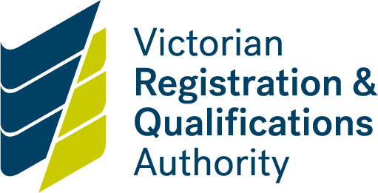

Home Schooling Internal Review

Application form

Submitting your application

Please note that your application for internal review must be received within 28 days of the date of the delegate’s original decision or proposed decision.

Send your application to:

Home Schooling Officer

Victorian Registration and Qualifications Authority

GPO Box 2317

Melbourne Vic 3001

Or scan and email the application and attachments to:

home.schooling@education.vic.gov.au

Supporting documentation

You are required to supply supporting documentation with this form:

* a copy of the notice informing you of the original decision or proposed decision
* a completed registration for home education application form (if the review is for a decision to refuse an application for registration)
* any additional information or documentation to support the application and address the reasons for the initial decision or proposed decision

|  |  |  |  |  |  |  |  |  |  |
| --- | --- | --- | --- | --- | --- | --- | --- | --- | --- |
| **Application details** | | |  | |  | |  |  | |
| 1 | Full name of child subject of internal review |  | | | | | | | |
| 2 | Date of VRQA delegate’s original decision or proposed decision  Listed on the notice you received | DD | | | | MM | | | YYYY |
|  | | **Copy of notice attached** | | | | | |
| 3 | Nature of the VRQA’s decision |  | | Proposed cancellation | | |  | Refusal of registration | |
|  | **Completed registration form attached** | |
| 4 | Is there anything you would like the VRQA to consider when conducting the internal review? |  | | | | | | | |
|  | | **Items for consideration attached** | | | | | |
|  |  |  | | Number of attachments for consideration | | | | | |
| 5 | Full name of parent responsible for home schooling |  | | | | | | | |
| 6 | Parent signature |  | | | | | | | |
| 7 | Date |  | | | | | | | |